Kenya Educators Publishers
231_{/3} - BIOLOGY - Paper 3
(Practical)
January/February 2021
𝟏𝟑/𝟒 𝐇𝐎𝐔RS

MARKING SCHEME

Question | Maximum  Score | Candidate’s Score
1 | 13
2 | 12
3 | 15
Total Score | 40

1. a) (i) Pisces; 1mk Rej Wrong spelling
Rej fish (pisces)
Rej pisces (fish)

(ii) Presence of scales;
Presence of fins;
] Presence of lateral line;
Presence of operculum; acc any first two
(2 mks)
Note (ii) is tied (i)


- (i) Streamlined; 1mk

d)

dorsal fin

caudal fin

lateral line

  - Reduces friction/resistance during locomotion/movements in water; (1 mk)

- (i) 162mm ±1mm; (1 mk)

  - 82mm ±mm; 1mk
(1 mk)
(iii)
lengthoftailtoanus100
Tail power  ;
lengthfromtailtomouth
820mm100  50% ; (2 mks) 162mm

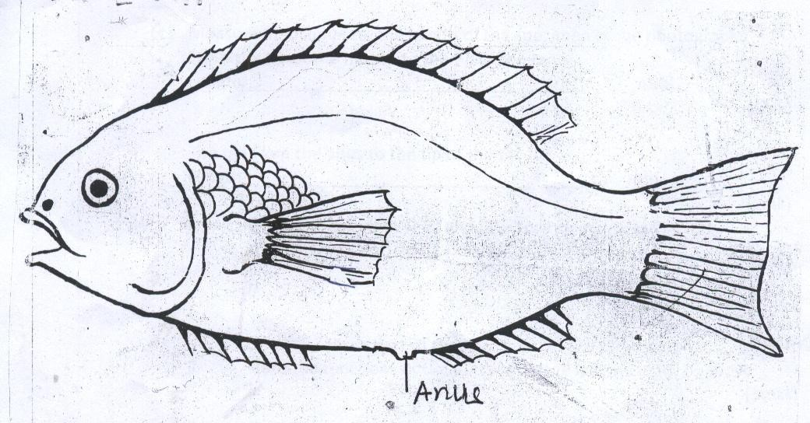

Pectoral fins and Pelvic fins 2mks
Rj. Pectoral fin or pelvic fin
Correct spelling
(i) Dorsal fin, Anal fin and Tail fin 3mks

2. (a) C – Hypocotyl 1mk

D - Cotyledon/ seed leaves 1mk

E
Importance-protects the delicate tip/first leaf/foliage leaf (1mk)

(b)
(i) nodules/root nodules (1mk)

(i) Rhizobium/Rhizobia/Rhizobium bacteria rej. Bacteria alone. (1mk)

(iii) Symbiotic relationship in which bacteria gets protection and nutrients while the plant gets nitrogen in form of nitrates fixed by bacteria. (1mk)

- ( i) Epigeal (1mk)

(ii) Hypocotyl elongates raising/ pulling cotyledons are brought out of the ground.

- Water
Oxygen;
Optimum temperature First two

3 (a) (i) Fruit 1mk

- - Has two scars
- – Presence of pericarp 1mk

(b) (i) 4mks

Drawing marks 2mks
D1 1mk - Proportionality- Seeds larger than placenta, Endocarp the largest size followed by
Mesocarp and Epicarp the smallest

D2 1mk - Complete outline, thin continuous outline
-Seeds present
-Complete outline for placenta

Labelling marks 2mks
Any 4 correctly labeled parts ⁴/₂
-Complete labeling line
-Labeling line must touch the labeled part
-Correct spelling on the parts
- Labeling lines not crisscrossing
-No double naming( giving the same part different names)

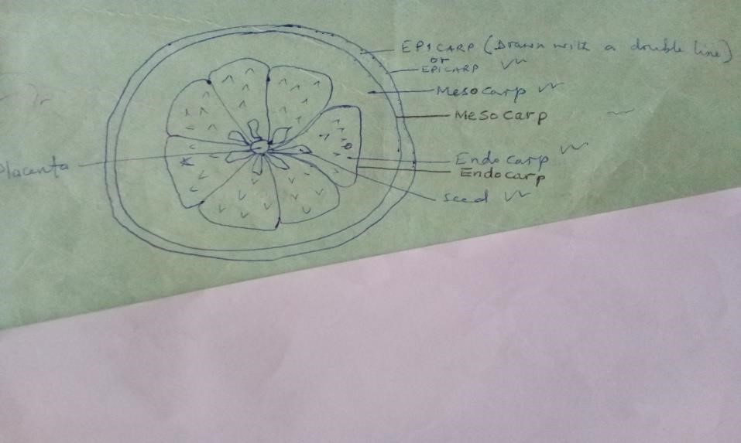

Magnification X¹/₂ - X3 1mk

(ii) Axile 1mk

- Animal

- - Seeds have hard/ slimy seed coats/ with mucus which prevent/ resist digestion/ make them indigestible
  - Scented to attract animal/ dispersal by animal
  - Succulent to attract/ so that it is edible/ can be eaten by animal 3mks

- (i) 2 drops (accpt from 1 to 4 drops) 1mk

(ii) 8 drops (accpt from 1 to 10 drops) 1mk

  - ²/₈ X 0.1% = 0.025%
The drops must be within stated ranges

  - – Period of storage of specimen E/ extent/ degree of ripening
    - Size of drops
    - Size of dropper
    - Impurities 1mk

