CHEM PAPER 1 MARKING SCHEME FORM 3
- (a) Draw the atomic structure of an element which has a mass number of 27 and 14 neutrons (2 mks)

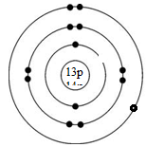

(b) To which period does the element belong? ( 1 mk)
Period 3
- Hydrocarbons burn in air to produce water and another product.
- Name the other product. (1 mk)
Carbon (iv) oxide
- Describe how the other product can be confirmed. (2 mks)
Bubbling it through calcium hydroxide solution/lime water. Formation of a white precipitate confirms it.
An electric current can be passed through some substances decomposing them in the process.
- Name the process. ………Electrolysis……………………(1 mk)

- Draw a diagram to show how an electric current can be used to decompose molten zinc chloride. (2 mks)

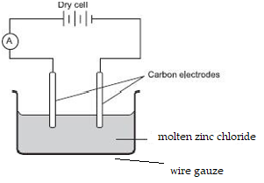

^{HEAT}
4. Boyle’s law investigates the relationship of two factors on gases.
- Name the two factors. (1 mk)
-Pressure
-Volume
- Draw a simple diagram that can be used to illustrate the relationship of the factors named above with respect to a given mass of a gas. (1 mk)

- State Charles law. (1 mk)
At constant pressure, the volume of a fixed mass of a gas is directly proportional to its absolute temperature.
………………………………………………………………………………………
- (a) Name two amorphous forms of carbon. (2 mks)
-Wood charcoal/Animal charcoal/Lamp black/Coal/coke/soot………………………
(b) What is the property of graphite that makes is suitable to be used in pencil leads?(1 mk)
Slippery/layers flake off onto paper……………….
- Gases react in simple whole number ratios to each other and to gaseous products. Determine the amount of residual gas produced when 180cm³ of sulphur (iv) oxide was exploded with 100cm³ of oxygen. (3 mks)
2SO_{2(g)} + O_{2(g)} 2SO_{3(g)}
2 : 1 : 2
180cm³ 90cm³ 180cm³
From the mole ratio, 180cm³ of sulphur (iv) oxide requires only 90cm³ of oxygen for the reaction to produce 180cm³ of sulphur (vi) oxide
Residual gas will be 180cm³ plus 10cm³ of unreacted oxygen = 190cm³
- (a) Draw a pipette (1 mk)

(b) Name two other apparatus that can be used to measure accurate volumes of liquids. (2 mks)
-Burette
-Volumetric flask
……………………………………………………………………………………………
- Sulphur (iv) oxide was reacted with hydrogen sulphide by form three students.
- Give one major observation made. (1 mk)
Formation of a yellow solid/yellow deposits
- Write a balanced chemical equation for the reaction. (1 mk)
2H₂S_{(g)} + SO_{2(g)} 3S_{(s)} + H₂O_{(l)}
- What precaution should the students undertake while carrying out the experiment? (1 mk)
Carry it out in the fume chamber or out in an open space. Gases being used are poisonous………
- Describe how a sample of sodium chloride can be prepared in the laboratory by direct synthesis. (2 mks)
-Heat a small piece of sodium metal on a deflagrating spoon.
-Lower the hot metal inside a gas jar or cylinder that contains chlorine gas.
…………………………………………………………………………………………………
- The diagram below shows preparation of ammonia gas in the lab. Study it and answer the questions that follow.
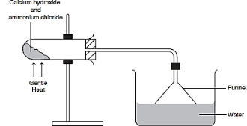

- Give a reason why the funnel is inverted in the trough. (1 mk)
To prevent suck back of water into the delivery tube/ to offer a large surface area for the gas to dissolve in water
- What property of ammonia gas necessitates this set up? (1 mk)
……Ammonia is very/highly soluble in water . *Reject soluble in water
- Write a balanced chemical equation for the decomposition of ammonium nitrate. (1 mk)
….… NH₄NO_{3(s)} N₂O_{(g)} + 2H₂O_{(l)}……………………
- A given mass of a gas occupies 20 cm3 at 25°C and 670 mmHg pressure. Find out the volume it will occupy at 40°C and 320 mmHg. (3 mks)

25ºC+273=298k, 40ºC+273= 313k
$\frac{P1V1}{T1}= \frac{P2V2}{T2}$.
…… $\frac{670 X 20}{298}= \frac{320 X V2}{313}$.
…… $V2= \frac{670 X 20 X 313}{298 X 320}$.
……V2 = 43.98cm³
- Explain the following.
- The ion of nitrogen is larger than the atom. (1 mk)
…Nitrogen gains three electrons to be stable. The incoming electrons cause electron- electron repulsion which makes the atom to bulge.………………....
- Calcium has lower first ionization energy than magnesium. (1 mk)
….An atom of calcium is larger than that of magnesium. The larger size means a weaker nuclear force of attraction therefore it loses its first electron more readily than magnesium.………………
- Aluminium is a better conductor than potassium. (1 mk)
…Aluminium has more delocalized electrons (3) than potassium which only has one..................................................................
- A mixture of sodium carbonate and sodium chloride measuring 5g was reacted with 24cm³ of 63g/l of nitric (v) acid. Determine the percentage of sodium chloride present in the mixture. (3 mks)
…RFM HNO₃ =63, Na₂CO₃ = 106
Molarity of nitric acid = 63/63 = 1M
1000cm³ = 1mole
24cm³ = ?
$= \frac{24 X 1}{1000}$
= 0.024moles
Na₂CO_{3(s)} + 2HNO_{3(aq)} 2NaNO_{3(aq)} + H₂O_{(l)} + CO_{2(g)}
Mole ratio 1 : 2
Moles of sodium carbonate = 0.024/2 = 0.012moles
Mass of sodium carbonate = 0.012 X 106 = 1.272g
Mass of sodium chloride = 5 - 1.272 = 3.728g
Percentage of NaCl = $\frac{3.728}{5} X 100$= 74.56%
………………………………………………………………………………………...…….

- Name;
- The green substance formed on copper coins when stored in a damp place for a while. (1 mk)
…Copper carbonate
- The complex ion responsible for the deep blue colour observed when excess ammonia solution is added to copper ions. (1 mk)
……Tetramine copper (ii) ions
- The alloy formed from a combination of copper and tin. (1 mk)
……Brass…

- Water molecules are bonded together as shown below.
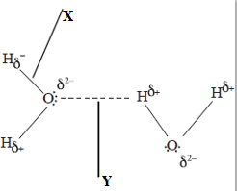

- Name the bonds labeled;
X …Covalent bond………………………………………(1 mk)
Y…Hydrogen bond…………………………………………………………….(1 mk)

- Give a reason why gases have generally a low boiling point. (1 mk)
………Most gases are generally molecular, where the molecules are held together by weak van der waals forces which require less hear to break.
- Study the diagram below and use it to answer the questions that follow.

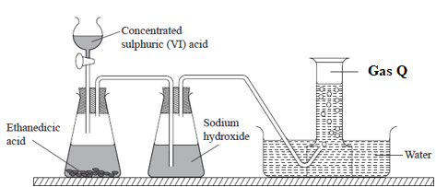

- Name gas Q (1 mk)
……carbon (ii) oxide……………………………………………………………
- Why is sodium hydroxide used in the process? (1 mk)
.......to remove carbon (iv) oxide gas
- Why is calcium hydroxide preferred to sodium hydroxide in identifying carbon (iv) oxide gas? (1 mk)
……calcium hydroxide forms an observable white precipitate with carbon (iv) oxide while sodium hydroxide does not…
- The structure of methanoic acid is shown below
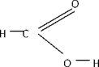

- What is the total number of electrons used for bonding in a molecule of methanoic acid? Give a reason. (2 marks)
....10 electrons
There are five covalent bonds in the structure each holding two electrons.
- What is the likely colour of universal indicator in methanoic acid? (1 mk)
…orange/ yellow
- The grid below is part of the periodic table. Use it to answer the questions that follow. (The letters are not the actual symbols of the elements).

- Which is the most reactive non-metallic element shown in the table? Explain . (1mk)
C
It has a very small atomic size making it the most electronegative/ has the highest tendency to gain electrons. 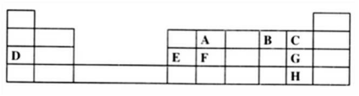

- (i) Write the formulae of the compounds formed when element A reacts with element B
-AB₂ …accept CO₂…… (1/2mk)
-AB…… …accept CO………… (1/2 mk)
(ii) To which family does element G belong? (1mk)
.........Halogens
- An experiment was carried out to prepare crystals of magnesium sulphate. Excess magnesium powder was added to 100cm³ of dilute sulphuric (VI) acid in a beaker and warmed until no further reaction took place.
The mixture was filtered and the filtrate evaporated to saturation, then left to cool for crystals to form.
  - Write an equation for the reaction. (1 mk)
Mg_{(s)} + H₂SO_{4(aq)} MgSO_{4(aq)} + H₂(g)
  - Explain why excess magnesium powder was used. (1 mk)
…To ensure that all the acid reacts……………..
  - State how completion of the reaction was determined. (1 mk)
…When effervescence/bubbles stopped…………………………………
- Rhombic sulphur is one of the allotropes of sulphur.
- Name the other allotrope (1 mk)
…Monoclinic sulphur……………………………………………………..
- Give two differences between the two allotropes of sulphur. (2 mks)
MONOCLINIC SULPHUR | RHOMBIC SULPHUR
Pale yellow | Bright yellow
Stable above 96⁰C | Stable below 96⁰C
Lower density/1.96g/cm³ | Higher density/2.06g/cm³
Hexagonal prisms | Octahedral in shape

- Study the flow chart below and answer the questions that follow.
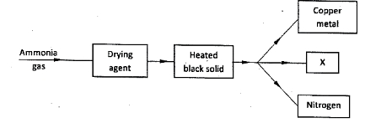
- Name a suitable drying agent for ammonia. (1 mark)
……Calcium oxide…………………………………………………
- Identify the black solid and substance X
Black solid ……Copper (ii) oxide/ CuO… ……… (1/2 mark)
X …………….Water…………… (1/2 mk).
- What property of ammonia is being investigated? (1 mark)
…reduction/reducing agent.…………………………………
- Potassium nitrate liberates oxygen gas when heated. 50.5g of potassium nitrate was heated completely in a closed system. Calculate the volume of the gas produced at r.t.p? (K=39, N=14, O=16, MGV =24000cm³) (3 marks)
…………………………………………………………………………………………………… 2KNO_{3(s)} 2KNO_{2(s)} + O_{2(g)}
RFM of KNO₃ =2(39+14+48) = 202
202g KNO₃ liberates 240000cm3 of oxygen gas.
50.5g will liberate $\frac{50.5}{202} X 24000$= 6000g oxygen.
- (a) Write a balanced chemical equation to show that concentrated sulphuric (vi) acid is a dehydrating agent. (1 mk)
CuSO₄.5H20_{(s)} ^{H2SO4} CuSO_{4(s)} + 5H₂0_{(l)} or
(Blue) (White)
C₂H₅OH_{(aq)} ^{H2SO4} C₂H_{4(g)} + H₂O_{(l)}
₁₆₀º_{C}
- Name the most suitable catalyst used in the large scale manufacture of sulphuric (vi) acid.(1 mk)
……Vanadium (v) oxide……………………………………………
- Oleum is one of the products formed during the contact process. Write a balanced chemical equation to show how it is formed. (1 mk)
SO₃(g) + H₂SO_{4(l)} H₂S₂O_{7(l)}
- In one of the laboratory sessions, students were provided with an unknown white solid. They were asked to dissolve it in about 5 cm³ of water and to it add a few drops of barium nitrate followed by about 5cm³ dilute nitric (v) acid. Complete the table below.
Test | Observation | Inference
Addition of barium nitrate | Formation of a white precipitate | SO₄²⁻, SO₃²⁻, CO₃²⁻ present ($1\frac{1}{2}$ mks)
Addition of nitric (v) acid | White precipitate dissolved to a colourless solution | SO₃²⁻ , CO₃²⁻ present  ($1$ mks)

- (a) Using dots and crosses to represent electrons, illustrate the type of bonding in hydrogen chloride.(H = 1, Cl = 17) (2 mks)
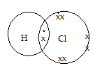

(b)What nature of solution is formed when hydrogen chloride is dissolved in water? (1mk)
-Acidic solution.
- Some oxides of nitrogen are pollutants that may have adverse effects on the environment.
- Explain how acid rain is formed from such oxides. (2 mks)
…Nitrogen (iv) oxide gets taken up into the atmosphere alongside other acidic gases. It mixes with moisture in the clouds, condenses and falls back as acid rain.
- List two effects of acid rain. (2 mks)
-corrosion of metallic and stone structures.
-damage to plant foliage/leaf chlorosis
-leaching of minerals in soil lowering soil fertility
-Death of aquatic plants and animals

- Define the following terms as used in describing metals.
- Lustre (1 mk)
The shiny appearance on the surface of metals when freshly cut or polished. ……………………………………
- Ductile (1 mk)
-Ability of metals to be drawn into wire. …………………
c) Metalloid- An element the exhibits both metallic and non-metallic properties. (1 mk)

