233/2
CHEMISTRY
PAPER 2 MARKING SCHEME

MARKING SCHEME
FORM 4
Kenya Certificate of Secondary Education (K.C.S.E)

- The table below shows the elements in period 3 of the periodic table. Study it and answer the questions that follow
Element | Na | Mg | Al | Si | P | S | Ci | Ar

I. a) Write the formulae for each of the following [2 marks]
- Sodium: Oxide I Oxide II
- Na₂O, Na₂O₂
- Sulphur: Oxide I Oxide II
- SO₂ SO₃
b) The products of the reaction between phosphorus and chlorine depend on the conditions used. Write the equation for the reaction when phosphorus reacts with limited chlorine gas[1 marks]
- P_{4(s)} + 6Cl_{2(g)} 4PCl_{3(l)}
c) Identify the most electronegative element. Give a reason [1 marks]
- Cl – smallest atomic radius hence can readily gain electrons / highest electron affinity
d) State and explain the difference in the boiling point of sulphure and phosphorus[2 marks]
- Sulphur has a higher boiling point than phosphorus. Sulphur has greater molecular mass hence stronger van der waals forces
II. Study the information below and answer the questions that follow. The letters do not represent the actual symbols of elements
element | Atomic number | M.P of element | M.P of chloride
G | 11 | 98 | 801
H | 12 | 650 | 715
J | 14 | 1410 | -70
K | 16 | 113 | -80
L | 20 | 851 | 780
- Write the formula of the compounds formed when element H reacts with element K[1 mark]
- HK
- Use dote (.) and (x) to show bonding between G and K[2 marks]
- G₂K
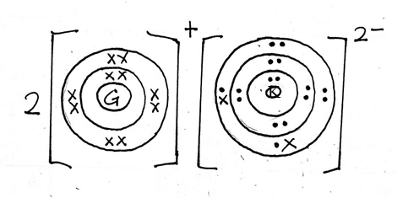
- What is the oxidation state of j in its chloride [1 marks]
- JCl₄
- -4 + X = 0
- X = +4
- How does the melting point of fluoride of G compare with that of it chloride [2 marks]
- Fluoride of G has a higher melting point than that of its chloride. This is because fluorine has a smaller atomic radius than chlorine making the fluoride to have stronger ionic bond and ionic structure
- Study the setup below and answer the questions that follow
- Give two reasons why it is necessary to heat the water in the flask just before heating the magnesium powder[2 marks]
- To generate steam, which will drive out the air in the combustion tube
- To avoid magnesium reacting with air.
- Write a chemical equation for the reaction taking place in the combustion tube[1 mark]
- Mg_{(s)} + H₂O_{(g)} MgO_{(s)} + H_{2(g)}
- Give the test for gas A[1 mark]
- Extinguishes burning splint with a pop sound
- Give two uses of gas A[1 mark]
- Used in large scale manufacture of ammonia
- As rocket fuel
- Manufacture of hydrochloric acid (Any 2 correct)
- Given that 240cm3 of gas A was produced in the experiment, determine the mass of magnesium powder used.(molar gas volume = 24000cm³ at R.T.P, Mg = 24)
- Mole of gas A = $\frac{240}{24000}=0.01 mole$
- Mole ratio = Mg : Gas A = 1 : 1 = 0.01 : 0.01
- Mass = Number of moles × Molar mass
- = 0.01 × 24 = 0.24g
- What would be observed if magnesium powder was replaced with;
- Copper metal? [1 marks]
- No gas will be collected because copper does not react with steam
- Potassium metal?[1 marks]
- The reaction will be explosive
- The diagram below is a flow chart for the extraction of copper from the chief ore. Study it and answer the questions that follow.
- Name two ores of copper metal[2 marks]
- Malachite, copper pyrites, cuprite
- Name process II[1 mark]
- Froth floatation
- Give an equation for the reaction that occurs in stage III[1 mark]
- 2CuFeS_{(s)} + 4O_{2(g)} Cu₂S_{(s)} + 2FeO_{(s)} + 3SO_{2(s)}
- Explain what happens in stage IV[1 mark]
- Silica is added which reacts with iron(ii)oxide to form iron(ii)silicate which separates out as slag leaving behind copper(i)sulphide.
- Write half-cell equations occurring at the anode and cathode in stage VII
Anode [1 marks]
- Cu_{(s)} Cu²⁺_{(aq)} + 2e⁻
Cathode [1 marks]
- Cu²⁺_{(aq)} + 2e⁻ Cu_{(s)}
- State one impurity in blister copper[1 mark]
- Gold, silver, platinum
- Draw a simple diagram showing the setup that is used in electrolytic purification of copper[1 mark]
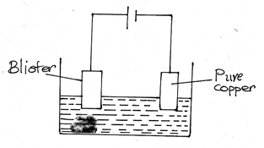

- Consider the electro chemical cell represented by the cell notation below, when X is an unknown metal:
Fe²⁺(_{aq)/} Fe³⁺_{(aq)} // X⁺(aq) / X_{(s)}
- The cell potential of the cell was found to be 0.03V
- What does the single line (|) in the above cell notation represent[1 mark]
- Indicates phase boundary / interphase / phase separator
- Write down the half reaction that takes place at the anode in the above cell[1 marks]
- Fe²⁺_{(aq)} Fe3+_{(aq)} + e⁻
- Given that:
Half reaction E^{θ}(volts)
Fe³⁺(_{aq)} + e⁻ Fe²⁺(_{aq),} +0.77
Ag⁺_{(aq)} + e⁻ Ag_{(s)} +0.80
Na⁺_{(aq)} + e⁻ Na_{(s)} -2.87
K⁺_{(aq)} + e⁻ K_{(s)} -2.92
Identify X with the aid of calculation[2 marks]
- E^{θ}_{cell} = E_{red} – E_{oxid}
- 0.03V = E_{red} – 0.77
- E_{red} = 0.03 + 0.77
- = +0.80V
- Thus X is silver, Ag
- The diagram below shows the apparatus that can be used to electrolyte dilute sulphuric acid. Study it and answer the questions that follow.
- Identify the gases H and G
- H[1 mark]
- Oxygen gas
- G[1 mark]
- Hydrogen gas
- What happens to the concentration of the sulphuric acid during the process with time? Explain [1 mark]
- Concentration increases because OH- ions and H+ ions are discharged; hence continuous dissociation of water from the electrolyte
- During electrolysis a current of 0.72A was passed through the electrolyte for 15 minutes. Calculate the volume of gas G produced. (1 Faraday = 96500C, molar gas volume = 24dm³ at r.t.p)
- 4H⁺_{(aq)} + 4e 2H_{2(g)}
- = 0.72 × 15 × 60
- = 738C
- 4 × 96500C 24dm³
738C
- $\frac{24 ×738}{386000}=$ 0.0459dm³ / 45.9cm³
- a) The sketch below represents a graph obtained when zinc granules were reacted with excess 0.2M sulphuric (vi) acid in the presence of a catalyst in a conical flask placed on an electronic balance.
- Write an equation for the reaction that took place[1 mark]
- Zn_{(s)} + H₂SO_{4(aq)} ZnSO_{4(aq)} + H_{2(g)}
- Explain why there is loss in mass[1 mark]
- Hydrogen gas is produced which escapes to the environment
- Name the catalyst used[1 mark]
- Copper(ii)sulphate
- Sketch on the same axes, the curves obtained when
- Zinc powder was used under the same conditions[1 mark]
- No catalyst was used[1 mark]
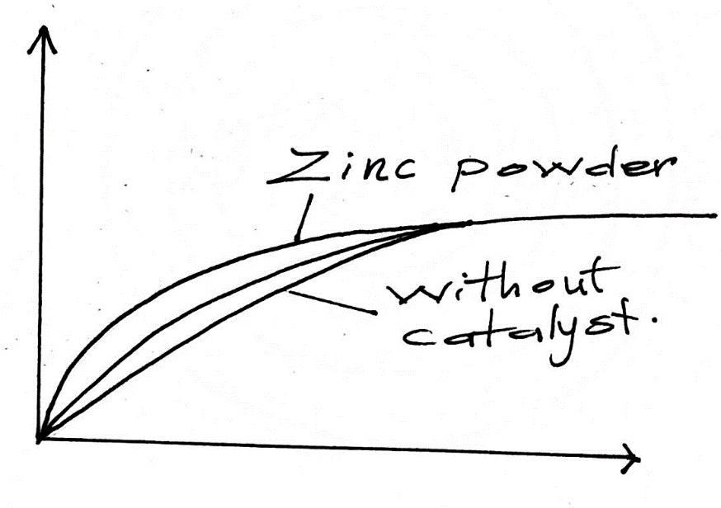
b) In the contact process, sulphur(iv)oxide is converted to sulphuric(vi)oxide in the catalytic chamber which a dynamic chemical equilibrium is reached.
2SO²_{(g)} + O2_{(g)} 2SO³_{(g)} ∆H = -197kJ/mol
- What is meant by dynamic equilibrium[1 mark]
- When a state of balance is attained the forward and reverse reaction occurs at the same rate
- State and explain how each of the following would affect the position of equilibrium[1 mark]
- Decrease in temperature[2 marks]
- Equilibrium shifts to the right, forward reaction is exothermic, it is favored by low temperature
- Decrease in pressure[1 mark]
- Equilibrium swift to the left, less pressure favors high volume which is the reactants
- Equilibrium exists between chromate and dichromate ions as shown below.
2Cr²⁻_{4(aq)} + 2H⁺_{(aq)} CrO²⁻7_{(aq)} + H₂O_{(l)}

State and explain the observation made when aqueous sodium hydroxide is added to the above mixture. [2 marks]
- Yellow colour intensifies. OH- ions react with H+ ions decreasing concentration on the reactants hence reverse reaction is favored.
- Study the formulae below and answer the questions that follow
I. CH₃CH₂COOH
II. CH₃CH₂CH₂CH₂OH
- i) Give the systematic name of each compound [2 marks]
- Propanoic acid
II. Butan-1-ol
ii) Write the molecular formula of the compounds[1 mark]
I. C₃H₆O₂
II. C₄H₁₀O
- How does the boiling point of I compare to that of II. Explain[2 marks]
- Boiling point of II is higher than I. II forms more hydrogen bonds than I hence higher boiling point
iv) A gas J is bubbled into concentrated sulphuric(vi)acid. Water is added to the mixture then boiled to yield compound II. Name gas J. [1 mark]
- But-1-ene
v) Draw the structural formula of the compound immediately after compound I in the homologous series [1 mark]
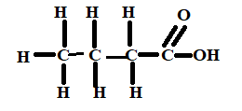
b) Study the structural formula of the two monomers and answer the questions that follow.
i) Name the type of polymerization these monomers would undergo to form a polymer[1 mark]
- Condensation
ii) Draw the structural formula to represent the polymer formed. [1 mark]
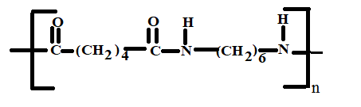
iii) What is the name of the plymer[1 mark]
- Nylon 6, 6
iv) State the use of this polymer[1 mark]
- Manufacture of ropes, carpets, brushes, fishing nets, parachutes
c) Two cleaning agents are represented below
Select one of the detergent which would be suitable for washing in water containing magnesium chloride. Explain [1 mark]
- Detergent p, does not form scum with water containing magnesium chloride
- a) Define the term half-life [1 mark]
- Time taken for a given mass or number of nuclides to decay to half its original mass or number
b) The table below contains information from the measurements made of the radioactivity in counts per minute from a radioactive iodine – 128
Counts per minute | 240 | 204 | 180 | 156 | 138 | 122 | 108
Time (min) | 0 | 5 | 10 | 15 | 20 | 25 | 30

i) Plot a graph of counts per minute against time [3 marks]
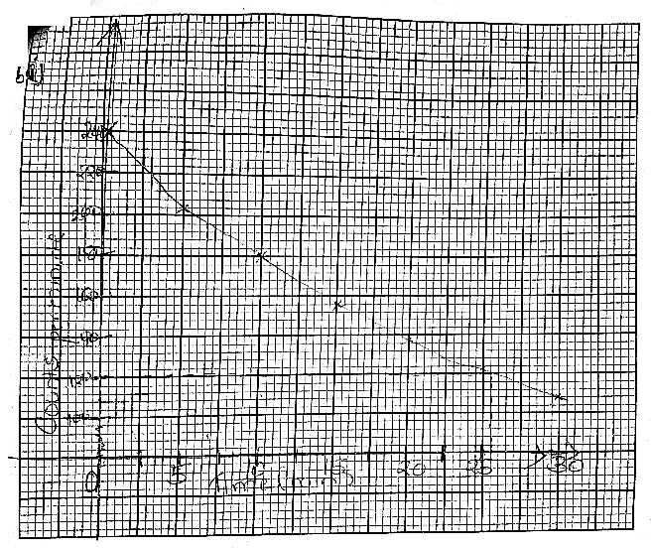
- P- 1
- S – ½
- A – ½
- C – 1

ii) Use the graph to determine the half-life of iodine - 128[1 mark]
- 26 minutes ± 2
iii) What is the count rate after 22 minutes[1 mark]
- 132 ±
iv) After how many minutes were the counts rate 160 counts per minute [1 mark]
- 14 minutes ± 1
c) Potassium has two isotopes ³⁹₁₉K and radio active ⁴⁰₁₉ K
i) State how the isotopes differ[1 mark]
- They differ with the number of neutrons i.e. 20 and 21 respectively
ii) The half life of is 1.3 ˟ 10⁹ years. Determine how long it would take for 4g of the isotope to decay to 1g[1 mark]
- Remaining amount = ( ½ )^{n} × original amount
- 4(g) 1st 2(g) 2nd 1(g)
- 1(g) = ( ½ )^{n} × 4
- ¼ = ( ½ )^{n} × 4
- N = 2
- 1.3 × 10⁹ × 2
- = 2.6 × 10⁹ years
iii) ³⁹₁₉K undergoes beta decay to form an isotope of calcium. Write the nuclear equation for this decay[1 mark]
d) The figure below shows how a radioactive material emitted radiations from its source. Study it and answer the questions that follows as shown.
Identify the radiation that: [1 mark]
i) Has no mass [1 mark]
- Y
ii) Contains helium particles
- X

