233/1
CHEMISTRY
PAPER 1 MARKING SCHEME

MARKING SCHEME
FORM 4
Kenya Certificate of Secondary Education (K.C.S.E)
Chemistry paper 1 233/1

- Air is a mixture of different components. Identify;
- A compound that turn lime water to a white precipitate[1 mk]
- Carbon(iv)oxide(CO₂) 1
- A compound that changes cobalt(ii)chloride from blue to pink[1 mk]
- Water vapour (H₂O) 1 or moisture rej. Water alone
- A diatomic that has triple bond[1 mk]
- Nitrogen (N₂) 1
- A mixture contains potassium chloride and lead(ii)sulphate. Describe how you would obtain crystals of potassium chloride from this mixture[3 mks]
- Add water to the mixture and stir thoroughly ½
- Potassium chloride dissolves ½
- Filter to obtain KCl as the filtrate ½
- Heat the filtrate up to saturation ½
- Allow the saturated solution to cool to form crystals ½
- Dry the crystals between filter papers ½
- Oxygen is prepared in the laboratory through catalytic decomposition of hydrogen peroxide.
- Name the catalyst in this experiment[1 mk]
- Manganese(iv)oxide
- What mass of hydrogen peroxide would be needed to produce 120cm³ of oxygen gas at r.t.p in this experiment? (Molar gas volume at RTP = 24000cm³, h = 1, 0= 16) [3 mks]
- 2H₂O_{2(l)} 2H₂O(_{l)} + O_{2(g)}
- Moles of oxygen = $\frac{120}{24000}=0.005mol ½$
- Moles of 2H₂O₂ = 2 × 0.005 = 0.01mol ½
- Mass of 2H₂O₂ ₌ 0.01 × 34 ½ = 0.34g ½
- Carbon(iv)oxide gas was passed over heated copper(ii)oxides shown in the diagram below.
- State the observation made in the tube P[1 mk]
- Copper (ii) oxide turns brown 1
- Write an equation for the reaction which took place in tube P[1 mk]
- CO(g) + CuO CO2(g) + Cu(s) 1 (wrong or missing S.S penalize ½ )
- Name the gas burning at point X[1 mk]
- Unreacted carbon(ii)oxide
- The diagram below illustrates the steps involved in the industrial manufacture of nitric(v)acid. Use it to answer the questions that follow.
- Identify the chamber in which a catalyst is used. [1 mk]
- Chamber I
- Name substance Z[1 mk]
- Nitrogen (ii) oxide rej. formula
- Write an equation for the reaction that takes place in chamber III[1 mk]
- 4NO_{2(g)} + H₂O_{(l)} + O_{2(g)} 4HNO_{3(aq)}
- Draw a well labelled setup for the laboratory preparation and collection of dry sample of hydrogen chloride gas[3 mks]
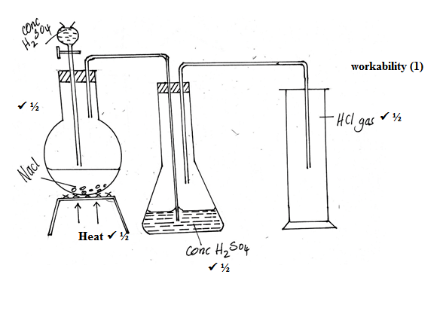
- Account for the following observations made when a piece of sodium is placed in a trough half filled with water.
- Hissing sound[1 mk]
- Production of hydrogen gas 1
- Darts on the water surface[1 mk]
- Propulsion by the hydrogen gas 1
- Solution formed turns red litmus paper blue[1 mk]
The solution is alkaline 1
- The diagram below shows the structure of iodine
- Name;
- Part X [1 mk]
- Van der waal
- Type of bond in the solid[1 mk]
- Covalent
- Explain why iodine has very low melting point[1 mk]
- The van der wall forces are weak between molecules
- 20g of salt X dissolves is 80g of water to form a saturated solution at 45ºC. calculate the solubility of salt X at 45ºC[2 mks]
- 80g of water 20g of X
- 100g of water ?
- $\frac{20 ×100}{80}$ 1= 25g/100g of water 1
- When excess chlorine gas is bubbled through dilute sodium hydroxide solution, the resulting solution acts as bleaching agent.
- Write an equation for the reaction between chlorine gas and sodium hydroxide[1 mk]
- NaOH_{(aq)} + Cl_{2(g)} NaCl_{(aq)} + NaOCl_{(aq)} + H₂O_{(l)}
- Wrong or missing S.S deduct ½
- Explain how the resulting solution acts as a bleaching agent[1 mk]
- The oxygen in NaOCl is donated to the dye 1 hence it bleaches by oxidation 1
- Element Z has initial mass of 80g. After 5 years the remaining mas was 5g.
- What is meant by the term half-life[1 mk]
- The time taken for a quantity (of substance) to reduce to half its initial value
- Calculate the half-life of element Z[1 mk]
- 80 t½ 40 t½ 20 t½10 t½ 5 1
- 4t ½ = 5
- t ½ = 1 ¼ years 1
- accept use of formula
- Complete the table below[3 mks]
- Galena ½
- Al₂O₃·2H₂O ½
- PbS ½
- NaCl ½
- Electrolysis ½
- Electrolysis ½
- Use the reaction scheme below to answer the questions that follow.
- Draw the structure of alcohol X[1 mk]
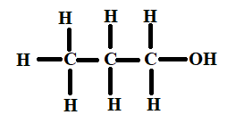
NB – should be open structure
- Name process Y[1 mk]
- Dehydration
- Write the molecular formulae of the 5th member of the homologous series in which propene belongs[1 mk]
- C₆H₁₂
- Calculate the enthalpy for the reaction:
C₂H_{4(g)} + H_{2(g)} C₂H₆ [3 mks]
Give the following bond energies
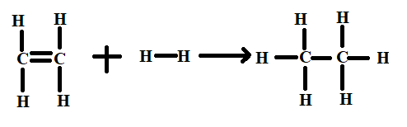
- Bond breaking
C = C ; 1 × 612 = 612
C – H ; 4 × 413 = 1652
H – H ; 1 × 436 = 436
= +2700kJ 1
- Bond formation
C – C ; 1 ×347 = 347
C – H ; 6 × 413 = 2478
= 2825kJmol-1 1 ΔH=+2700-2825=-125kJ/mol
- Study the reactions below and answer the questions that follow.
- Precipitation reaction -J
- Displacement -K
- Neutralization -L
- An atom of element A has mass number 39 and 19 protons. (A is not the actual symbol of the element)
- Using crosses (x) to represent electrons, draw the atomic structure of element A[1 mk]
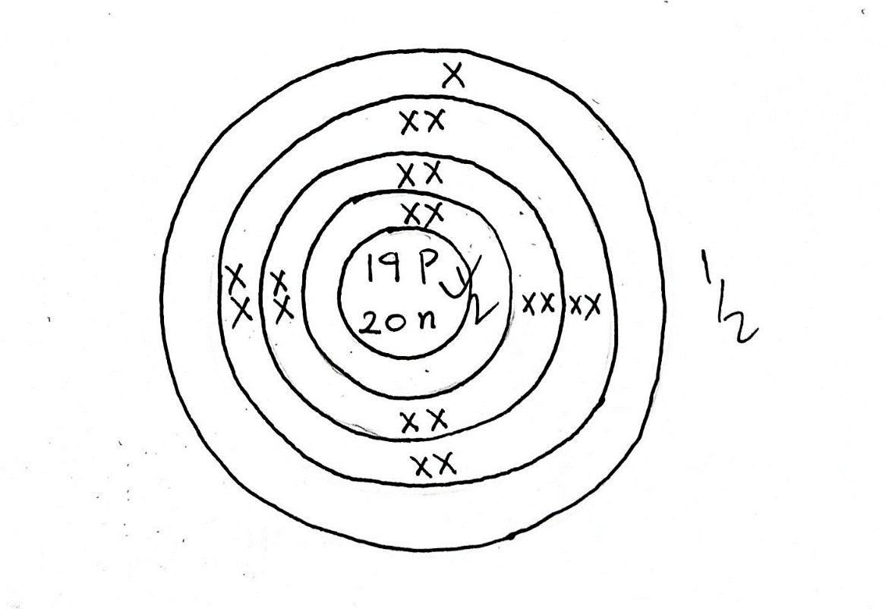
- State the group and period to which element A belongs[1 mk]
- Group I
- Period 4
- Name the type of structure adopted by element A[1 mk]
- Giant metallic structure
- a) State Graham’s law of rate of diffusion of gasses[1 mk]
- The rate of diffusion of a gas is inversely proportional to the square root of its density provided temperature and pressure are kept constant.
b) It take 44 seconds for nitrogen(iv)oxide to diffuse through a porous pot. Calculate how long it will take an equal volume of chlorine gas to diffuse through the same porous pot under the same conditions.(N = 4, O = 16, Cl = 35.5) [2 mks]
- $\frac{{TNO}_{2}}{{TCl}_{2}}= \sqrt{\frac{{MNO}_{2}}{{MCl}_{2}}}$
- $\frac{44}{{TCl}_{2}}= \sqrt{\frac{46}{71}}$ ½
- $\frac{{44}^{2}}{{TCL}_{2}^{2}}= \frac{46}{71}$ ½
- $\frac{1936}{{TCl}_{2}^{2}}= \frac{46}{71}$
- ${TCl}_{2}^{2}= \frac{1936 ×71}{46}$
- ${TCl}_{2}^{2}= \sqrt{\frac{1936 ×71}{46}}$ ½
- $56.66 sec$ ½
- The setup below represents electrolysis of dilute sulphuric(vi)acid.
- Name gas:
- M - Hydrogen
- N - Oxygen
- At what electrode does oxidation take place? [1 mk]
- Anode
- Dichromate (vi) ions are orange in colour while chromate (vi) ions are yellow. Consider the following equation at equilibrium
Cr₂O²-_{7(aq)} + 2OH⁻_{(aq)} 2CrO²⁻_{4(aq)} + H₂O_{(l)}
State and explain the observation which would be made if a few drops of dilute sulphuric(vi)acid were added to the equilibrium mixture[2 mks]
- Orange color intensifies 1
- Backward reaction favored / equilibrium shifts to the left
- Addition of H+ combine with OH⁻ to form water which increase on product side1
- An element has an electron configuration of 2.8.6
- Name the element[1 mk]
- Sulphur 1
- This element forms a puckered ring. Draw the ring[1 mk]
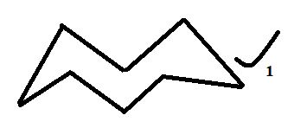

- Write the formulae of the puckered ring[1 mk]
- S₈ 1
- The melting point of sodium oxide is 1193oC while that of sulphure(iv)oxide is -72oC. In terms of the structure and bonding, explain why there is a large difference in the melting points of the two oxides[2 mks]
- Sodium oxide has giant ionic ½ structure with ionic bonding hence a lot of energy is required ½
- SO2 has a simple molecular structure in which molecules are held together by weak van der waals forces of attraction
- Little energy is required
- The diagram below illustrates some steps involved in manufacturing sodium carbonate. Use it to answer the questions that follow
- Name the industrial process illustrated by the above flowchart[1 mk]
- Solvay process 1
- Write an equation for the reaction that takes place in chamber M[1 mk]
- NaCl_{(aq)} + H₂O_{(l)} + CO_{2(g)} + NH_{3(g)} NaHCO_{3(s)} + NH₄Cl_{(aq)} 1
- Wrong or missing S.S penalize ½
- Name the process which takes place in chamber N[1 mk]
- Filtration 1
- How is sodium carbonate obtained in this process[1 mk]
- Thermal decomposition of NaHCO₃ 1
- Explain why potassium is kept under water. [2 mks]
- Potassium does not react with paraffin but reacts with water while phosphorus react with paraffin not water
- Dilute sulphuric (vi) acid was added to each of the three beakers containing the substances shown below
State the observation made in each beaker[3 mks]
- A – Effervescence 1
- B – White ppt 1
- C – No observable change 1
- Hydrogen chloride gas was separately dissolved in water and methylbenzene and the solutions labelled B and A respectively. A piece of magnesium ribbon was placed in each of the solutions. There was a lot of bubbles in solution A but no bubbling occurred in solution B. Explain the observations[3 mks]
- Methyl benzene is non polar compound ½
- HCL dissolves but not dissociate into ions ½
- Solution formed has no acidic properties ½
- Water is polar ½ HCl dissolves and dissociate into H+ ½ . The solution react with Mg to produce bubbles ½
- Give the IUPAC names of the following compounds[3 mks]
- 2- bromo – 3 – methyl butane 1
- Pent – 2 – ene 1
- Propylpropanoate 1
- A solution contains 40.32g per liter of compound XOH. 25cm³ of this solution was exactly neutralized by 30cm³ of 0.3M sulphuric(vi)acid. Determine the relative atomic mass of X(O = 16, H = 1)
2XOH_{(aq)} + H2SO4_{(aq)} X₂SO_{(l)} + 2H₂O_{(l)} 1
Moles of acid = $\frac{30}{1000}×0.3=0.009mol ½$
Moles of XOH = 2 × 0.009 = 0.018mol ½
Molarity of XOH =$\frac{0.018 ×1000}{25}=0.72M$ ½
RFM $\frac{40.32}{0.72}=56$ ½
X + 16 + 1 = 56 ½
X = 39 ½

