JUNIOR SCHOOL EDUCATION ASSESSMENT
GRADE 9 MIDTERM TERM 2 ASSESSMENT
CREATIVE ARTS Time: 1¹/₂ Hours.
Learner’s Name:______________________Assessment No:_____________

SCHOOL:_______________________________________SECTION A (20 MARKS)
Answer ALL questions in this section

- During athletics practice, Mr. Otieno asked learners to name a long-distance race.
Which answer is correct?
A. 200 metres B. 400 metres
C. 800 metres D. 5000 metres
- While jogging, Amina noticed she got tired quickly when sprinting.
What advice should her coach give?
A. Take longer breaks
B. Walk slowly
C. Maintain a steady pace
D. Run at full speed
- During an art lesson, learners examined different artworks.
Which characteristic identifies a mosaic?
A. Paper cut-outs
B. Small pieces like tiles or stones
C. Pencil sketch
D. Watercolour painting
- A contractor took a photograph of a construction site from above.


From which viewpoint was the photo taken?
A. Eye level B. Bird’s eye view
C. Worm’s eye view D. Side angle
- During rugby practice, the coach instructed Liam to use a short upward pass near the goal line.
Which type of pass is this?
A. Spin pass B. Drop kick
C. Pop pass D. Long throw
- During a field trip, Rose took a photograph of a mountain and river.


What type of photograph is this?
A. Portrait B. Still life
C. Scenic view D. Street view
- During a Creative Arts lesson, learners discussed different areas under performing arts.
Which of the following is NOT part of performing arts?
A. Illustration B. Music
C. Elocution D. Theatre
- After researching careers using digital tools, Biko discovered new opportunities in Creative Arts.
Which is an emerging career in this field?
A. Electrician
B. Artificial Intelligence Artist
C. Pharmacist
D. Civil Engineer
- During a career guidance session, learners explored jobs related to Creative Arts and Sports.
Which of the following belongs ONLY to performing arts?
A. Nutritionist B. Choreographer
C. Book illustrator D. Sculptor
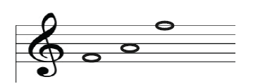
- During a music lesson, learners were asked to identify notes on a treble staff diagram.

Which of the following correctly names the notes?
A. G C D B. A F D
C. B E G D. A C F
- While learning music theory, the teacher introduced the concept of a grand staff.
What is a grand staff?
A. Grouping of notes
B. Position of notes
C. Combination of scales
D. Two staves joined
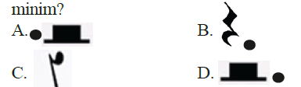
- During rhythm practice, learners identified different types of rests in music notation.

Which of the following represents a dotted minim rest?
A. A B. B C. D.D
- In a music class, learners studied time signatures such as 4/4.
What does the bottom number represent?
A. Minim
B. Crotchet
C. Denominator
D. Beats
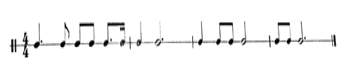
- During a rhythm exercise, learners translated beats into French rhythm names.

Which of the following is the correct interpretation?
A. taa-a-te ta-te ta-e fe
B. taa-a-te ta-te ta-e fe
C. taa-aa-te ta-te ta-e fe
D. taa-a-te ta-te ta-te fe
- In a discussion on entrepreneurship, Amina listed opportunities in Creative Arts and Sports.
Which of the following is NOT an opportunity in this field?
A. Owning an art gallery
B. Coaching a sports team
C. Becoming a museum guide
D. Working as a bank teller
- Jabali used analogous colours in his artwork to create harmony.
Which set of colours does NOT represent analogous colours?
A. Yellow, yellow-green, green
B. Blue, blue-violet, violet
C. Green, red-orange, yellow
D. Red, red-orange, orange

- During athletics training, learners practiced triple jump techniques.
Which represents correct phases of triple jump?
A. Approach, take-off
B. Stage, arm action
C. Stride, stand up
D. Release, positioning
- During a sports lesson, learners discussed types of passes used in games.
A learner gave “push pass” as an example. Which game were they discussing?
A. Rounders B. Tag rugby
C. Soccer D. Rope work
- Learners observed a diagram of a triple jump facility during a PE lesson.
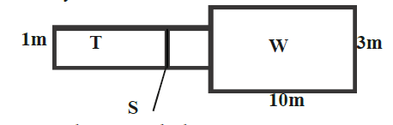

Name the part marked S.
A. Landing pit B. Runway
C. Take-off D. Take-off board
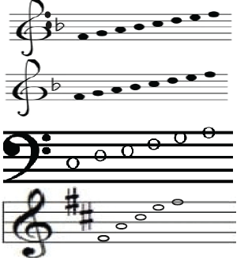
- During a music lesson, learners practiced scales.
M
N
O
P
Which staff shows an ascending F major scale?
A.M
B.N
C.O
D.P

SECTION B
Answer ALL questions in this section

PERFORMING ARTS (10 MARKS)
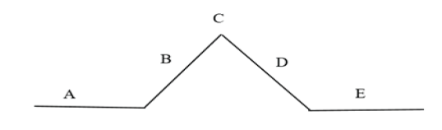
- Zuena used a diagram to explain the plot structure of a story during group discussion.

(a) Briefly explain what happens in sections B and E. (2 marks)
________________________________________________________________________________________________________________________________________________________________________________
(b) Mention two elements of a play. (2 marks)
- __________________________________________________________________________________
- __________________________________________________________________________________

- During a music lesson, learners analyzed a rhythmic composition written on a bass staff.
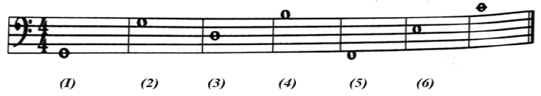
(a) Name the pitches numbered 1, 3 and 5. (3 marks)
- __________________________________________________________________________________
- __________________________________________________________________________________
- __________________________________________________________________________________
(b) State the interval between pitches 3 and 4. (1 mark)
___________________________________________________________________.
(c) Explain how repeating pitch 6 affects the melody. (1 mark)
________________________________________________________________________________________________________________________________________________________________________________
(d) Why is correct pitch identification important in music? (1 mark)
________________________________________________________________________________________________________________________________________________________________________________

VISUAL ARTS (10 MARKS)
- During an Art lesson, learners used a colour wheel to study colour relationships.
(a) Define analogous colours. (1 mark)
________________________________________________________________________________________________________________________________________________________________________________
(b) Give one example of analogous colours. (1 mark)
___________________________________________________________.
- A learner painted a sunset using warm colours like red, orange and yellow.
(a) What type of colour mood is shown? (1 mark)
__________________________________________________.
(b) Explain how warm colours affect mood in artwork. (1 mark)
________________________________________________________________________________________________________________________________________________________________________________
- While painting a forest scene, Samuel used a sponge to apply paint and create texture.
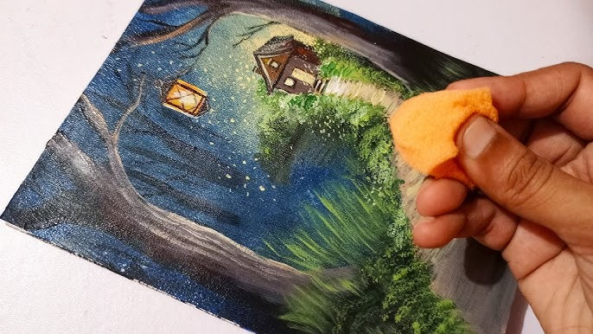
(a) Name the technique used. (1 mark)
________________________________________________
(b) Explain how this technique improves a painting. (1 mark)
______________________________________________________________________________
- Rose was asked to create a colour gradation using blue and green.
(a) Draw a four-step colour gradation strip. (2 marks)

(b) Define colour harmony. (1 mark)
________________________________________________________________________________________________________________________________________________________________________________
- During a photography project, learners took pictures of Mount Kenya and surrounding areas.
Give one scenic feature they might have captured. (1 mark)
______________________________________________________________________________________
_______________________________________________________________________________________

PHYSICAL EDUCATION AND SPORTS (10 MARKS)
- During athletics practice, a learner demonstrated the triple jump.
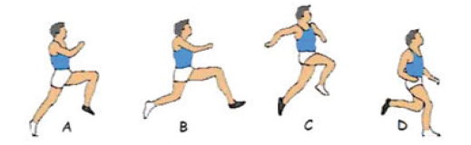
Identify the phases marked A, B, C and D. (2 marks)
A _____________________________________________.
B _____________________________________________.
C _____________________________________________.
D _____________________________________________.
- While training for a sprint race, Amina practiced her starting techniques.
(a) What is reaction time? (1 mark) _______________________________________________________________________________________.
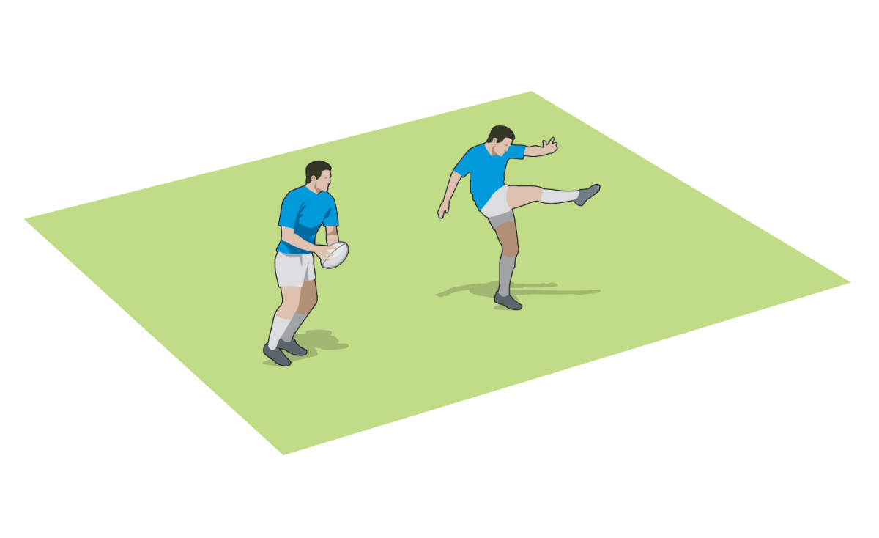
(b) Explain why reaction time is important in sprinting. (1 mark)
________________________________________________________________________________________________________________________________________________________________________________
- During rugby training, a player practiced kicking techniques using a training manual.

(a) Identify the type of kick shown. (1 mark)
____________________________________________________.
(b) Name one other type of rugby kick. (1 mark)
_______________________________________________________________________________________

- During rugby drills, learners practiced different types of passes.
(a) Define a spin pass and state when it is used. (1 mark)
________________________________________________________________________________________________________________________________________________________________________________
(b) Define a pop pass and state when it is used. (1 mark)
________________________________________________________________________________________________________________________________________________________________________________
- During group practice, learners were trained on proper passing techniques in rugby.
State two correct techniques for effective passing. (2 marks)
- __________________________________________________________________________________
- __________________________________________________________________________________

SECTION A MARKING SCHEME (20 MARKS)
Qn | Answer
1 | D
2 | C
3 | B
4 | C
5 | C
6 | C
7 | A
8 | B
9 | B
10 | D
11 | D
12 | A
13 | B
14 | A/B
15 | D
16 | C
17 | A
18 | C
19 | D
20 | B
✔ TOTAL = 20 MARKS

SECTION B MARKING SCHEME (30 MARKS)
✔ Award 1 mark per correct point
✔ Accept equivalent correct answers

🎭 PERFORMING ARTS (10 MARKS)

21. Plot Structure

(a) (2 marks)
✔ B – Rising action (events build tension/conflict develops)
✔ E – Resolution/Denouement (problem solved/story ends)
Keywords: tension, climax, resolution

(b) (2 marks)
✔ Characters
✔ Plot
✔ Setting
✔ Dialogue
✔ Theme
Keywords: characters, plot, setting

22. Music (Bass Staff)

(a) Pitches (3 marks)
1 – G, 3 – D, 5 – F

(b) Interval (1 mark)

An interval of 4 and half

(c) Repeating pitch effect (1 mark)
✔ Creates rhythm
✔ Adds emphasis
✔ Creates pattern
Keywords: repetition, rhythm

(d) Importance (1 mark)
✔ Ensures correct singing/playing
✔ Improves accuracy in melody and harmony
✔ Avoids mistakes
Keywords: accuracy, correctness

VISUAL ARTS (10 MARKS)

23. Colour

(a) Definition (1 mark)
✔ Colours next to each other on the colour wheel

(b) Example (1 mark)
✔ Red, red-orange, orange
✔ Blue, blue-green, green

24. Warm Colours

(a) (1 mark)
✔ Warm/energetic/happy mood

(b) (1 mark)
✔ Create warmth
✔ Attract attention
✔ Give energetic feeling

25. Texture

(a) (1 mark)
✔ Sponge painting / Dabbing/dubbing

(b) (1 mark)
✔ Adds texture
✔ Makes artwork realistic
✔ Enhances appearance

26. Colour Gradation

(a) (2 marks)
✔ Must show gradual change (light → dark)
✔ 4 visible steps



(b) (1 mark)
✔ Pleasing arrangement of colours

27. Scenic Feature (1 mark)
✔ Mountain
✔ River
✔ Forest
✔ Sky
✔ Hills

PHYSICAL EDUCATION & SPORTS (10 MARKS)

28. Triple Jump (2 marks)
✔ A – Approach/run-up
✔ B – Take off
✔ C – flight
✔ D – landing

29. Sprinting

(a) (1 mark)
✔ Time taken to respond to a signal/stimulus

(b) (1 mark)
✔ Helps quick start
✔ Improves performance
✔ Gives advantage

30. Rugby Kicks

(a) (1 mark)
✔ Drop kick

(b) (1 mark)
✔ Place kick

31. Passes

(a) Spin pass (1 mark)
✔ Fast rotating pass over distance

(b) Pop pass (1 mark)
✔ Short upward pass at close range

32. Passing Techniques (2 marks)
✔ Accurate aim
✔ Proper grip
✔ Use both hands
✔ Follow through
✔ Good timing

CBC PERFORMANCE LEVEL GRID
Marks (/30) | % Range | Level | Points
27–30 | 90–100 | EE1 | 8
23–26 | 75–89 | EE2 | 7
18–22 | 58–74 | ME1 | 6
13–17 | 41–57 | ME2 | 5
10–12 | 31–40 | AE1 | 4
7–9 | 21–30 | AE2 | 3
4–6 | 11–20 | BE1 | 2
1–3 | 1–10 | BE2 | 1

