JUNIOR SCHOOL EDUCATION ASSESSMENT

GRADE 9 MIDTERM TERM 2 ASSESSMENT

PRETECHNICAL Time: 1¹/₂ Hours.

Learner’s Name:______________________Assessment No:_____________

SCHOOL:_______________________________________

SECTION A (20 MARKS) Answer ALL questions in this section

- A company installs antivirus software on all computers. What is the role of antivirus software?
A. Protects computer from malware
B. Stores data
C. Improves typing speed
D. Improves accessibility
- Learners studied characteristics of different types of wood. Which is NOT a characteristic of softwood?
A. Intricate grain patterns
B. Less dense and lighter
C. Easy to carve
D. Straight grain
- A company focuses on offering services rather than selling goods. Which is a service business?
A. Operating a barbershop
B. Selling water
C. Operating a bookshop
D. Selling furniture
- The following image was created by a learner using freehand. Which technique of freehand sketching did the learner use?

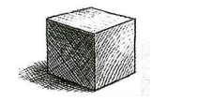

A. Box method B. Cross hatching

C. Stippling D. Blending
- Learners studied different types of drawings used in engineering. Oblique projection is:
A. All sides are equal
B. Side faces are not visible
C. All angles are 90°
D. A drawing where one face is true size and others are slanted
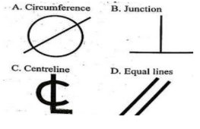
- During a Technical Drawing lesson, learners studied various symbols and abbreviations commonly used in drawings and their meanings. Select the symbol for perpendicularity.
A B

C D

- Learners studied different forms of drawings used in technical fields. Which is NOT a technical drawing?
A. Mechanical drawing
B. Structural drawing
C. Graffiti drawing
D. Architectural drawing
- Computers are used to perform different tasks. Which characteristic allows this?
A. Speed
B. Versatility
C. Accuracy
D. Cost
- Learners examined materials used in daily life. Which item is made from clay?
A. Ceramic mug
B. Metallic pan
C. Wooden spoon
D. Plastic bottle
- A learner studied input devices used in computers. Which is NOT a pointing input device?
A. Microphone
B. Light pen
C. Mouse
D. Trackball
- During a Pre-Technical Studies lesson, Wanzala wanted to draw a perfect circle in his sketchbook.
Which instrument is most appropriate for drawing a circle?
A. Set square B. Ruler
C. Protractor D. Compass

- A teacher displayed a diagram of a computer system unit and asked learners to identify its components.

Which of the following is NOT a component of the CPU?
A. Control Unit
B. Registers
C. Arithmetic Logic Unit
D. Software Unit
- Bayo runs a textile business and wants to identify synthetic fabrics. Which material is synthetic?
A. Wool
B. Acrylic
C. Cotton
D. Leather
- During a business lesson, learners discussed starting a business. The initial money used to start a business is called:
A. Revenue
B. Capital
C. Profit
D. Expense
- A hospital requires utensils and tools that resist rust and corrosion. Which metal is best suited?
A. Stainless steel B. Cast iron
C. Zinc D. Copper
- Sammy operates a cyber café and must protect his system from online threats. Which is an example of an online threat?
A. Saving a document
B. Printing a file
C. Burglar attack
D. Phishing attack
- Learners are developing applications using visual programming tools. Which of the following is NOT a visual programming tool?
A. Skype B. Scratch
C. Blockly D. Node-RED
- George is saving money to improve his financial future. Saving means:
A. Setting aside money for future use
B. Spending money immediately
C. Donating money to charity
D. Buying goods on credit
- The following picture was used to illustrate a firefighting technique. Which method is being illustrated?

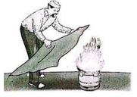
A. Cooling B. Smothering
C. Starving D. Interrupting

- During a workshop visit, learners identified tools used in carpentry.
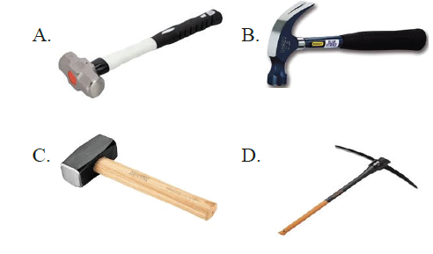
Which tool is used to drive nails into wood?
A. A B. B C. C D. D

SECTION B: (30 MARKS)

Answer all questions in this section

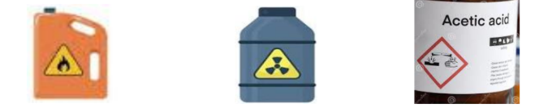
Grade 9 learners found containers labelled with the following symbols. State the meaning of the Symbols on the containers (3 marks)

X Y Z
X | Y | Z

During a Business Studies lesson, learners were taught how to apply the accounting equation to determine missing values in financial records.

Fill in the missing values in the table below. (4 marks)
Assets (Ksh) | Liabilities (Ksh) | Capital (Ksh)
120,000 | A | 70,000
B | 14,000 | 96,000
108,000 | 50,000 | C
203,000 | D | 89,000

Hassan owns a furniture workshop where he uses strong and durable wood to make chairs and tables. During a lesson on types of wood, learners were asked to identify hardwood materials.
Mention three examples of hardwood. (3 marks)
- ________________________________________.
- ________________________________________.
- ________________________________________.

In a Pre-Technical lesson, learners were taught how timber is prepared before use in construction and furniture making. They learned about the importance of removing moisture from wood.
(a) State two methods of wood seasoning. (2 marks)
- ________________________________________.
- ________________________________________.
(b) State two reasons for seasoning timber. (2 marks)
- ______________________________________________________________________________.
- ______________________________________________________________________________.

During a practical lesson, learners were working on elevated surfaces such as scaffolds and ladders. The teacher emphasized the importance of safety while working at heights.
State two safety precautions to observe when working on raised platforms. (2 marks)
- ______________________________________________________________________________.
- ______________________________________________________________________________.

In an industrial visit, learners observed workers handling chemicals and other dangerous substances. The instructor explained the importance of safety when dealing with hazardous materials.
State two ways of safely handling hazardous substances. (2 marks)
- ______________________________________________________________________________.
- ______________________________________________________________________________.

During a class discussion on construction and maintenance work, learners learned about different working surfaces used above the ground level.
Identify the following raised platforms? (3 marks)
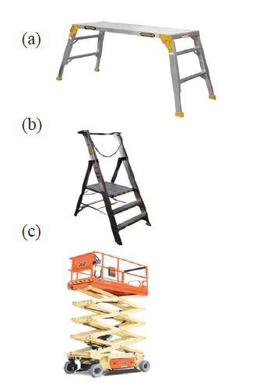

E | F | G
E: ____________________________________.
F: ____________________________________.
G: ____________________________________.

While in the computer laboratory, Lavine observed a device connected to a computer that was used to display information to users.

(a) Identify the output device shown. (1 mark)
___________________________________________
(b) Give two other examples of output devices. (2 marks)
- ______________________________________________________________________________.
- ______________________________________________________________________________.

A school purchased learning materials and needed to pay suppliers using different methods. Learners discussed various ways of making payments in business transactions.
Apart from cheques, outline two methods of payment. (2 marks)
- ______________________________________________________________________________.
- ______________________________________________________________________________.

In a business studies lesson, learners discussed how money is used in everyday life and its important features.
Mention two characteristics of money. (2 marks)
- ______________________________________________________________________________.
- ______________________________________________________________________________.

Alex, a student, often buys items without planning or budgeting. During a financial literacy lesson, learners discussed responsible spending habits.
Question:
What is impulsive buying? (2 marks)
- ______________________________________________________________________________.
- ______________________________________________________________________________.
THIS IS THE LAST PRINTED PAGE

MARKING SCHEME

SECTION A (20 MARKS)
No. | Answer
1 | A
2 | A
3 | A
4 | A
5 | D
6 | B
7 | C
8 | B
9 | A
10 | A
11 | D
12 | D
13 | B
14 | B
15 | A
16 | D
17 | A
18 | A
19 | B
20 | B

SECTION B (30 MARKS)

21. Meaning of symbols on containers
- X: Radioactive substance
- Y: Corrosive substance
- Z: Flammable substance

22. Accounting equation (A = L + C)
Assets | Liabilities | Capital
120,000 | A = 50,000 | 70,000
B = 110,000 | 14,000 | 96,000
108,000 | 50,000 | C = 58,000
203,000 | D = 114,000 | 89,000

23. Examples of hardwood
i. Mahogany/meru oak/podo/camphor/cedar/mvule
ii. Teak
iii. Iroko

24.
(a) Methods of wood seasoning:
i. Air seasoning
ii. Kiln seasoning
(b) Reasons for seasoning timber:
i. To reduce moisture content and prevent warping
ii. To increase strength and durability of wood

25. Safety precautions when working on raised platforms
i. Wear protective equipment such as helmets and safety harness
ii. Ensure ladders/scaffolds are stable and properly secured

26. Safe handling of hazardous substances
i. Wear protective clothing (gloves, goggles, masks)
ii. Store chemicals in labelled and sealed containers

27. Raised platforms (E, F, G)
(E) Ladder (F) Scissor lift (G) Trestle

28.
(a) Output device shown:
Projector
(b) Other output devices:
- Monitor (VDU / screen)
- Printer
- Speakers
- Headphones / Earphones
- Plotter
- Braille reader (for visually impaired users)
- LED display boards
- Smart TVs (when used as output screens)
- Head-up displays (HUDs) in vehicles and aircraft

29. Methods of payment (apart from cheques)
i. Cash payment
ii. Mobile money transfer (e.g., M-Pesa)

30. Characteristics of money
i. Durability (long-lasting)
ii. Acceptability (widely accepted as a medium of exchange)

31. Impulsive buying
i. Buying goods without planning or budgeting
ii. Purchasing items suddenly without considering financial needs or priorities

