JUNIOR SCHOOL EDUCATION ASSESSMENT
GRADE 9 MIDTERM TERM 2 ASSESSMENT
AGRICULTURE Time: 1¹/₂ Hours.
Learner’s Name:______________________Assessment No:_____________

SCHOOL:_______________________________________

SECTION A (20 MARKS)
Answer ALL questions in this section

- Organic farming avoids the use of harmful chemicals in crop production.
Which practice does NOT support organic farming?
A. Mechanical weeding
B. Use of organic pesticides
C. Use of inorganic foliar feed
D. Use of organic manure
- A farmer conserves animal feed during rainy seasons for future use.
What is the main purpose of this practice?
A. To feed animals during dry periods
B. To increase farm size
C. To improve meat taste
D. To prevent grazing
- A farmer combines different farming activities on the same land.
Which of the following is NOT part of integrated farming?
A. Poultry keeping B. Livestock keeping
C. Agroforestry D. Soil conservation
- Grade 7 learners are preparing chapati for the first time during a cooking lesson.
Which ingredient is NOT required?
A. Yeast B. Wheat flour
C. Cooking oil D. Water
- Leah noticed a crack in the wall of a granary where maize is stored.
What is the best action she should take?
A. Cover it with a poster
B. Monitor it over time
C. Seal it immediately
D. Ignore it
- Lavine wants to practice organic gardening methods on her farm.
Which practice should she avoid?
A. Composting
B. Using synthetic pesticides
C. Mulching
D. Crop rotation
- A farmer is inspecting crops for signs of disease.
Which of the following is NOT a sign of diseased crops?
A. Wilting
B. Dark green leaves
C. Black or brown spots
D. Rotting stems
- During a farm visit, Maria observed a farmer piling harvested grass into a compact heap for storage.
Which method is being used?
A. Standing forage B. Stacking
C. Baled hay making D. Box baling
- Abraham visited a fish processing site where different preparation steps were demonstrated.
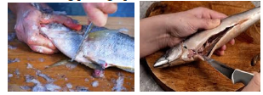
Which of the following correctly shows the processes in order?
A. Scaling and gutting
B. Cleaning and scaling
C. Gutting and cleaning
D. Gutting and scaling
- A butcher in a rural area lacks electricity and is looking for ways to preserve meat.
Which method would you NOT advise him to use?
A. Sun drying B. Salting
C. Fermentation D. Smoking
- Residents of a large city dispose of waste in designated dumping areas such as Dandora dumpsite.
This type of waste mainly pollutes soil through:
A. Agricultural chemical wastes
B. Artificial fertilizers
C. Plastic wastes
D. Waste water
- During a home science lesson, learners discussed how to preserve nutrients in vegetables during preparation.
Which practice is NOT correct?
A. Avoid soaking vegetables
B. Wash vegetables with cold water
C. Wash vegetables with warm water
D. Avoid cutting before washing
- A farmer wants to maintain good hygiene while rearing animals to prevent diseases.
Which of the following is NOT a hygienic practice?
A. Providing clean water
B. Feeding animals using infected feeders
C. Cleaning animals regularly
D. Killing sick animals
- A dairy farmer is experiencing losses due to milk spoilage and seeks advice on preservation.
Which method is most appropriate?
A. Smoking and fermentation
B. Boiling and sun drying
C. Boiling and fermentation
D. Boiling and cooling
- During an agriculture lesson, learners were shown planting materials used for pineapple.
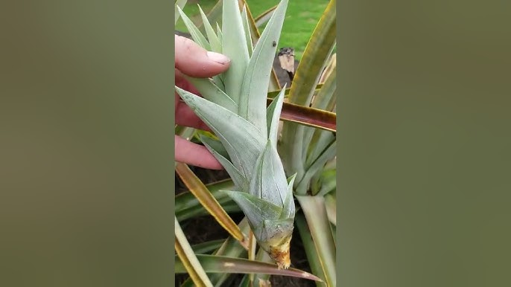

Identify the planting material shown.
A. Tuber B. Slips C. Seeds D. Suckers
- A restaurant owner often has leftover food after closing time and wants to avoid wastage.
What advice would you give?
A. Keep it uncovered in the refrigerator
B. Donate it to a food bank
C. Freeze it in a plastic bag
D. Mix it with fresh food the next day
- Tina is preparing food for her birthday party and must choose suitable cooking methods.
Which factor does NOT influence her choice?
A. Time available
B. Fuel available
C. Cooking equipment available
D. Amount of food
- During a practical lesson, learners made soap using different ingredients including salt.
What is the role of salt in soap making?
A. Disinfecting the soap
B. Separating the soap
C. Softening the soap
D. Thickening the soap

- A farmer practicing organic gardening grows crops without using chemicals.
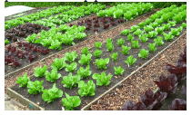

Which crop is suitable for this method?
A. Sugarcane
B. Cotton
C. Spinach
D. Tea
- In a food preservation lesson, learners discussed foods that can be preserved using multiple methods.
Which food can be preserved by boiling, drying, smoking, and freezing?
A. Eggs
B. Meat
C. Fruits
D. Milk

SECTION B (30 MARKS)
Answer all questions in this section
- A farmer constructed a structure to collect and store water for future use.
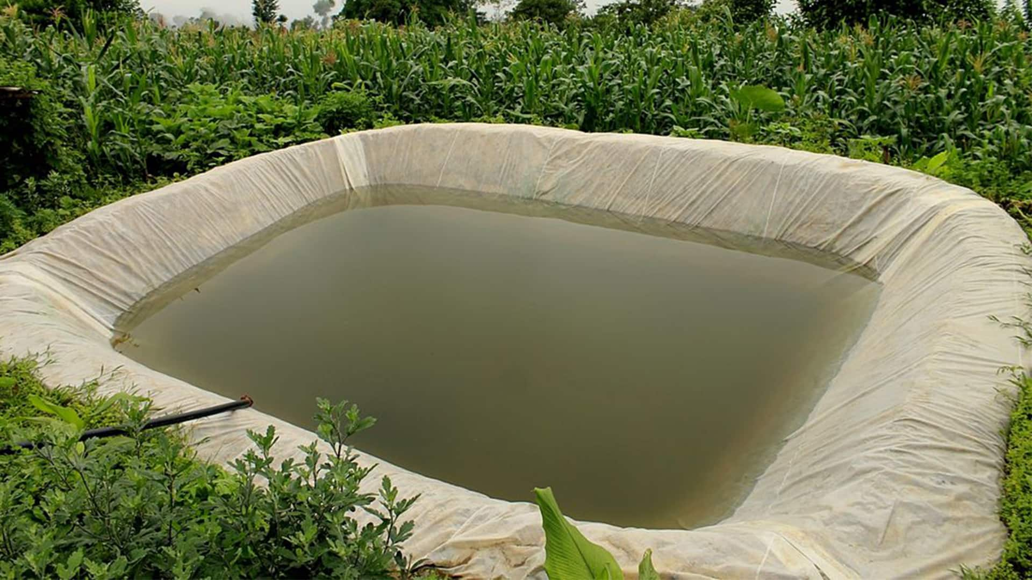
(a) Identify the water conservation structure. (1 mark)
______________________________________________________________
(b) State two other methods of storing water. (2 marks)
- __________________________________________________________________________________
- __________________________________________________________________________________
(c) State two benefits of harvested water. (2 marks)
- __________________________________________________________________________________
- __________________________________________________________________________________

- Davis started a small garden at home using modern farming techniques.
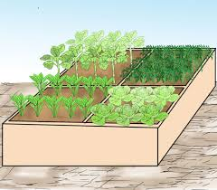
(a) Name the type of garden. (1 mark)
__________________________________________________.
(b) State three importance of organic gardening in producing healthy food. (3 marks)
- __________________________________________________________________________________
- __________________________________________________________________________________
- __________________________________________________________________________________
- Grade 9 learners visited a farm where different farming activities were combined.
(a) Define integrated farming. (2 marks)
________________________________________________________________________________________________________________________________________________________________________________
(b) State three ways integrated farming conserves resources. (3 marks)
- __________________________________________________________________________________
- __________________________________________________________________________________
- __________________________________________________________________________________
- Learners observed a storage structure used by a farmer to keep harvested crops.
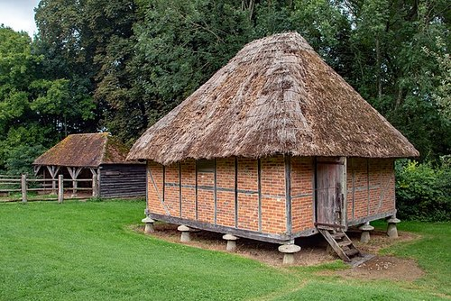
(a) Name the storage structure. (1 mark)
_________________________________________________.
(b) State two features of the structure. (2 marks)
- __________________________________________________________________________________
- __________________________________________________________________________________
(c) Give two ways of preparing the structure before storage. (2 marks)
- __________________________________________________________________________________
- __________________________________________________________________________________
- Maurine noticed her friend carrying leftover food to school.
(a) State three ways of preparing leftover foods. (3 marks)
- __________________________________________________________________________________
- __________________________________________________________________________________
- __________________________________________________________________________________
(b) State three importance of conserving leftover foods at home. (3 marks)
- __________________________________________________________________________________
- __________________________________________________________________________________
- __________________________________________________________________________________
- Florah observed her aunt drying tomatoes at home to preserve them.
(a) State three ways of adding value to crop produce. (3 marks)
- __________________________________________________________________________________
- __________________________________________________________________________________
- __________________________________________________________________________________
(b) Give two reasons why value addition is important. (2 marks)
- __________________________________________________________________________________
- __________________________________________________________________________________

THIS IS THE LAST PRINTED PAGE

SECTION A MARKING SCHEME (20 MARKS)
Qn | Answer
1 | C
2 | A
3 | D
4 | A
5 | C
6 | B
7 | B
8 | B
9 | A
10 | C
11 | C
12 | C
13 | B
14 | D
15 | B
16 | B
17 | D
18 | B
19 | C
20 | B

SECTION B MARKING SCHEME (30 MARKS)
NOTE: Accept any relevant correct answer. Award marks per valid point.

21. (5 MARKS)
(a) (1 mark)
✔ shallo water pan.
Keyword: water storage / harvesting structure
(b) (2 marks) (1 mark each)
✔ Dams
✔ Water pans
✔ Reservoirs
✔ Buckets / containers (accept small-scale answers)
Water tank / Storage tank / Rainwater harvesting tank
Reservoirs and ponds - Ground water recharge
Keywords: dam, pan, reservoir, storage
(c) (2 marks) (1 mark each)
✔ Irrigation during dry season
✔ Water for livestock
✔ Domestic use
✔ Reduces water scarcity
Keywords: irrigation, livestock, domestic use, dry season

22. (4 MARKS)
(a) (1 mark)
✔ Horizontal garden
(b) (3 marks) (1 mark each)
✔ Produces chemical-free / safe food
✔ Improves soil fertility (organic manure)
✔ Environmental conservation
✔ Reduces health risks
Keywords: organic, safe food, soil fertility, environment

23. (5 MARKS)
(a) (2 marks)
✔ Definition must include:
- Combination of enterprises (1 mark)
- Same farm / interrelated system (1 mark)
Keywords: combining activities, same farm, crops + livestock
(b) (3 marks) (1 mark each)
✔ Recycling waste (manure use)
✔ Efficient land use
✔ Efficient water use
✔ Reduces input costs
Keywords: recycling, efficiency, reduced inputs

24. (5 MARKS)
(a) (1 mark)
✔ Granary
Keyword: granary
(b) (2 marks) (1 mark each)
✔ Raised structure
✔ Well ventilated
✔ Rodent-proof
Keywords: raised, ventilation, pest control
(c) (2 marks) (1 mark each)
✔ Cleaning
✔ Disinfecting
✔ Repairing cracks
✔ Fumigation
Keywords: clean, repair, disinfect

25. (6 MARKS)
(a) (3 marks) (1 mark each)
✔ Reheating
✔ Refrigeration
✔ Freezing
✔ Re-cooking / frying
Keywords: reheat, refrigerate, freeze
(b) (3 marks) (1 mark each)
✔ Reduces wastage
✔ Saves money
✔ Food security / availability
✔ Efficient resource use
Keywords: waste reduction, saving, availability

26. (5 MARKS)
(a) (3 marks) (1 mark each)
✔ Drying
✔ Processing (juice, paste)
✔ Packaging
✔ Grading
Keywords: drying, processing, packaging
(b) (2 marks) (1 mark each)
✔ Increases shelf life
✔ Increases value / income
✔ Improves marketability
Keywords: shelf life, value, income

FINAL SCORING GUIDE
Section | Marks
Section A | 20
Section B | 30
TOTAL | 50 MARKS

EXAMINER NOTES
- Accept equivalent correct wording (do not penalize language if concept is correct)
- Award marks per valid point only
- Do NOT award marks for repeated answers
- For definitions, ensure key ideas are present

KNEC PERFORMANCE LEVEL DESCRIPTORS (USE THIS TO GRADE)
Level | Score Range (%) | Points | Description
EE1 | 90–100 | 8 | Excellent – Complete, accurate, all points correct, well explained
EE2 | 75–89 | 7 | Very good – Minor omissions, mostly correct
ME1 | 58–74 | 6 | Good – Some correct points, few gaps
ME2 | 41–57 | 5 | Average – Basic understanding, several gaps
AE1 | 31–40 | 4 | Below average – Limited correct responses
AE2 | 21–30 | 3 | Weak – Few correct points
BE1 | 11–20 | 2 | Very weak – Minimal understanding
BE2 | 1–10 | 1 | Poor – Almost no correct response

EXAMINER CHECKLIST
Before awarding final level, confirm:
✔ All questions attempted
✔ No double marking of same idea
✔ Accept alternative correct answers
✔ Ignore grammar/spelling if meaning is correct
✔ Award marks only for relevant agricultural concepts

HOW TO SCORE EE1 (FULL MARKS)
To award EE1 (8 points), the learner must:
- Give ALL required points
- Use correct agricultural terms (e.g., irrigation, granary, composting)
- Avoid contradictions
- Answer every sub-part fully

COMMON EXAMINER PENALTIES
❌ Repeated answers → count once
❌ Vague answers (e.g., “helps crops”) → no mark
❌ Wrong context → no mark
❌ Missing sub-parts → lose marks directly

