NAME…………………………………………………………………….ADM NO…………......……….
SCHOOL……………………………………………………CANDIDATES SIGN ….......……………...
DATE………………………………………….CLASS..........................................................................
233/2
CHEMISTRY PAPER 2
OCTOBER-2026
TIME: 2 HOURS

FORM THREE END-YEAR EXAM-2026

Kenya Certificate of Secondary Education. (K.C.S.E.)

INSTRUCTIONS TO CANDIDATES
- Write your name and admission number in the space provided.
- Answer all the questions in the spaces provided.
- Mathematical tables and scientific calculators may be used.
- All working must be clearly shown where necessary.
- Candidates should check the question paper to ascertain that all pages are printed as indicated and that no questions are missing.
FOR EXAMINERS' USE ONLY
QUESTION | MARKS | CANDIDATES SCORE
1 | 13
2 | 11
3 | 11
4 | 11
5 | 11
6 | 12
7 | 11
TOTAL | 80 MARKS

1. The table below shows some elements in the periodic table. Use it to answer the questions that follow. The letters are not the actual symbols of the elements.

 |  |  |  |  |  |  |  |  | F
A | G |  | E |  | B |  | D
C
a) i) Show the electron arrangement of ions of elements:
A (½ mk)
.......................................................................................................................................................................................
B (½ mk)
.......................................................................................................................................................................................
ii) Using dots (.) and crosses (x) to represent electrons, draw a diagram to show how elements C and oxygen combine to form a compound. (O = 8) (1 mk)

b) Show on the grid above an element Y whose ion Y²⁻ has an electron configuration of 2.8.8. (1mk)
c) Compare the following with an explanation.
i) The reactivity of A and C (2 mks)
.......................................................................................................................................................................................
.......................................................................................................................................................................................
.......................................................................................................................................................................................
.......................................................................................................................................................................................
ii) Atomic radii of elements A and B. (2 mks)
.......................................................................................................................................................................................
.......................................................................................................................................................................................
.......................................................................................................................................................................................
.......................................................................................................................................................................................
iii) The melting point of the oxide of element G and the oxide of D (2 mks)
.......................................................................................................................................................................................
.......................................................................................................................................................................................
.......................................................................................................................................................................................
.......................................................................................................................................................................................
d) Name the type of bond formed when E and D react. Explain your answer. (2 mks)
.......................................................................................................................................................................................
.......................................................................................................................................................................................
.......................................................................................................................................................................................
.......................................................................................................................................................................................
e) The ionic radius of element E is bigger than its atomic radius. Explain. (2 mks)
.......................................................................................................................................................................................
.......................................................................................................................................................................................
.......................................................................................................................................................................................
2. The flow diagram below shows a reaction scheme starting from propene.

Propane

CH₃CH=CH₂

Tetra chloropropane

J

M

L

Chlorine

Polymerization

Step I

Combustion

K

H₂O

Step II

Bromine
Water

(a) Draw the structural formula of propene (1 Mk).
.......................................................................................................................................................................................
.......................................................................................................................................................................................
(b)State the reagent and condition necessary for step1 to occur
Reagent: (1 Mk)
.......................................................................................................................................................................................
.......................................................................................................................................................................................
Condition: (1 Mk)
.......................................................................................................................................................................................
(c) Give the names of the following substances. (2 Mks)
J......................................................................................................................................................................................
K.....................................................................................................................................................................................
L.....................................................................................................................................................................................
M...................................................................................................................................................................................
(d) Write the equation for the reaction that produces substance L. (1 Mk)
.......................................................................................................................................................................................
.......................................................................................................................................................................................
(e) State the type of reaction that occurs in step I. (1 Mk)
.......................................................................................................................................................................................
.......................................................................................................................................................................................
(f) Write the equation for complete combustion of propene. (1 Mk)
.......................................................................................................................................................................................
.......................................................................................................................................................................................
(g) (i) Give one use of substances M. (1 Mk)
.......................................................................................................................................................................................
.......................................................................................................................................................................................
(ii) State the environmental effects of the continued use of plastics to the environment. Explain. (2 Mks)
.......................................................................................................................................................................................
.......................................................................................................................................................................................
3. The set up below was used to prepare hydrogen gas

Round bottomed flask
Dilute HCl acid
Zinc granules

(a) Complete the diagram to show how a dry sample of hydrogen can be collected. (2 Mks)
(b) Write an experiment for the reaction which takes place.
(i)In the round-bottomed flask. (1 Mark)
.......................................................................................................................................................................................
.......................................................................................................................................................................................
(ii) When hydrogen gas burns in air. (1 Mk)
.......................................................................................................................................................................................
.......................................................................................................................................................................................
(c) State two industrial uses of hydrogen gas. (2 Mks)
.......................................................................................................................................................................................
.......................................................................................................................................................................................
(d) Dry hydrogen gas passed over heated copper (ii) oxide in the setup below.

Flame
Copper (II) Oxide
Dry hydrogen

(i)State two observations made in the experiment. (2 Mks)
.......................................................................................................................................................................................
.......................................................................................................................................................................................
(ii) What property of hydrogen was being investigated? (1 Mk)
.......................................................................................................................................................................................
.......................................................................................................................................................................................
(iii) Write an equation for the reaction which proves the property in (ii). (1 Mk)
.......................................................................................................................................................................................
.......................................................................................................................................................................................
(iv) Why should hydrogen be passed for some time through the combustion tube before being lit.
(1 Mk)
.......................................................................................................................................................................................
.......................................................................................................................................................................................
4. State one form of amorphous carbon other than charcoal and state its use. (1 Mk)
......................................................................................................................................................................................
(b) The diagram below represents a ‘jiko’ when in use .Study it and answer the questions that follow.

Region A

Region B

Region C

Air in

(i) Write equations for the reactions that occur in the region.
I: B (1 mk)
.......................................................................................................................................................................................
.......................................................................................................................................................................................
II: C (1 mk)
.......................................................................................................................................................................................
.......................................................................................................................................................................................
(ii) Explain what happens in region A. (1 mk)
.......................................................................................................................................................................................
.......................................................................................................................................................................................
(c) The following flow chart represents the Solvay process used in the manufacture of sodium carbonate. Study it and
Answer the questions that follow.

Solid L

Brine

Water

Gas M

N_{2(g)} + H_{2(g)} 500⁰C
Catalyst R

NH₄Cl+ NaHCO₃
Solvay Tower

CO_{2(g)}

NH₄Cl

Step I

NaHCO₃

Na₂CO₃

Step II

Step III

(i) Identify
I. Solid L (½ mk)
.......................................................................................................................................................................................
.......................................................................................................................................................................................
II. Gas M (½ mk)
.......................................................................................................................................................................................
.......................................................................................................................................................................................
(ii) Name the processes that take place in steps
II (½ mk)
.......................................................................................................................................................................................
III (½ mk)
.......................................................................................................................................................................................
(iii) Give the name of catalyst R. (1 Mk)
.......................................................................................................................................................................................
.......................................................................................................................................................................................
(iv) Write an equation for the reaction that occurs in steps.
I (1 Mk)
.......................................................................................................................................................................................
.......................................................................................................................................................................................
II (1 Mk)
.......................................................................................................................................................................................
.......................................................................................................................................................................................
(v) Describe how carbon (IV) oxide for this process is obtained. (1 mk)
.......................................................................................................................................................................................
.......................................................................................................................................................................................
(vi) State one commercial use of sodium carbonate (1 mk)
.......................................................................................................................................................................................
.......................................................................................................................................................................................
5. a) (i) Name two reagents to prepare hydrogen chloride in the laboratory. (1 Mk)
.......................................................................................................................................................................................
.......................................................................................................................................................................................
(ii) State a suitable drying agent for hydrogen chloride gas (1 mk).
.......................................................................................................................................................................................
.......................................................................................................................................................................................
(iii) Write an equation for the reaction that produces hydrogen chloride using the reagents named above.
(1 Mk)
.......................................................................................................................................................................................
.......................................................................................................................................................................................(iv) Describe a test for hydrogen chloride gas. (1 mk)
.......................................................................................................................................................................................
.......................................................................................................................................................................................
.......................................................................................................................................................................................
(b) Dry hydrogen gas was reacted with iron filings using the setup below: -
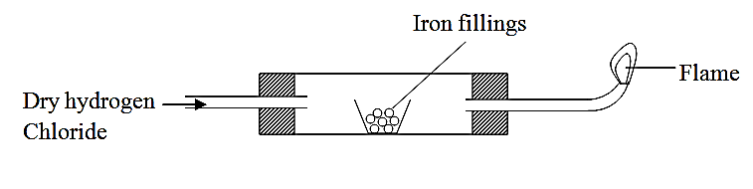

Heat

(i) Write 'occur' in the combustion tube. (1 mk)
.......................................................................................................................................................................................
.......................................................................................................................................................................................
(ii) Write an equation at the point of the flame. (1 Mk)
.......................................................................................................................................................................................
.......................................................................................................................................................................................
(iii) 1.96 g of iron filings reacted completely with hydrogen chloride. Calculate the volume of hydrogen gas produced.
(Molar gas volume at r.t.p. is 24 dm³, Fe=56.0) (2 Mks)
.......................................................................................................................................................................................
.......................................................................................................................................................................................
.......................................................................................................................................................................................
.......................................................................................................................................................................................
(c) One of the industrial uses of chlorine gas is the manufacture of hydrochloric acid.
(i) Give one source of chlorine gas (1 Mk)
.......................................................................................................................................................................................
.....................................................................................................................................................................................
(ii) Name another major raw material for this process and state its source. (2 Mks)
.......................................................................................................................................................................................
.......................................................................................................................................................................................

6. The diagram below shows a setup that can be used to obtain nitrogen gas in an experiment.
Water

Nitrogen

Dry
Ammonia
Copper (II)
Oxide
Tube J

Heat
Ice
Liquid K
Beaker

(i)Name liquid K (1 Mk)
.......................................................................................................................................................................................
.......................................................................................................................................................................................
(ii) What observation would be made in tube J after heating for some time? (2 Mks)
.......................................................................................................................................................................................
.......................................................................................................................................................................................
.......................................................................................................................................................................................
.......................................................................................................................................................................................
(iii) Write an equation for the reaction that took place in the tube J. (1 Mk)
.......................................................................................................................................................................................
.......................................................................................................................................................................................(iv) If 320 cm³ of ammonia gas reacted completely with the copper.
Calculate
I volume of nitrogen gas produced. (1 Mk)
.......................................................................................................................................................................................
.......................................................................................................................................................................................
II. The mass of copper (II) oxide that reacted. (3 Mks)
(Cu = 63.5, O = 16.0, MGV = 24 litres at r.t.p)
.......................................................................................................................................................................................
.......................................................................................................................................................................................
.......................................................................................................................................................................................
.......................................................................................................................................................................................
.......................................................................................................................................................................................
…………………………………………………………………………………………………………………………………………………………………………………

(v) At the end of the experiment, the pH of the water in the beaker was found to be about 10.
Explain (2 marks)
.......................................................................................................................................................................................
.......................................................................................................................................................................................
.......................................................................................................................................................................................
.......................................................................................................................................................................................
(b) In another experiment a gas jar containing ammonia was inverted over a burning splint. What observation would be made? (1 Mk)
.......................................................................................................................................................................................
.......................................................................................................................................................................................
(c) Why is it advisable to obtain nitrogen from air instead of from ammonia? (1 Mk)
.......................................................................................................................................................................................
.......................................................................................................................................................................................
7. Study the setup of apparatus shown below and answer the questions that follow.
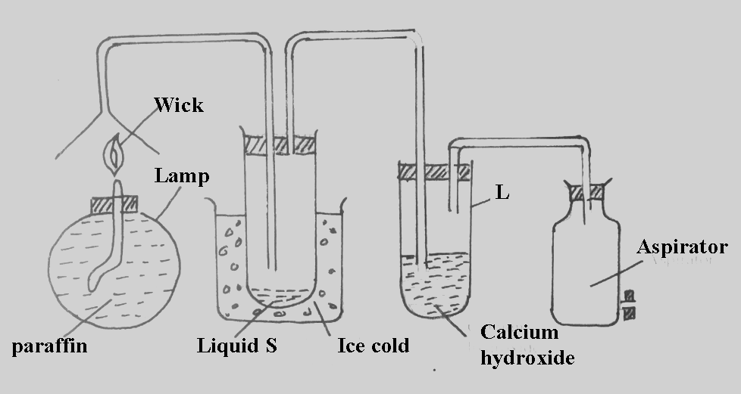

a) State and explain the observation that would be made in tube L as the experiment progresses in the first few minutes.
Observations (1 mk)
…………………………………………………………………………………………………….................
…………………………………………………………………………………………………….................
Explanation (1 mk)
………………………………………………………………………………………………………………
……….……………………………………………………………………………………………………....
b) How would the observations in tube L change if the experiment is carried out for a long time? Explain using a chemical equation.
Observation (1 mk)
……………………………………………………………………………………………………………….
…………………………………………………………………………………………………….................
Equation (1mk)
……………………………………………………………………………………………………………….
…………………………………………………………………………………………………….................
c) State and explain three observations made when liquid S is reacted with sodium metal (1 mark).
……………………………………………………………………………………………………………….
…………………………………………………………………………………………………….................
……………………………………………………………………………………………………………….
…………………………………………………………………………………………………….................
d) State the use of the aspirator in this experiment. (1 mk)
……………………………………………………………………………………………………………….
…………………………………………………………………………………………………….................

e) Diamond and graphite are allotropes of carbon. Graphite conducts electricity, and diamond does not. Explain this phenomenon. (1¹/₂mks)
……………………………………………………………………………………………………………….
…………………………………………………………………………………………………….................
……………………………………………………………………………………………………………….
…………………………………………………………………………………………………….................
f) State two uses of carbon (IV) oxide (1 mk).
……………………………………………………………………………………………………………….
…………………………………………………………………………………………………….................
g) Explain how water gas is formed (2 marks).
……………………………………………………………………………………………………………….
…………………………………………………………………………………………………….................
……………………………………………………………………………………………………………
THIS IS THE LAST PRINTED PAGE

