233/1 - FORM 3 CHEMISTRY - Paper 1
(Theory)

Name: ………………………………………………….…..…….......… Adm. No: ……….…………
Stream: ………………Candidate’s Signature: ……………..……………..Date: …..…….………..

OCTOBER - 2026 – 2 hours

Instructions to candidates
- Write your name, admission number, date, index number and school in the spaces provided
- Answer all the questions in the spaces provided
- All working MUST BE clearly shown where necessary
- Scientific calculators may be used
- Candidates should answer the questions in English
FOR EXAMINER’S USE ONLY
Questions | Maximum score | Candidate’s score
1 – 27 | 80

This paper contains 10 printed pages. The candidates should check to confirm that all pages are printed and that no question is missing.
- (a) Draw the atomic structure of an element which has a mass number of 27 and 14 neutrons (2 mks)

(b) To which period does the element belong? ( 1 mk)
…………………………………………………………………………………………………...
- Hydrocarbons burn in air to produce water and another product.
- Name the other product. (1 mk)
………………………………………………………………………………………………….
- Describe how the other product can be confirmed. (2 mks)
………………………………………………………………………………………………………………………………………………………………………………………………………………………………………………………………………………………………………………………………………………
- An electric current can be passed through some substances decomposing them in the process.
- Name the process. ………………………………………………………… (1 mark)
(b) Draw a diagram to show how an electric current can be used to decompose molten zinc chloride.
(2 marks)

- Boyle’s law investigates the relationship of two factors on gases.
- Name the two factors. (1 mark)
………………………………………………………………………………………………………………………………………………………………………………………………………………………………
- Draw a simple diagram that can be used to illustrate the relationship of the factors named above with respect to a given mass of a gas. (1 mark)

- State Charles law. (1 mk)
………………………………………………………………………………………………………………………………………………………………………………………………………………………………………………………………………………………………………………………………………………
- (a) Name two amorphous forms of carbon. (2 marks)
………………………………………………………………………………………………………………………………………………………………………………………………………………………………
(b) What is the property of graphite that makes is suitable to be used in pencil leads?(1 mark)
………………………………………………………………………………………………………………………………………………………………………………………………………………………….….
- Gases react in simple whole number ratios to each other. Determine the amount of residual gas produced when 180cm³ of sulphur (iv) oxide was exploded with 100cm³ of oxygen. (3 marks)
…………………………………………………………………………………………………………………………………………………………………………………………………………………………………………………………………………………………………………………………………………………………………………………………………………………………………………………………………………………………………………………………………………………………….
- (a) Draw a pipette (1 mark)

(b) Name two other apparatus that can be used to measure accurate volumes of liquids. (2 marks)
………………………………………………………………………………………………………………………………………………………………………………………………………………………………
- Sulphur (iv) oxide was reacted with hydrogen sulphide by form three students.
- Give one major observation made. (1 mark)
………………………………………………………………………………………………………………
- Write a balanced chemical equation for the reaction. (1 mark)
………………………………………………………………………………………………………………
- What precaution should the students undertake while carrying out the experiment? (1 mark) ………………………………………………………………………………………………………………
- Describe how a sample of sodium chloride can be prepared in the laboratory by direct synthesis. (2 marks)
………………………………………………………………………………………………………………………………………………………………………………………………………………………………………………………………………………………………………………………………………………………………………………………………………………………………………………………………………………………………………………………………………………………………..…………

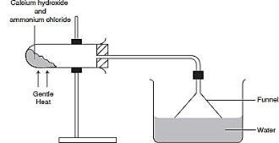
- The diagram below shows preparation of ammonia gas in the lab. Study it and answer the questions that follow.

- Give a reason why the funnel is inverted in the trough. (1 mark)
…………………………………………………………………………………………….
- What property of ammonia gas necessitates this set up? (1 mark)
……………………………………………………………………………………………
- Write a balanced chemical equation for the decomposition of ammonium nitrate. (1 mark)
….…………………………………………………………………………………………………
- A given mass of a gas occupies 20 cm³ at 25°C and 670 mmHg pressure. Find out the volume it will occupy at 40°C and 320 mmHg. (3 marks)
….……………………………………………………………………………………………………………………………………………………………………………………………………………………………………………………………………………………………………………………………………………………………………………………………………………………………………………………………
- Explain the following.
- The ion of nitrogen is larger than the atom. (1 mark)
….……………………………………………………………………………………………………………………………………………………………………………………………………………………………
- Calcium has a lower first ionization energy than magnesium. (1 mk)
….………………………………………………………………………………………………………………………………………………………………………………………………………………………………………………………………………………………………………………………………………..…
- Aluminium is a better conductor than potassium. (1 mk)
………………………………………………………………………………………………………………………………………………………………………………………………………………………………………………………………………...........................................................................................................
- A mixture of sodium carbonate and sodium chloride measuring 5g was reacted with 24cm³ of 63g/l of nitric (v) acid. Determine the percentage of sodium chloride present in the mixture. (3 marks)
………………………………………………………………………………………………………………………………………………………………………………………………………………………………………………………………………………………………………………………………………………………………………………………………………………………………………………………………
- Name;
- The green substance formed on copper coins when stored in a damp place for a while. (1 mark)
……………………………………………………………………………………………………………………………………………………………………………………………………………………..……….
- The complex ion responsible for the deep blue colour observed when excess ammonia solution is added to copper ions. (1 mark)
………………………………………………………………………………………………………………
- The alloy formed from a combination of copper and tin. (1 mark)
………………………………………………………………………………………………………………
- Water molecules are bonded together as shown below.
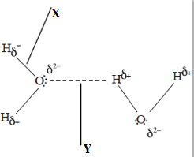

- Name the bonds labeled;
X ……………………………………………………………………………………(1 mark)
Y…………………………………………………………………………………….(1 mark)
- Give a reason why gases have generally a low boiling point. (1 mark)
………………………………………………………………………………………………………………………………………………………………………………………………………………………………
- Study the diagram below and use it to answer the questions that follow.
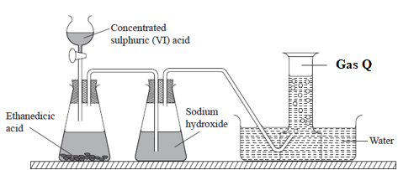
- Name gas Q (1 mark)
…………………………………………………………………………………………………
- Why is sodium hydroxide used in the process? (1 mark)
.........................................................................................................................................................................
- Why is calcium hydroxide preferred to sodium hydroxide in identifying carbon (iv) oxide gas? (1 mark)
………………………………………………………………………………………………………………………………………………………………………………………………………………………………
- The structure of methanoic acid is shown below
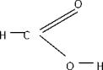
- What is the total number of electrons used for bonding in a molecule of methanoic acid? Give a reason. (2 marks)
..........................................................................................................................................................................................................................................................................................................................................................................................................................................................................................................................
- What is the likely colour of universal indicator in methanoic acid? (1 mark)
…………………………………………………………………………………………………………………………………………………………………………………………………………………….………...
- The grid below is part of the periodic table. Use it to answer the questions that follow. (The letters are not the actual symbols of the elements).
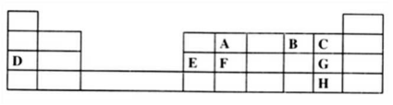
- Which is the most reactive non-metallic element shown in the table? Explain . (1mk)
……………………………………………………………………………………………………………………………………………………………………………………………………………………………….
- (i) Write the formulae of the compounds formed when element A reacts with element B …………………………………………………………………………………………… (1 mark)
(ii) To which family does element G belong? (1mark)
…………………………………………………………………………………………….
- An experiment was carried out to prepare crystals of magnesium sulphate. Excess magnesium powder was added to 100cm³ of dilute sulphuric (VI) acid in a beaker and warmed until no further reaction took place.
The mixture was filtered and the filtrate evaporated to saturation, then left to cool for crystals to form.
  - Write an equation for the reaction. (1 mark)
………………………………………………………………………………………………………………
  - Explain why excess magnesium powder was used. (1 mark)
………………………………………………………………………………………………………………
  - State how completion of the reaction was determined. (1 mark)
………………………………………………………………………………………………………………………………………………………………………………

- Rhombic sulphur is one of the allotropes of sulphur.
- Name the other allotrope (1 mark)
………………………………………………………………………………………..
- Give two differences between the two allotropes of sulphur. (2 marks)
………………………………………………………………………………………………………………………………………………………………………………………………………………………………………………………………………………………………………………………………………………
- Study the flow chart below and answer the questions that follow.
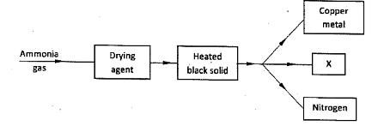
- Name a suitable drying agent for ammonia. (1 mark)
………………………………………………………………………………………
- Identify the black solid and substance X
Black solid ……………………………………………………………(1/2 mark)
X ………………………………………………………………………… (1/2 mark).
- What property of ammonia is being investigated? (1 mark)
………………………………………………………………………………………
- Potassium nitrate liberates oxygen gas when heated. 50.5g of potassium nitrate was heated completely in a closed system. Calculate the volume of the gas produced at r.t.p? (K=39, N=14, O=16, MGV =24000cm³) (3 marks)
………………………………………………………………………………………………………………………………………………………………………………………………………………………………………………………………………………………………………………………………………………………………………………………………………………………………………………………………………………………………

- (a) Write a balanced chemical equation to show that concentrated sulphuric (vi) acid is a dehydrating agent. (1 mark)
………………………………………………………………………………………………………………………………………………………………………………………………
- Name the most suitable catalyst used in the large scale manufacture of sulphuric (vi) acid. (1 mark)
…………………………………………………………………………………………
- Oleum is one of the products formed during the contact process. Write a balanced chemical equation to show how it is formed. (1 mark)
………………………………………………………………………………………………………………
- In one of the laboratory sessions, students were provided with an unknown white solid. They were asked to dissolve it in about 5 cm³ of water and to it add a few drops of barium nitrate followed by about 5cm³ dilute nitric (v) acid. Complete the table below.
Test | Observation | Inference
Addition of barium nitrate | Formation of a white precipitate | (11/2 mks)
Addition of nitric (v) acid | White precipitate dissolved to a colourless solution | (1 mk)

- (a) Using dots and crosses to represent electrons, illustrate the type of bonding in hydrogen chloride.(H = 1, Cl = 17) (2 marks)

(b)What nature of solution is formed when hydrogen chloride is dissolved in water? (1/2mk)
………………………………………………………………………………………………
- Some oxides of nitrogen are pollutants that may have adverse effects to the environment.
- Explain how acid rain is formed from such oxides. (2 marks)
…………………………………………………………………………………………………………………………………………………………………………………………………………………………………………………………………………………………………………………………………………………………………………
- List two effects of acid rain. (2 mks)
………………………………………………………………………………………………………………………………………………………………………………………………………………………………
- Define the following terms as used in describing metals.
- Lustre (1 mark)
…………………………………………………………………………………………
- Ductile (1 mark)
…………………………………………………………………………………………
- Metalloid
………………………………………………………………………………… (1 mark)
THIS IS THE LAST PRINTED PAGE

