NAME…………………………..……………….. DATE …………………………

INDEX NO. ……….……….…………………...…..… SIGNATURE ……………..…………..

231/1
BIOLOGY
PAPER 1
(THEORY)
OCT 2026
TIME: 2 HOURS

Kenya Certificate of Secondary Education

231/1
BIOLOGY
PAPER 1
(THEORY)
OCT/NOV 2026
TIME: 2 HOURS

INSTRUCTIONS TO CANDIDATES.
- Write your name and index number in spaces provided above.
- Sign and write the date.
- Answer ALL the questions in the spaces provided.
- Answers must be written in the spaces provided in the question paper. Additional pages must not be inserted.
- This paper consists of 8 printed pages. Candidates should check to ensure that all pages are printed as indicated and no questions are missing

FOR EXAMINER’S USE ONLY.
Questions | Maximum score | Candidate’s score
1 - 27 | 80

- State THREE importances of studying Biology (3 Marks)
………………………………………………………………………………………………………………
………………………………………………………………………………………………………………
………………………………………………………………………………………………………………
………………………………………………………………………………………………………………
- (a) What is meant by the term binomial nomenclature? (1 Mark)
………………………………………………………………………………………………………………
………………………………………………………………………………………………………………
(b) Give two reasons why classification is important. (2 Marks)
………………………………………………………………………………………………………………
………………………………………………………………………………………………………………
………………………………………………………………………………………………………………
- Ascaris Lumbricoides, is an example of an endoparasite. The name Ascaries refer to
………………………………………………………………………………………………………………
………………………………………………………………………………………………………………
………………………………………………………………………………………………………………
- The diagram below illustrates a cell organelle.
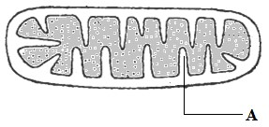
  - (i) Name part labelled A (1 Mark)
………………………………………………………………………………………………………………
………………………………………………………………………………………………………………
(ii) State the function of the organelle (1 Mark)
………………………………………………………………………………………………………………
………………………………………………………………………………………………………………
………………………………………………………………………………………………………………
………………………………………………………………………………………………………………
  - Describe the structure of the chloroplast. (2 Marks)
………………………………………………………………………………………………………………
………………………………………………………………………………………………………………

- Differentiate between a light microscope and an electronic microscope in terms of:-
(i) Type of lenses (1 Mark)
………………………………………………………………………………………………………………
……………………………………………………………………………………………………………… (ii) Source of illumination (1 Mark)
………………………………………………………………………………………………………………
………………………………………………………………………………………………………………
- Explain why plant cells do not burst when immersed in distilled water. (2 Marks)
………………………………………………………………………………………………………………
………………………………………………………………………………………………………………
………………………………………………………………………………………………………………
………………………………………………………………………………………………………………
- An experiment was set up as shown below.

Sucrose solution

Glass
rod

Thread

Distilled water

Visking tubing

The set up was left for 30 minutes.
  - State the expected results. (1 Mark)
…………………………………………………………………………………………………………
…………………………………………………………………………………………………………
  - Explain your answer in (a) above (3 Marks)
…………………………………………………………………………………………………………
…………………………………………………………………………………………………………
…………………………………………………………………………………………………………
- The graph below shows the effect of substrate concentration on the rate of enzyme reaction.

  - Account for the shape of the graph between
    - A and B (3 Marks)
…………………………………………………………………………………………………………
…………………………………………………………………………………………………………
…………………………………………………………………………………………………………
…………………………………………………………………………………………………………
…………………………………………………………………………………………………………
    - B and C (2 Marks)
…………………………………………………………………………………………………………
…………………………………………………………………………………………………………
…………………………………………………………………………………………………………
…………………………………………………………………………………………………………
  - How can the rate of reaction be increased after point B?
………………………………………………………………………………………………………… …………………………………………………………………………………………………………
…………………………………………………………………………………………………………
…………………………………………………………………………………………………………
  - Give two factors that affect the rate of enzyme reaction other than substrate concentration. (2 Marks)
…………………………………………………………………………………………………………
…………………………………………………………………………………………………………
…………………………………………………………………………………………………………
…………………………………………………………………………………………………………
- State two ways in which xylem are adapted to their function. (2 Marks)
………………………………………………………………………………………………………………
………………………………………………………………………………………………………………
………………………………………………………………………………………………………………
………………………………………………………………………………………………………………
- The diagram below represents a transverse section of a plant organ.

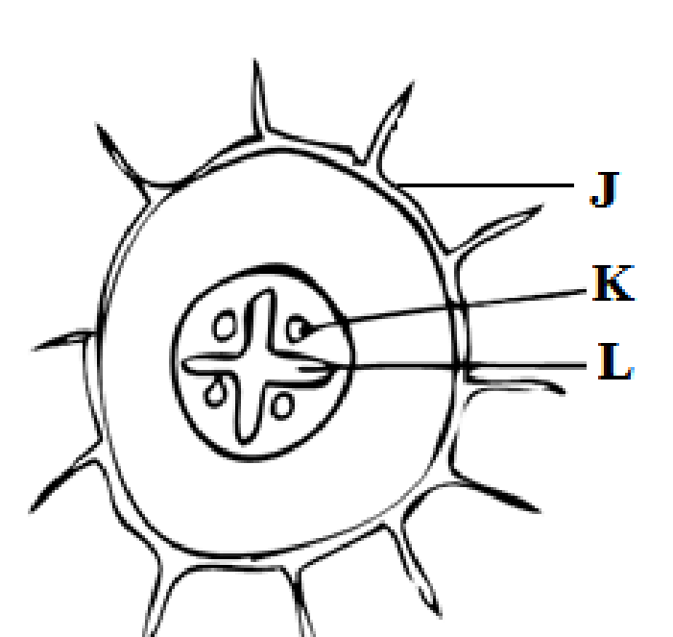

  - From which plant organ was the section obtained? (1 Mark)
…………………………………………………………………………………………………………
…………………………………………………………………………………………………………
…………………………………………………………………………………………………………
  - Name parts labelled J, K and L (3 Marks )
J………………………………………………………………………………………………………… K………………………………………………………………………………………………………
L…………………………………………………………………………………………………………
- (a) Name the blood vessels that link arterioles with venuoles (1 Mark)
………………………………………………………………………………………………………………
………….…………………………………………………………………………………………………...
(c) State two ways in which the composition of blood in the pulmonary arterioles differ from that in the pulmonary venuoles. (1 Mark)
………………………………………………………………………………………………………………
………….…………………………………………………………………………………………………...
………………………………………………………………………………………………………………
………….…………………………………………………………………………………………………...
- State three ways that make alveolus adapted to its function. (3 Marks)
………………………………………………………………………………………………………………
………….…………………………………………………………………………………………………...
………………………………………………………………………………………………………………
………….…………………………………………………………………………………………………...
- A process that occurs in plants is represented by the equation below.
C₆H₁₂O₆ 2C₂H₅OH + 2CO₂ + Energy
Glucose Ethanol Carbon (IV)
Oxide (a) Name the process (1 Mark)
…………………………………………………………………………………………………………
……………….…………………………………………………………………………………………
(b) State the economic importance of the process named in (a) above. (3 Marks)
…………………………………………………………………………………………………………
……………….………………………………………………………………………………………… …………………………………………………………………………………………………………

- In an investigation the pancreatic duct of a mammal was blocked. It was found that the blood sugar regulation remained normal while food digestion was impaired. Explain this observation. (2 Marks)
………………………………………………………………………………………………………………
………….…………………………………………………………………………………………………...
………………………………………………………………………………………………………………
………….…………………………………………………………………………………………………...
- State three ways by which the mammalian skin responds to low temperature in the environment.
(3 Marks)
………………………………………………………………………………………………………………
………….…………………………………………………………………………………………………...
………………………………………………………………………………………………………………
………….…………………………………………………………………………………………………...
- How would you find out from a sample of urine whether a person is suffering from diabetes mellitus?
(2 Marks)
………………………………………………………………………………………………………………
………….…………………………………………………………………………………………………...
………………………………………………………………………………………………………………
………….…………………………………………………………………………………………………...
- State two characteristics features of members of division bryophyte. (2 Marks)
………………………………………………………………………………………………………………
………….…………………………………………………………………………………………………...

- (a) List two characteristics that mammals share with birds. (2 Marks)
………………………………………………………………………………………………………………
………….…………………………………………………………………………………………………...
………………………………………………………………………………………………………………
(b) State two major characteristics that are unique to mammals. (2 Marks)
………………………………………………………………………………………………………………
………….…………………………………………………………………………………………………...
………………………………………………………………………………………………………………
- State how excessive use of pesticides may affect soil fertility. (2 Marks) ………………………………………………………………………………………………………………
………….…………………………………………………………………………………………………...
………………………………………………………………………………………………………………
………….…………………………………………………………………………………………………...
- Industrial wastes may contain metallic pollutants. State how such pollutants may indirectly reach and accumulate in the human body if the wastes were dumped into a river.
………………………………………………………………………………………………………………
………….…………………………………………………………………………………………………...
………………………………………………………………………………………………………………
- A flower was found to have the following characteristics ✓ Inconspicuous petals.
  - Long feathery stigma.
  - Small light pollen grains.
  - What is the likely agent of pollination of the flower. (1 Mark)
…………………………………………………………………………………………………………
……………….…………………………………………………………………………………………
  - What is the significance of the long feathery stigma in the flower? (1 Mark)
…………………………………………………………………………………………………………
……………….…………………………………………………………………………………………
…………………………………………………………………………………………………………
……………….…………………………………………………………………………………………
- Explain why sexual reproduction is important in organisms. (3 Marks)
………………………………………………………………………………………………………………
………….…………………………………………………………………………………………………...
………………………………………………………………………………………………………………
- What part does the placenta play in the protection of the embryo. (2 Marks)
………………………………………………………………………………………………………………
………….…………………………………………………………………………………………………...
………………………………………………………………………………………………………………
………….…………………………………………………………………………………………………...
- State two processes which occur during anaphase of mitosis (2 Marks)
………………………………………………………………………………………………………………
………….…………………………………………………………………………………………………...
………………………………………………………………………………………………………………
- Why is oxygen necessary during germination? (2 Marks) ………………………………………………………………………………………………………………
………….…………………………………………………………………………………………………...
………………………………………………………………………………………………………………

- State two environmental conditions that can cause seed dormancy (2 Marks)
………………………………………………………………………………………………………………
………….…………………………………………………………………………………………………...
………………………………………………………………………………………………………………
- Differentiate between the following terms
  - Growth and development (2 Marks)
…………………………………………………………………………………………………………
……………….…………………………………………………………………………………………
…………………………………………………………………………………………………………
  - Seed dormancy and seed viability (2 Marks)
…………………………………………………………………………………………………………
……………….…………………………………………………………………………………………
…………………………………………………………………………………………………………
- (a) Distinguish between a seed and fruit. (2 Marks)
………………………………………………………………………………………………………………
………….…………………………………………………………………………………………………...
………………………………………………………………………………………………………………
………….…………………………………………………………………………………………………... (b) Name one type of germination. (1 Mark)
………………………………………………………………………………………………………………
………….…………………………………………………………………………………………………...
………………………………………………………………………………………………………………

