NAME………………………………………………… INDEX NUMBER…………….
SCHOOL……………………………….SIGNATURE………..............................
ADMNO……………………….STREAM………………………….DATE……………………………………….

443/2
AGRICULTURE
PAPER 2
2 HRS

TERM 3 2026
AGRICULTURE

INSTRUCTIONS TO CANDIDATES:
- Write your name and index number in the spaces provided above.
- Sign and write the date of examination in the spaces provided above.
- This paper consists of THREE Sections A, B and C.
- Answer all questions in Section A and B.
- Answer two questions in Section C in the spaces provided.

FOR EXAMINER’S USE ONLY

Section | Question | Maximum  Score | Candidate’s  Score
A | 1 - 22 | 30
B | 23 - 26 | 20
C | 27 - 29 | 20
C |  | 20
Total Score |  | 90

SECTION A (30 MARKS)
Answer all questions in this section.
1. Name two methods of selection n livestock production. (1 mark)
……………………………………………………………………………………………………………………………………………………………………………………………………………………
2. Mention two ways in which the gizzard is adapted to its function. (1 mark)
………………………………………………………………………………………………………………………………………………………………………………………………………………………………………………………………………………………………………………………………
3. Name four main dairy breeds of goats reared in Kenya. ( 2 marks)
………………………………………………………………………………………………………………………………………………………………………………………………………………………………………………………………………………………………………………………………
…………………………………………………………………………………………………………
4.State four factors that can affect digestibility of a feedstuff in livestock. (2 marks)
………………………………………………………………………………………………………………………………………………………………………………………………………………………………………………………………………………………………………………………………
…………………………………………………………………………………………………………
5. State three reasons for castrating male animals. (1 ½ marks)
………………………………………………………………………………………………………………………………………………………………………………………………………………………………………………………………………………………………………………………………
6. Give four signs of heat observed on female rabbit (2 marks)
………………………………………………………………………………………………………………………………………………………………………………………………………………………………………………………………………………………………………………………………
…………………………………………………………………………………………………………

7. Differentiate the following terms as used in livestock management;
Mothering ability and prolificacy (1 mark)
……………………………………………………………………………………………………………………………………………………………………………………………………………………
Flushing and steaming up (1 mark)
……………………………………………………………………………………………………………………………………………………………………………………………………………………
8. State four signs of infestation by external parasites in goat (2 marks)
……………………………………………………………………………………………………………………………………………………………………………………………………………………………………………………………………………………………………………………………………………………………………………………………………………………………………………………………….
9.State two way in which a vaccine can be administered to livestock.
(1mk)
……………………………………………………………………………………………………………………………………………………………………………………………………………………
10. Give three disadvantages of natural mating in a dairy cow. (1 ½ marks)
………………………………………………………………………………………………………………………………………………………………………………………………………………………………………………………………………………………………………………………………
11. State four qualities of a good honey. (1 ½ marks)
………………………………………………………………………………………………………………………………………………………………………………………………………………………………………………………………………………………………………………………………
…………………………………………………………………………………………………………
12. Give two reasons why most farmers keep livestock in Kenya (1 mark)
……………………………………………………………………………………………………………………………………………………………………………………………………………………
13. Give two disadvantages of using thatch as a roofing material. (1 mark)
……………………………………………………………………………………………………………………………………………………………………………………………………………………
14. Give three predisposing factors to livestock diseases. ( 1 ½ marks)
………………………………………………………………………………………………………………………………………………………………………………………………………………………………………………………………………………………………………………………………
…………………………………………………………………………………………………………
15. State two functions of a footbath in a plunge cattle dip. (1 mark)
………………………………………………………………………………………………………………………………………………………………………………………………………………………………………………………………………………………………………………………………
16. State three reasons for debeaking birds in poultry. (1 ½ marks)
………………………………………………………………………………………………………………………………………………………………………………………………………………………………………………………………………………………………………………………………
…………………………………………………………………………………………………………
17. Give two reasons for raising rabbits hatch above the ground level. (1 mark)
………………………………………………………………………………………………………………………………………………………………………………………………………………………………………………………………………………………………………………………………
…………………………………………………………………………………………………………
18. State the use of a stir up pump. (½ mark)
………………………………………………………………………………………………………………………………………………………………………………………………………………………………………………………………………………………………………………………………
19. List two additives in livestock nutrition. (1 mark)
………………………………………………………………………………………………………………………………………………………………………………………………………………………………………………………………………………………………………………………………
…………………………………………………………………………………………………………

- Name the intermediate host of liver fluke
……………………………………………………………………………………………………… (1 mark)
- State two characteristics of the Duroc Jersey pig.
(1 mark)
……………………………………………………………………………………………………………………………………………………………………………………………………………………
22. Give four reasons for culling a breeding boar. (2 marks)
………………………………………………………………………………………………………………………………………………………………………………………………………………………………………………………………………………………………………………………………
…………………………………………………………………………………………………………

SECTION B (20 MARKS)
23. Study the livestock production structure below and answer the questions that follow:
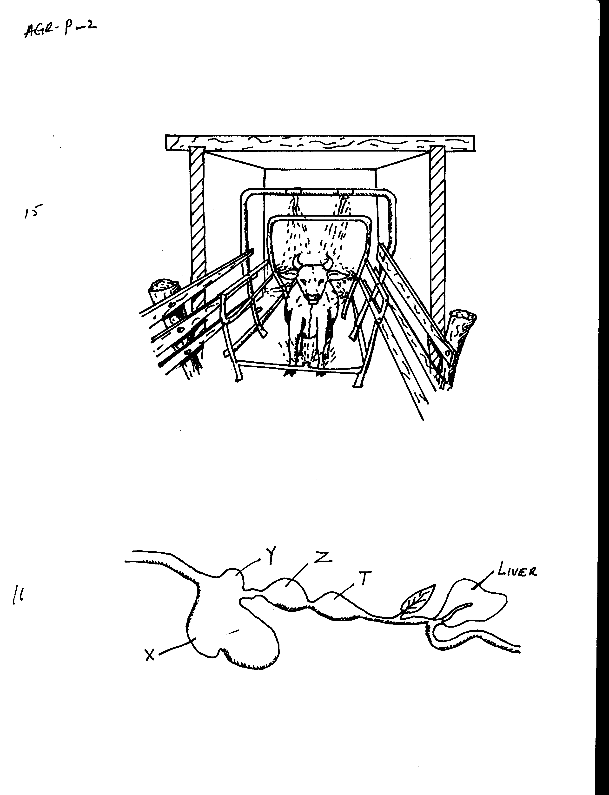

a) Identify the structure. (1mk)
……………………………………..…………………………………………………………
b) State TWO animal status that may necessitate the use of the above structure other than a dip. (2mks)
……………………………………………………………………………………………………………………………………………………...…………………………………………….
c) Name another structure that will serve under same conditions as in (b) above. (1mk)
………………………………………………………………………………………………….
24. Below is a diagram of a digestive system of a ruminant.

a) Identify the parts labeled Y and Z. (2mks)
Y ………………………………………………
Z ……………………………………………….
b) State any TWO digestive processes taking place at the part marked X. (2mks)
………………………………………………………………………………………………………………………………………………..…………………………………………………..
c) Name one enzyme secreted in the part labeled T that helps in digestion. (1mk)
…………………………………………………………………………………………………
25. Study methods of identification represented below
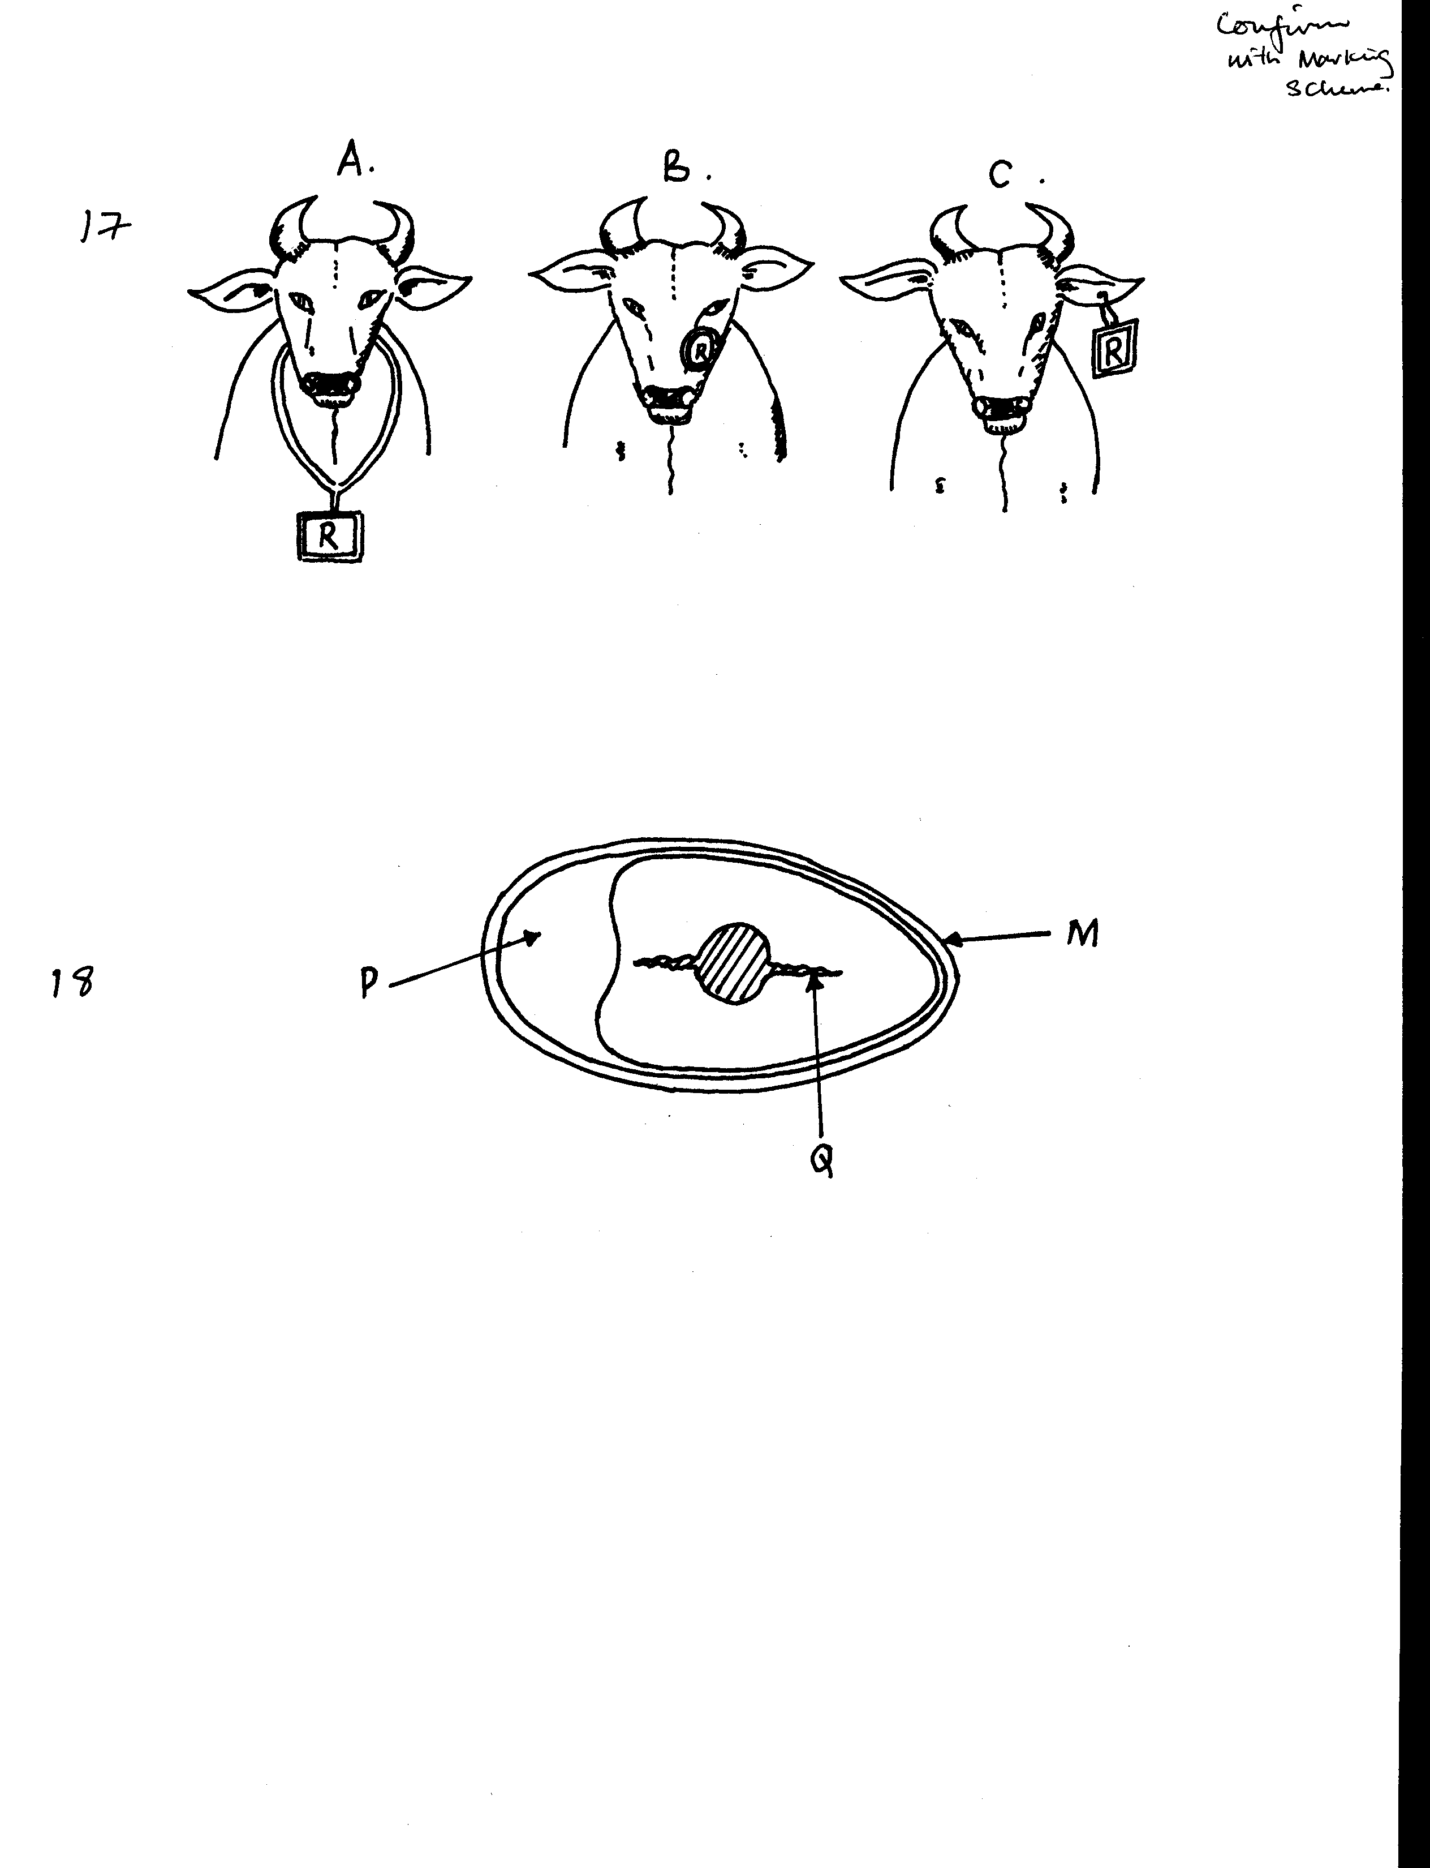

a) Identify each of the methods. (3mks)
A ………………………………………………………..
B ………………………………………………………..
C ………………………………………………………..
b) Outline the procedure of making identification mark labeled B. (3mks)
………………………………………………………………………………………………………………………………………………………………………………………………………………………………………………………………………………………………………
…………………………………………………………………………………………………
26. The diagram below illustrates an internal parasites of livestock. Study it and answer questions that follow.
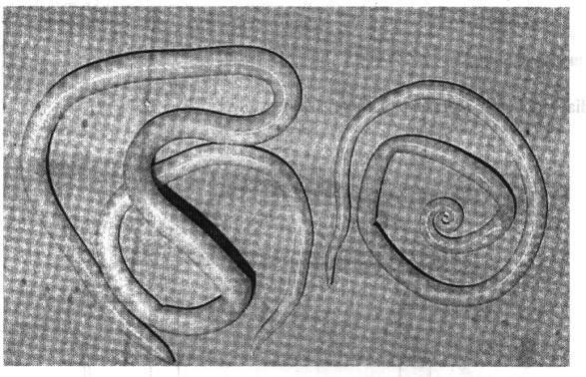

- Identifytheparasite. (1mark)
…………………………………………………………………………………………………………………………
- Name two common species of the parasite illustrated above
(2mks)
………………………………………………………………………………………………………………………………………………………………………………………………………………………………………….............
(c). State two signs of worm infestation that may be observed in the dung of livestock (2mks)

……………………………………………………………………………………………………………………………………………………………………………………………………………………………………………….............

SECTION C (40 MARKS)
Answer TWO questions from this section in the spaces provided after question 29
27. (a)Explain five control measures for tapeworms.(5marks)

(b).Describe thel ife cycle of a one-host tick.(5marks)

(c). Outline the procedure of processing honey using heat method. (6mks)

(d) .State four reasons for maintain tools and equipment. (4mks)

28. (a) Discuss Rinderpest disease of livestock under the following sub-headings: -
(i) Causal organism (1mk)
(ii) Symptoms (5mks)
(iii) Control (4mks)
(b) Explain five preventive measures of livestock diseases. (10mks)

29. (a)Explain five factors that should be considered when siting a farm store. (5mks)
(b)Describe the uses of fences on the farm. (10mks)
(c) Outline five practices that are carried out on fish before preservation. (5mks)
………………………………………………………………………………………………………………………………………………………………………………………………………………………………………………………………………………………………………………………………
…………………………………………………………………………………………………………
………………………………………………………………………………………………………………………………………………………………………………………………………………………………………………………………………………………………………………………………
…………………………………………………………………………………………………………
………………………………………………………………………………………………………………………………………………………………………………………………………………………………………………………………………………………………………………………………
…………………………………………………………………………………………………………
………………………………………………………………………………………………………………………………………………………………………………………………………………………………………………………………………………………………………………………………
…………………………………………………………………………………………………………
………………………………………………………………………………………………………………………………………………………………………………………………………………………………………………………………………………………………………………………………
…………………………………………………………………………………………………………
………………………………………………………………………………………………………………………………………………………………………………………………………………………………………………………………………………………………………………………………
…………………………………………………………………………………………………………
………………………………………………………………………………………………………………………………………………………………………………………………………………………………………………………………………………………………………………………………
…………………………………………………………………………………………………………
………………………………………………………………………………………………………………………………………………………………………………………………………………………………………………………………………………………………………………………………
…………………………………………………………………………………………………………
………………………………………………………………………………………………………………………………………………………………………………………………………………………………………………………………………………………………………………………………
…………………………………………………………………………………………………………
………………………………………………………………………………………………………………………………………………………………………………………………………………………………………………………………………………………………………………………………
…………………………………………………………………………………………………………
………………………………………………………………………………………………………………………………………………………………………………………………………………………………………………………………………………………………………………………………
…………………………………………………………………………………………………………
………………………………………………………………………………………………………………………………………………………………………………………………………………………………………………………………………………………………………………………………
…………………………………………………………………………………………………………
………………………………………………………………………………………………………………………………………………………………………………………………………………………………………………………………………………………………………………………………
…………………………………………………………………………………………………………
………………………………………………………………………………………………………………………………………………………………………………………………………………………………………………………………………………………………………………………………
…………………………………………………………………………………………………………
………………………………………………………………………………………………………………………………………………………………………………………………………………………………………………………………………………………………………………………………
…………………………………………………………………………………………………………
………………………………………………………………………………………………………………………………………………………………………………………………………………………………………………………………………………………………………………………………
…………………………………………………………………………………………………………
………………………………………………………………………………………………………………………………………………………………………………………………………………………………………………………………………………………………………………………………
…………………………………………………………………………………………………………
………………………………………………………………………………………………………………………………………………………………………………………………………………………………………………………………………………………………………………………………
…………………………………………………………………………………………………………

