NAME______________________________ ADM NO_______________
SCHOOL____________________________ SIGN__________________
CLASS______________________________ DATE_________________
233/2
CHEMISTRY PAPER 2
TIME: 2 HOURS
RIFT VALLEY REGION SCHOOLS’ JOINT PREMOCKS
Kenya Certificate of Secondary Education (K.C.S.E)
CHEMISTRY PAPER 2 (233/2)
INSTRUCTIONS TO CANDIDATES
- Write your name, admission number, index number and the school in the spaces provided above.
- Sign and write the date of examination in the above spaces
- Answer all the questions in the spaces provided
- Mathematical tables and scientific electronic calculators may be used
- All workings must be clearly shown where necessary
- Check the question paper to ascertain no question is missing
FOR EXAMINER USE ONLY
QUESTIONS | MAXIMUM SCORE | CANDIDATES SCORE
1 | 12
2 | 10
3 | 10
4 | 11
5 | 12
6 | 13
7 | 12
TOTAL | 80

- The table below shows the elements in period 3 of the periodic table. Study it and answer the qestions that follow
Element | Na | Mg | Al | Si | P | S | Cl | Ar

I. a) Write the formulae of two oxides for each of the following [2 marks]
- Sodium: Oxide I Oxide II
_______________________________________________________________________________________
- Sulphur: Oxide I Oxide II
_______________________________________________________________________________________
b) The products of the reaction between phosphorus and chlorine depend on the conditions used. Write the equation for the reaction when phosphorus reacts with limited chlorine gas [1 marks]
______________________________________________________________________________________________________________________________________________________________________________
c) Identify the most electronegative element. Give a reason [1 marks]
_______________________________________________________________________________________
d) State and explain the difference in the boiling point of sulphur and phosphorus [2 marks]
______________________________________________________________________________________________________________________________________________________________________________
II. Study the information below and answer the questions that follow. The letters do not represent the actual symbols of elements
element | Atomic number | M.P of element | M.P of chloride
G | 11 | 98 | 801
H | 12 | 650 | 715
J | 14 | 1410 | -70
K | 16 | 113 | -80
L | 20 | 851 | 780
- Write the formula of the compound formed when element H reacts with element K [1 mark]
______________________________________________________________________________________________________________________________________________________________________________
- Use dot (.) and cross (x) to show bonding between G and K [2 marks]

- What is the oxidation state of J in its chloride [1 marks]
_______________________________________________________________________________________
- How does the melting point of fluoride of G compare with that of its chloride [2 marks]
____________________________________________________________________________________________________________________________________________________________________________________________________________________________________________________________________________________________________________________________________________________________
- Study the setup below and answer the questions that follow
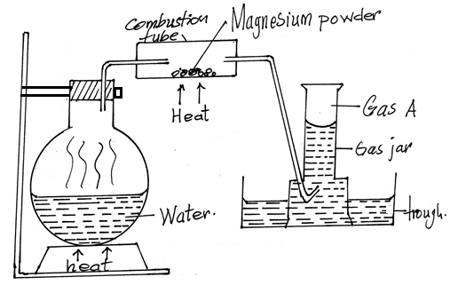
- Give two reasons why it is necessary to heat the water in the flask just before heating the magnesium powder [2 marks]
_____________________________________________________________________________________________________________________________________________________________________________________________________________________________________________________________________
- Write a chemical equation for the reaction taking place in the combustion tube [1 mark]
_______________________________________________________________________________________
- Give the test for gas A [1 mark]
_______________________________________________________________________________________
- Give two uses of gas A [2marks]
_______________________________________________________________________________________
- Given that 240cm3 of gas A was produced in the experiment, determine the mass of magnesium powder used.(molar gas volume = 24000cm³ at R.T.P, Mg = 24) [2 marks]
____________________________________________________________________________________________________________________________________________________________________________________________________________________________________________________________________________________________________________________________________________________________
- What would be observed if magnesium powder was replaced with;
- Copper metal? [1 marks]
_____________________________________________________________________________________________________________________________________________________________________________________________________________________________________________________________________
- Potassium metal? [1 marks]
_____________________________________________________________________________________________________________________________________________________________________________________________________________________________________________________________________
- The diagram below is a flow chart for the extraction of copper from the chief ore. Study it and answer the questions that follow. 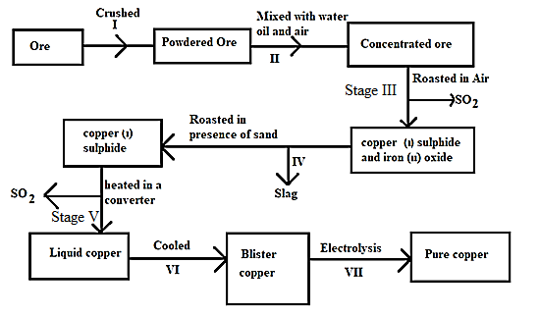

- Name two ores of copper metal [2 marks]
______________________________________________________________________________________________________________________________________________________________________________
- Name process II [1 mark]
_______________________________________________________________________________________
- Give an equation for the reaction that occurs in stage III [1 mark]
______________________________________________________________________________________________________________________________________________________________________________
- Explain what happens in stage IV [1 mark]
_____________________________________________________________________________________________________________________________________________________________________________________________________________________________________________________________________
- Write half-cell equations occurring at the anode and cathode in stage VII
Anode [1 marks]
_______________________________________________________________________________________
Cathode [1 marks]
_______________________________________________________________________________________
- State one impurity in blister copper [1 mark]
_______________________________________________________________________________________
- Draw a simple diagram showing the setup that is used in electrolytic purification of copper [2 marks]

- Consider the electrochemical cell represented by the cell notation below, when X is an unknown metal:
Fe²⁺(_{aq)} / Fe³⁺_{(aq)} // X⁺(aq) / X_{(s)}
- The cell potential of the cell was found to be 0.03V
- What does the single line (|) in the above cell notation represent? [1 mark]
______________________________________________________________________________________________________________________________________________________________________________
- Write down the half reaction that takes place at the anode in the above cell [1 marks]
______________________________________________________________________________________________________________________________________________________________________________
- Given that:
Half reaction E^{θ}(volts)
Fe³⁺(_{aq)} + e⁻ Fe²⁺(_{aq),} +0.77
Ag⁺_{(aq)} + e⁻ Ag_{(s)} +0.80
Na⁺_{(aq)} + e⁻ Na_{(s)} -2.87
K⁺_{(aq)} + e⁻ K_{(s)} -2.92
Identify X with the aid of calculation [2 marks]
____________________________________________________________________________________________________________________________________________________________________________________________________________________________________________________________________________________________________________________________________________________________
- The diagram below shows the apparatus that can be used to electrolyze dilute sulphuric acid. Study it and answer the questions that follow.
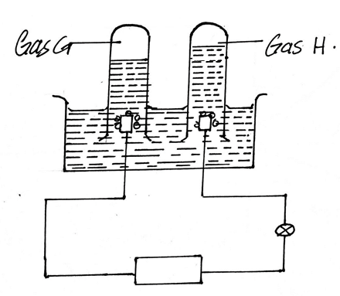

- Identify the gases H and G
- H [1 mark]
_______________________________________________________________________________________
- G [1 mark]
_______________________________________________________________________________________
- What happens to the concentration of the sulphuric acid during the process with time? Explain [2marks]
______________________________________________________________________________________________________________________________________________________________________________
- During electrolysis a current of 0.72A was passed through the electrolyte for 15 minutes. Calculate the volume of gas G produced. (1 Faraday = 96500C, molar gas volume = 24dm³ at r.t.p) [3 marks]
___________________________________________________________________________________________________________________________________________________________________________________________________________________________________________________________________________________________________________________________________________________________________________________________________________________________________________________
- a) The sketch below represents a graph obtained when zinc granules were reacted with excess 0.2M sulphuric (VI) acid in the presence of a catalyst in a conical flask placed on an electronic balance.

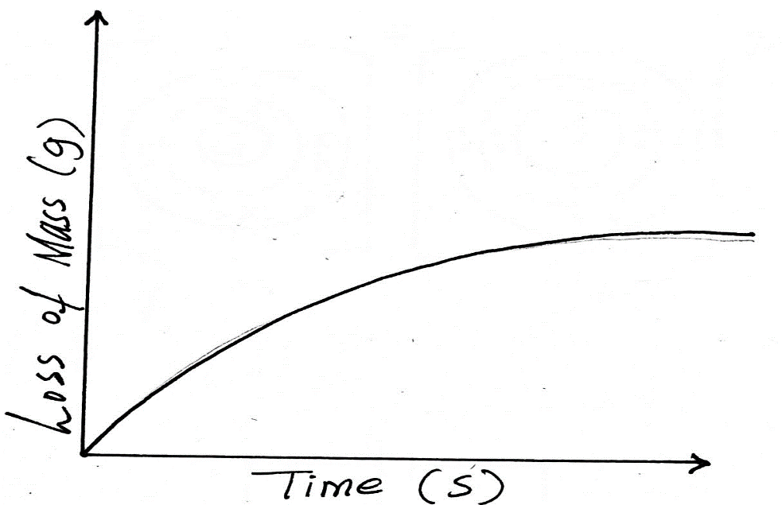
- Write an equation for the reaction that took place [1 mark]
_______________________________________________________________________________________
- Explain why there is loss in mass [1 mark]
_____________________________________________________________________________________________________________________________________________________________________________________________________________________________________________________________________
- Name the catalyst used [1 mark]
_______________________________________________________________________________________
- Sketch on the same axes, the curves obtained when
- Zinc powder was used under the same conditions[1 mark]
- No catalyst was used[1 mark]
b) In the contact process, sulphur(iv)oxide is converted to sulphuric(vi)oxide in the catalytic chamber which a dynamic chemical equilibrium is reached.
2SO_{2(g)} + O_{2(g)} 2SO_{3(g)} ∆H = -197kJ/mol
- What is meant by dynamic equilibrium [1 mark]
_____________________________________________________________________________________________________________________________________________________________________________________________________________________________________________________________________
- State and explain how each of the following would affect the position of equilibrium
- Decrease in temperature [2 marks]
_____________________________________________________________________________________________________________________________________________________________________________________________________________________________________________________________________
- Decrease in pressure [2marks]
_____________________________________________________________________________________________________________________________________________________________________________________________________________________________________________________________________
- Equilibrium exists between chromate and dichromate ions as shown below.
+ 2H⁺_{(aq)} + H₂O_{(l)}
Yellow Orange
State and explain the observation made when aqueous sodium hydroxide is added to the above mixture. [2 marks]
___________________________________________________________________________________________________________________________________________________________________________________________________________________________________________________________________________________________________________________________________________________________________________________________________________________________________________________

- Study the formulae below and answer the questions that follow
I. CH₃CH₂COOH
II. CH₃CH₂CH₂CH₂OH
- i) Give the systematic name of each compound [2 marks]
I.
_______________________________________________________________________________________
II.
_______________________________________________________________________________________
ii) Write the molecular formula of the compounds [1 mark]
I.
_______________________________________________________________________________________
II.
_______________________________________________________________________________________
iii) How does the boiling point of I compare to that of II. Explain [2 marks]
____________________________________________________________________________________________________________________________________________________________________________________________________________________________________________________________________________________________________________________________________________________________
iv) A gas J is bubbled into concentrated sulphuric(vi)acid. Water is added to the mixture then boiled to yield compound II. Name gas J. [1 mark]
_______________________________________________________________________________________
v) Draw the structural formula of the compound immediately after compound I in the homologous series [1 mark]

b) Study the structural formula of the two monomers below and answer the questions that follow.
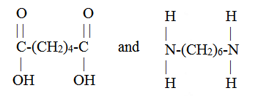
i) Name the type of polymerization these monomers would undergo to form a polymer [1 mark]
______________________________________________________________________________________________________________________________________________________________________________

ii) Draw the structural formula to represent the polymer formed. [1 mark]

iii) What is the name of the polymer [1 mark]
_______________________________________________________________________________________
iv) State the use of this polymer [1 mark]
______________________________________________________________________________________________________________________________________________________________________________
c) Two cleaning agents are represented below
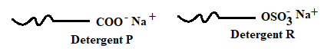
Select one of the detergent which would be suitable for washing in water containing magnesium chloride. Explain [2marks]
____________________________________________________________________________________________________________________________________________________________________________________________________________________________________________________________________________________________________________________________________________________________

- a) Define the term half-life [1 mark]
_____________________________________________________________________________________________________________________________________________________________________________________________________________________________________________________________________
b) The table below contains information from the measurements made of the radioactivity in counts per minute from a radioactive iodine – 128
Counts per minute | 240 | 204 | 180 | 156 | 138 | 122 | 108
Time (min) | 0 | 5 | 10 | 15 | 20 | 25 | 30

i) Plot a graph of counts per minute against time [3 marks]

ii) Use the graph to determine the half-life of iodine – 128 [1 mark]
____________________________________________________________________________________________________________________________________________________________________________________________________________________________________________________________________________________________________________________________________________________________
iii) What is the count rate after 22 minutes [1 mark]
____________________________________________________________________________________________________________________________________________________________________________________________________________________________________________________________________________________________________________________________________________________________
iv) After how many minutes were the counts rate 160 counts per minute [1 mark]
_____________________________________________________________________________________________________________________________________________________________________________________________________________________________________________________________________
c) Potassium has two isotopes and radio active
i) State how the two isotopes differ [1 mark]
_____________________________________________________________________________________________________________________________________________________________________________________________________________________________________________________________________
ii) The half life of is 1.3 ˟ 10⁹ years. Determine how long it would take for 4g of the isotope to decay to 1g [1 mark]
_____________________________________________________________________________________________________________________________________________________________________________________________________________________________________________________________________
iii) undergoes beta decay to form an isotope of calcium. Write the nuclear equation for this decay [1 mark]
_____________________________________________________________________________________________________________________________________________________________________________________________________________________________________________________________________
d) The figure below shows how a radioactive material emitted radiations from its source. Study it and answer the questions that follows as shown.
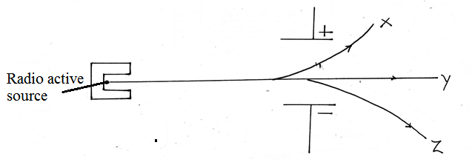
Identify the radiation that:
i) Has no mass [1 mark]
_______________________________________________________________________________________
ii) Contains helium particles [1 mark]
_______________________________________________________________________________________

