NAME………………………………………………………….ADM NO………………………………….
SCHOOL………………………………………………………..CLASS………………..SIGN……………...
BIOLOGY
231/2
TIME: 2HOURS
RIFT VALLEY REGION SCHOOLS’ JOINT PREMOCKS
Kenya Certificate of Secondary Education. (K.C.S.E)
BIOLOGY PAPER 2
INSTRUCTIONS TO CANDIDATES.
1. Write your name and index number in the spaces provide above.
2. Sign and write the date of examination in the spaces provided above.
3. All working must be clearly shown where necessary.
5. Answer all the questions in English.
For Examiners’ Use Only.
QUESTIONS | MAXIMUM SCORE | CANDIDATE’S SCORE
1 | 8
2 | 8
3 | 8
4 | 8
5 | 8
6 | 20
7 | 20
8 | 20
TOTAL | 80

SECTION A (40MARKS)
1. In an experiment, Euglena was put in a petri dish. One side of the petri dish was illuminated and the other kept in the dark as shown below.
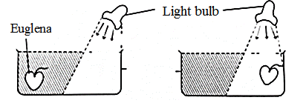
Start of the experiment End of the experiment
(a) Name this type of response. (1mark)
…………………………………………………………………………………………………………..
(b) State the significance of this type of response in an organism. (1mark)
…………………………………………………………………………………………………………...
…………………………………………………………………………………………………………...
(c) Other than light, outline other two factors that may cause change of position in Euglena and state the respective type of response. (2marks)
…………………………………………………………………………………………………………...
…………………………………………………………………………………………………………...
(d) (i) If the above experiment was repeated using a young potted seedling, name the type of response which will be observed. (1mark)
…………………………………………………………………………………………………………...
(ii) Explain the behavior of the seedling after 3days. (3marks)
…………………………………………………………………………………………………………...
…………………………………………………………………………………………………………...
…………………………………………………………………………………………………………...
2. The equation below represents a metabolic process that occurs in a certain organ in the mammalian body.
Ammonia+ carbon (IV) oxide enzyme organic compound Q + water
(a) Name the process represented in the equation above. (1mark)
…………………………………………………………………………………………………………...
(b) Name the organ in which the process occurs. (1mark)
…………………………………………………………………………………………………………...
(c) Identify the organic compound Q. (1mark)
…………………………………………………………………………………………………………...
…………………………………………………………………………………………………………...
(d) Explain the source of ammonia in the organ named in (b) above. (2marks)
…………………………………………………………………………………………………………...
…………………………………………………………………………………………………………...
…………………………………………………………………………………………………………...
…………………………………………………………………………………………………………...
e) Outline three ways in which plants excrete nitrogenous wastes (3marks)
…………………………………………………………………………………………………………...
…………………………………………………………………………………………………………...
…………………………………………………………………………………………………………...
…………………………………………………………………………………………………………...

3. (a) In human, a certain rare sex linked recessive allele on X chromosome results in a change to the shape of iris. The condition is known as cleff iris. A woman with normal iris becomes pregnant by a man with normal iris. Their first born son had cleff iris. What are the chances that their fifth born son would have cleff iris. Use letter R for the dominant allele. (5marks)

(b) Other than using a test/back cross, name another method that can be used in determining unknown genotype. (1mark)
…………………………………………………………………………………………………………...
(c) State two importance of human genome project. (2marks)
…………………………………………………………………………………………………………...
…………………………………………………………………………………………………………...
…………………………………………………………………………………………………………...
4. The diagram below shows a section through the human ovary. Study it and answer the questions that follow.

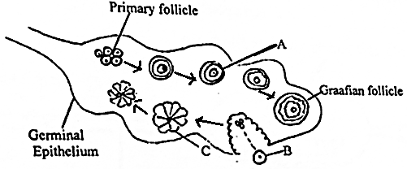
(a)(i) Which part of the ovary divides to form the primary follicle. (1mark)
…………………………………………………………………………………………………………...
(ii) Which type of cell division is responsible for the production of primary follicles? (1mark)
…………………………………………………………………………………………………………...
(b) Follicle stimulating hormone reaches the ovary so that part A begins to mature.
(i) Name the first hormone which is secreted by the ovary as result of arrival of FSH. (1mark)
…………………………………………………………………………………………………………...

(ii) What is the role of this hormone in the menstrual cycle? (1mark)
………………………………………………………………………………………………………….
(c) Structure B leaves the ovary.
(i) Where does structure B enter immediately after leaving the ovary? (1mark)
…………………………………………………………………………………………………………...
(ii) Which hormone level peaks just before structure B leaves the ovary? (1mark)
…………………………………………………………………………………………………………...
(d) Name structure C and State its role (2marks)
…………………………………………………………………………………………………………...
…………………………………………………………………………………………………………...
…………………………………………………………………………………………………………...
5. (a) Some students investigated gaseous exchange in a locust. They set up the apparatus as shown below.
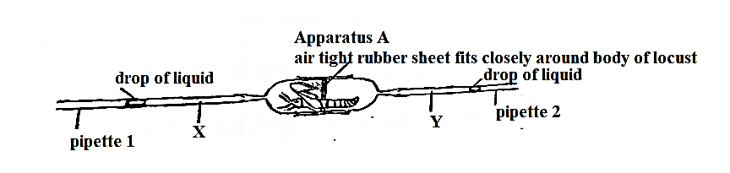
The drop of the liquid in the pipette 1 moves towards the locust while that in pipette 2 moves away from the locust.
(i) What does the direction of the movement of liquids suggest about the mechanism of gaseous exchange of the locust. (2marks)
…………………………………………………………………………………………………………...
…………………………………………………………………………………………………………...
…………………………………………………………………………………………………………...
(ii) Account for the difference in concentration of carbon (IV) oxide in the air at points X and Y. (2marks)
…………………………………………………………………………………………………………...
…………………………………………………………………………………………………………...
…………………………………………………………………………………………………………...
(b) Study the following data and answer the questions that follows.
Individuals | Breathing rates(breathe per minute) | Haemoglobin(g/100ml of blood) | Oxygen content (ml/100ml of blood)
A(normal) | 15 | 15.1 | 19.5
B | 21 | 8 | 13.7
C | 12 | 17.9 | 22.1
D | 22 | 16 | 14.1
(i) Which individual has recently moved from a low altitude area to high altitude area? Explain . (2marks)
…………………………………………………………………………………………………………...
…………………………………………………………………………………………………………...
(ii) Which individual is suffering from dietary iron deficiency? (1mark)
…………………………………………………………………………………………………………...
(iii) Name part of the brain that controls breathing in humans. (1mark)
…………………………………………………………………………………………………………...
SECTION B (40MARKS)
Answer question 6(compulsory) and their question 7 or 8 in the spaces provided.
6. The relationship between oxygen concentration, sugar consumption and potassium ion uptake in isolated wheat roots was determined. The results obtained were tabulated as shown below. The loss of sugar and potassium uptake or gain are in arbitrary units.
Percentage of oxygen concentration | 0 | 5 | 10 | 15 | 20 | 30 | 100
Sugar consumption | 15 | 20 | 43 | 45 | 45 | 44 | 43
Potassium ion gain | 5 | 55 | 70 | 75 | 75 | 72 | 70

(a) Plot graphs of sugar loss and potassium ion gain against oxygen concentration on the same axes.
(8marks)
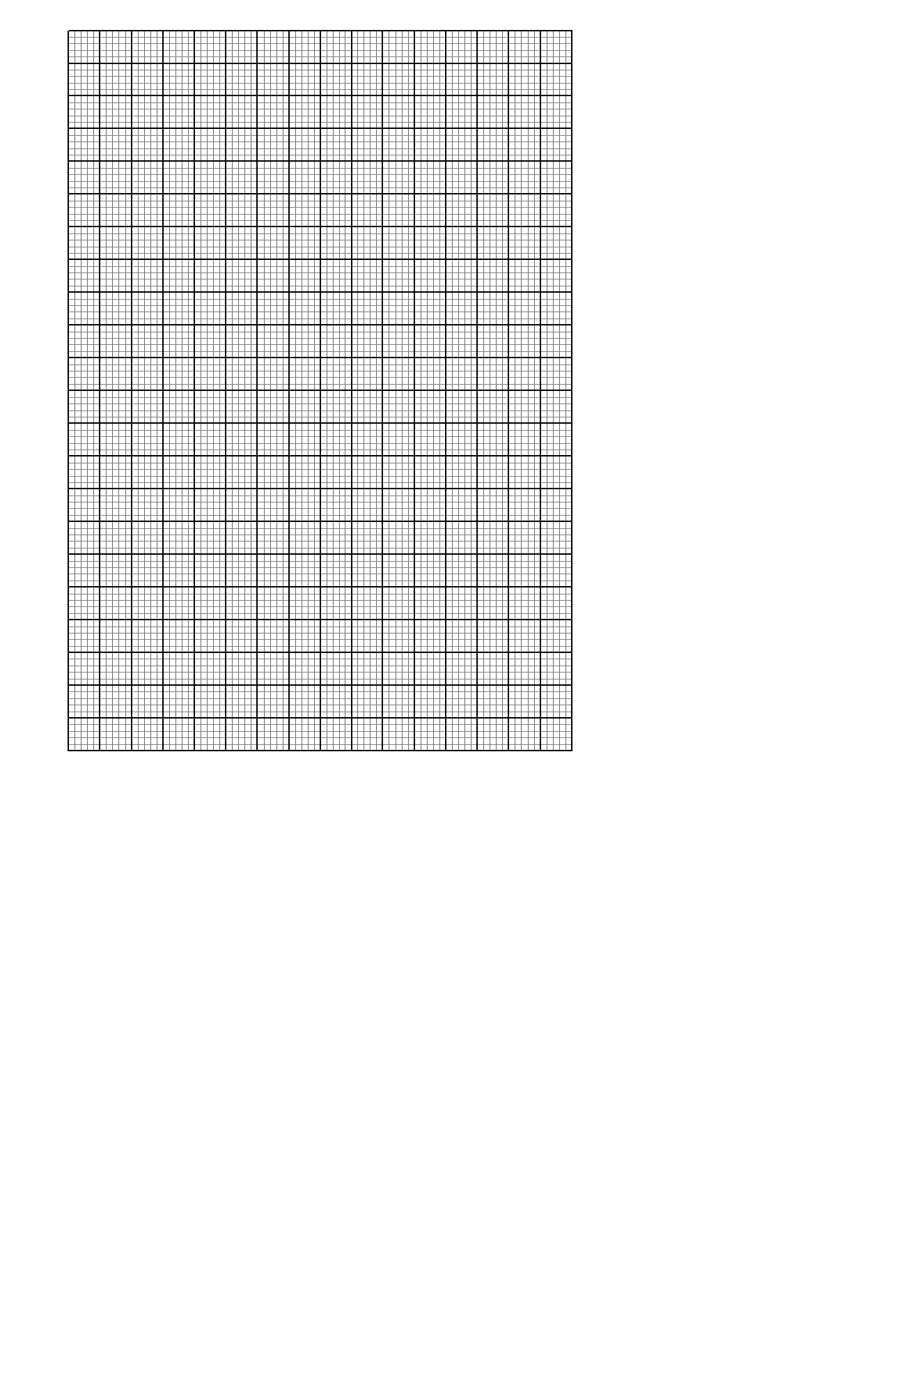

(b)(i) Identify the process by which potassium ions are taken up by the roots. (1mark)
…………………………………………………………………………………………………………...
…………………………………………………………………………………………………………...
(ii) Give an explanation for your answer in b (i) above. (2marks)
…………………………………………………………………………………………………………...
…………………………………………………………………………………………………………...
…………………………………………………………………………………………………………...
(c) Account for sugar consumption and potassium ions gain.
(i) at 0% oxygen concentration (2marks)
…………………………………………………………………………………………………………...
…………………………………………………………………………………………………………...
(ii) Between 5% and 20% oxygen concentration. (3marks)
…………………………………………………………………………………………………………...
…………………………………………………………………………………………………………...
…………………………………………………………………………………………………………...
…………………………………………………………………………………………………………...
(d) (i) State two ways by which the process involved in potassium uptake can be stopped. (2marks)
…………………………………………………………………………………………………………...
…………………………………………………………………………………………………………...
(ii) Name two organs in a mammalian body where the above process occurs. (2marks)
…………………………………………………………………………………………………………...
…………………………………………………………………………………………………………...
7. (a) Explain how endotherms respond to cold conditions in their environment. (10marks)
(b) Describe ways in which the human body protects itself against infections (10marks)
8. (a) State the processes involved in uptake of water and mineral salts from the roots to the leaves(4marks)
(b) Describe secondary growth in dicotyledonous plants (16 marks)
…………………………………………………………………………………………………………...
…………………………………………………………………………………………………………...
…………………………………………………………………………………………………………...
…………………………………………………………………………………………………………...
…………………………………………………………………………………………………………...
…………………………………………………………………………………………………………...
…………………………………………………………………………………………………………...
…………………………………………………………………………………………………………...
…………………………………………………………………………………………………………...
…………………………………………………………………………………………………………...
…………………………………………………………………………………………………………...
…………………………………………………………………………………………………………...
…………………………………………………………………………………………………………..
…………………………………………………………………………………………………………...
…………………………………………………………………………………………………………...
…………………………………………………………………………………………………………...
…………………………………………………………………………………………………………...
…………………………………………………………………………………………………………...
…………………………………………………………………………………………………………...
…………………………………………………………………………………………………………...
…………………………………………………………………………………………………………...
…………………………………………………………………………………………………………...
…………………………………………………………………………………………………………...
…………………………………………………………………………………………………………...
…………………………………………………………………………………………………………...
…………………………………………………………………………………………………………...
…………………………………………………………………………………………………………...
…………………………………………………………………………………………………………...
…………………………………………………………………………………………………………...
…………………………………………………………………………………………………………...
…………………………………………………………………………………………………………...
…………………………………………………………………………………………………………...
…………………………………………………………………………………………………………...
…………………………………………………………………………………………………………...
…………………………………………………………………………………………………………...
…………………………………………………………………………………………………………...
…………………………………………………………………………………………………………...
…………………………………………………………………………………………………………...
…………………………………………………………………………………………………………...
…………………………………………………………………………………………………………...
…………………………………………………………………………………………………………...
…………………………………………………………………………………………………………...
…………………………………………………………………………………………………………...
…………………………………………………………………………………………………………...
…………………………………………………………………………………………………………...
…………………………………………………………………………………………………………...
…………………………………………………………………………………………………………...
…………………………………………………………………………………………………………...
…………………………………………………………………………………………………………...
…………………………………………………………………………………………………………...
…………………………………………………………………………………………………………...
…………………………………………………………………………………………………………...
…………………………………………………………………………………………………………...
…………………………………………………………………………………………………………...
…………………………………………………………………………………………………………...
…………………………………………………………………………………………………………...
…………………………………………………………………………………………………………...
…………………………………………………………………………………………………………...
…………………………………………………………………………………………………………...
…………………………………………………………………………………………………………...
…………………………………………………………………………………………………………...
…………………………………………………………………………………………………………...
THIS IS THE LAST PRINTED PAGE

