NAME…………………………………………………………... ADM NO……………….…

SCHOOL………………………………………………………CANDIDATE’S SIGN…………

CLASS………………………………………………………… DATE…………………………

443/2
AGRICULTURE
PAPER 2
TIME: 2 HOURS

RIFT VALLEY REGION SCHOOLS’ JOINT PREMOCKS
Kenya Certificate of Secondary Education (K.C.S.E)
INSTRUCTIONS TO CANDIDATES
- Write your name, class, admission numbers and school in the spaces provided
- Sign and write the date of examination in space provided
- This paper consists of three sections A, B and C
- Answer all questions in section A and B in the spaces provided
- In section C, answer any two questions in the spaces provided
- This paper consists of 10 printed pages
- Candidates should check the question paper to ascertain that all pages are printed as indicated and that no questions are missing
FOR EXAMINERS USE ONLY
SECTION | QUESTION | MAX SCORE | CANDIDATE SCORE
A | 1 – 16 | 30 MARKS
B | 17-20 | 20 MARKS
C | 21-23 | 40 MARKS
 | TOTAL | 90 MARKS

SECTION A (30 MARKS)
Answer all the questions in the spaces provided

1. Name four zoonotic diseases in livestock (2mks)
………………………………………………………………………………………………
………………………………………………………………………………………………
………………………………………………………………………………………………
………………………………………………………………………………………………
………………………………………………………………………………………………
2. State four reasons for maintaining farm tools (2mks)
……………………………………………………………………………………………………………………………………………………………………………………………………………………………………………………………………………………………..
………………………………………………………………………………………………
………………………………………………………………………………………………

3. State four advantages of artificial rearing in calves (2mks)
………………………………………………………………………………………………
………………………………………………………………………………………………
………………………………………………………………………………………………
………………………………………………………………………………………………
………………………………………………………………………………………………

4. State four reasons for steaming up in dairy cattle (2mks)
………………………………………………………………………………………………
………………………………………………………………………………………………
………………………………………………………………………………………………
………………………………………………………………………………………………
………………………………………………………………………………………………

5. Fill in the table below giving the terms used in reference to animals (2mks)
Young one of; | Sheep  ………………………….… | Rabbit  ……………………..
Mature female of; | Cattle  …………………. | Goat  ……………………….......

6. State four effects of livestock parasite (2mks)
………………………………………………………………………………………………
………………………………………………………………………………………………………………………………………………………………………………………………………………………………………………………………………………………………
………………………………………………………………………………………………

7. Give four signs of ill health observed in the animals skin (2mks)
………………………………………………………………………………………………
……………………………………………………………………………………………...
……………………………………………………………………………………………...
……………………………………………………………………………………………...
………………………………………………………………………………………………

8. State four characteristics of a broody hen (2mks)
………………………………………………………………………………………………
………………………………………………………………………………………………
………………………………………………………………………………………………
………………………………………………………………………………………………
………………………………………………………………………………………………

9. Identify the nutrient that is deficient in the following disorder (2mks)
i) Curled toe paralysis in chicks
………………………………………………………………………………………………
………………………………………………………………………………………………
ii) Milk fever
………………………………………………………………………………………………
………………………………………………………………………………………………
iii) Piglet anaemia
………………………………………………………………………………………………
………………………………………………………………………………………………
iv) Sway back in lambs
………………………………………………………………………………………………
………………………………………………………………………………………………

10. State four signs of farrowing (2mks)
………………………………………………………………………………………………
………………………………………………………………………………………………
………………………………………………………………………………………………
………………………………………………………………………………………………
11. Give four components of power transmission system in a tractor (2mks)
………………………………………………………………………………………………
………………………………………………………………………………………………
………………………………………………………………………………………………
………………………………………………………………………………………………
12. State four factors that favour fish farming (2mks)
………………………………………………………………………………………………
………………………………………………………………………………………………
………………………………………………………………………………………………
………………………………………………………………………………………………

13. State four factors that stimulates milk let down (2mks)
………………………………………………………………………………………………
………………………………………………………………………………………………
………………………………………………………………………………………………
………………………………………………………………………………………………
14. State four symptoms of Gumboro disease in poultry (2mks)
………………………………………………………………………………………………
………………………………………………………………………………………………
………………………………………………………………………………………………
………………………………………………………………………………………………
15. If a cow is detected to have signs of heat at 6am on 12th May 2024, when should it be served? (1mk)
………………………………………………………………………………………………
16. Give two categories of vitamins (1mk)
………………………………………………………………………………………………
………………………………………………………………………………………………

SECTION B (20 MARKS)
Answer all questions in this section in the spaces provided

17. Study the farm tools below and answer the questions that follow

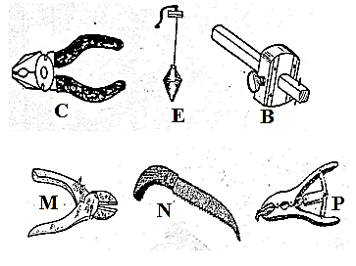
a) Identify the farm tools C,E and B (3mks)
C …………………………………………
E……………………………………………
B…………………………………………….
b) State the functional difference between M and N (1mk)
………………………………………………………………………………………………
………………………………………………………………………………………………
c)State two maintenance practices carried out on tool labelled P (1mk)
………………………………………………………………………………………………
………………………………………………………………………………………………

18. The diagram J and K below shows livestock parasites
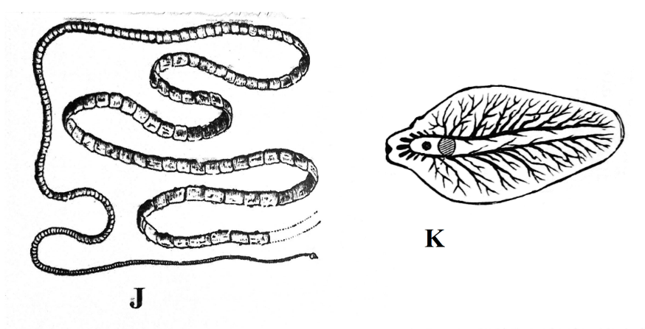
a) Identify parasite labeled J and K (2mks)
J…………………………………………………………………………………………
K…………………………………………………………………………………………
b) Name the organ in which each parasite is commonly found (1mk)
Parasite J
………………………………………………………………………………………………
Parasite K
………………………………………………………………………………………………
c) State two control measures of the parasite labeled K in livestock production
(2mks)
………………………………………………………………………………………………
………………………………………………………………………………………………
19. The illustration below shows an animal handling structure. Study it and answer the following questions
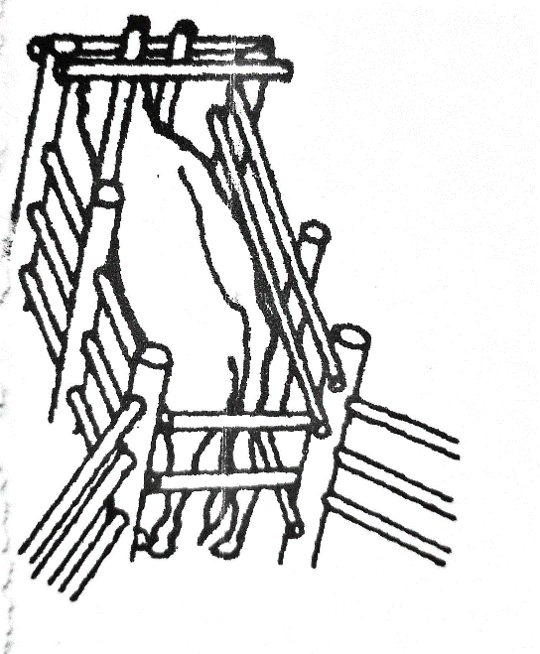
- Identify the structure illustrated (1mk)
………………………………………………………………………………………………
- State two operations given to animals when confined in the above structure
(2mks)
………………………………………………………………………………………………
………………………………………………………………………………………………
- Name two other related structures that are used in parasite and disease control
(2mks)
………………………………………………………………………………………………
………………………………………………………………………………………………
20. Below are farm implements. Study them and answer the questions that follow
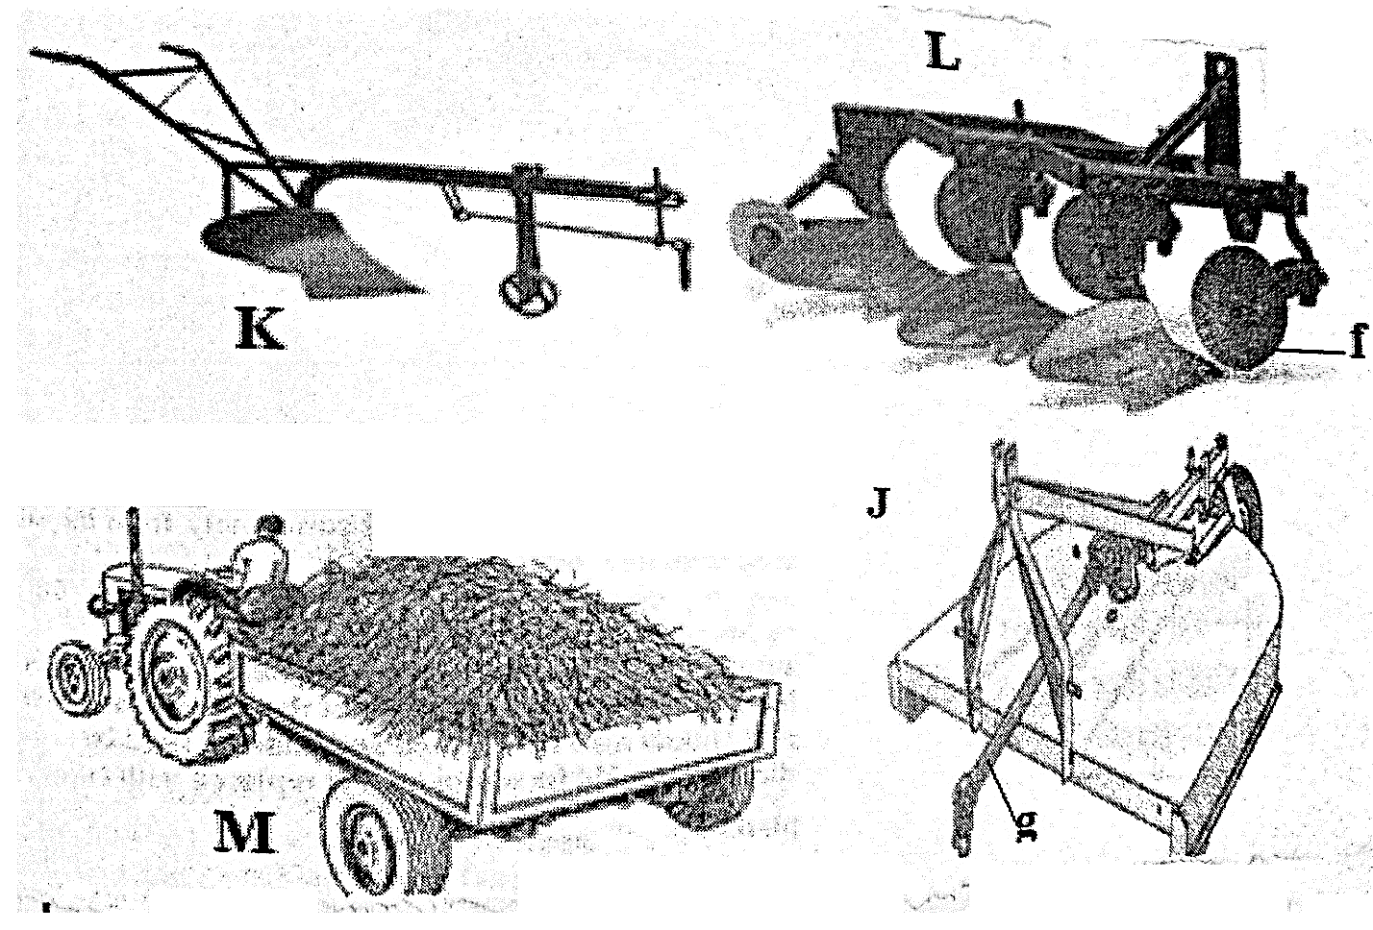

a) Identify the implements K and M (2mks)
K……………………………………………
M……………………………………………
b) State the function of implement J and L (2mks)
J……………………………………………………………………………………..
L…………………………………………………………………………………….
c) State two maintenance practices carried out on part labeled F (1mk)
………………………………………………………………………………………………
………………………………………………………………………………………………
SECTION C (40 MARKS)
Answer any two questions in this section
21. a) Describe coccidiosis under the following sub headings
i) Causal organism (1mk)
ii) Animals attacked (2mks)
iii) Symptoms (3mks)
iv) Control (4mks)
b) Describe five essentials of clean milk production (5mks)
c) State five advantages of using artificial insemination (5mks)
22. a) Describe the strokes in a four stroke cycle petrol engine (10mks)
b) State the differences between ruminants and non-ruminants (5mks)
c) State five characteristics of good dairy cattle breed (5mks)
23. a) Describe management of layers from point of lay to culling (10mks)
b) Explain six factors to consider when sitting farm structures (6mks)
c) State four factors that determine quality of honey (4mks)
………………………………………………………………………………………………………………………………………………………………………………………………………………………………………………………………………………………………………………………………………………………………………………………………………………………………
………………………………………………………………………………………………………………………………………………………………………………………………………………………………………………………………………………………………………………………
………………………………………………………………………………………………………………………………………………………………………………………………………………………………………………………………………………………………………………………
………………………………………………………………………………………………………………………………………………………………………………………………………………………………………………………………………………………………………………………
………………………………………………………………………………………………………………………………………………………………………………………………………………………………………………………………………………………………………………………
………………………………………………………………………………………………………………………………………………………………………………………………………………………………………………………………………………………………………………………
………………………………………………………………………………………………………………………………………………………………………………………………………………………………………………………………………………………………………………………
………………………………………………………………………………………………………………………………………………………………………………………………………………………………………………………………………………………………………………………
………………………………………………………………………………………………………………………………………………………………………………………………………………………………………………………………………………………………………………………
………………………………………………………………………………………………………………………………………………………………………………………………………………………………………………………………………………………………………………………
………………………………………………………………………………………………………………………………………………………………………………………………………………………………………………………………………………………………………………………
………………………………………………………………………………………………………………………………………………………………………………………………………………………………………………………………………………………………………………………
………………………………………………………………………………………………………………………………………………………………………………………………………………………………………………………………………………………………………………………
………………………………………………………………………………………………………………………………………………………………………………………………………………………………………………………………………………………………………………………
………………………………………………………………………………………………………………………………………………………………………………………………………………………………………………………………………………………………………………………
………………………………………………………………………………………………………………………………………………………………………………………………………………………………………………………………………………………………………………………
………………………………………………………………………………………………………………………………………………………………………………………………………………………………………………………………………………………………………………………
………………………………………………………………………………………………………………………………………………………………………………………………………………………………………………………………………………………………………………………
………………………………………………………………………………………………………………………………………………………………………………………………………………………………………………………………………………………………………………………
………………………………………………………………………………………………………………………………………………………………………………………………………………………………………………………………………………………………………………………
………………………………………………………………………………………………………………………………………………………………………………………………………………………………………………………………………………………………………………………
………………………………………………………………………………………………………………………………………………………………………………………………………………………………………………………………………………………………………………………
………………………………………………………………………………………………………………………………………………………………………………………………………………………………………………………………………………………………………………………
………………………………………………………………………………………………………………………………………………………………………………………………………………………………………………………………………………………………………………………
………………………………………………………………………………………………………………………………………………………………………………………………………………………………………………………………………………………………………………………
………………………………………………………………………………………………………………………………………………………………………………………………………………………………………………………………………………………………………………………
………………………………………………………………………………………………………………………………………………………………………………………………………………………………………………………………………………………………………………………
………………………………………………………………………………………………………………………………………………………………………………………………………………………………………………………………………………………………………………………
………………………………………………………………………………………………………………………………………………………………………………………………………………………………………………………………………………………………………………………
………………………………………………………………………………………………………………………………………………………………………………………………………………………………………………………………………………………………………………………
………………………………………………………………………………………………………………………………………………………………………………………………………………………………………………………………………………………………………………………
………………………………………………………………………………………………………………………………………………………………………………………………………………………………………………………………………………………………………………………
………………………………………………………………………………………………………………………………………………………………………………………………………………………………………………………………………………………………………………………
………………………………………………………………………………………………………………………………………………………………………………………………………………………………………………………………………………………………………………………
………………………………………………………………………………………………………………………………………………………………………………………………………………………………………………………………………………………………………………………
………………………………………………………………………………………………………………………………………………………………………………………………………………………………………………………………………………………………………………………
………………………………………………………………………………………………………………………………………………………………………………………………………………………………………………………………………………………………………………………
………………………………………………………………………………………………………………………………………………………………………………………………………………………………………………………………………………………………………………………
………………………………………………………………………………………………………………………………………………………………………………………………………………………………………………………………………………………………………………………
………………………………………………………………………………………………………………………………………………………………………………………………………………………………………………………………………………………………………………………
………………………………………………………………………………………………………………………………………………………………………………………………………………………………………………………………………………………………………………………
………………………………………………………………………………………………………………………………………………………………………………………………………………………………………………………………………………………………………………………
………………………………………………………………………………………………………………………………………………………………………………………………………………………………………………………………………………………………………………………
………………………………………………………………………………………………………………………………………………………………………………………………………………………………………………………………………………………………………………………
………………………………………………………………………………………………………………………………………………………………………………………………………………………………………………………………………………………………………………………
………………………………………………………………………………………………………………………………………………………………………………………………………………………………………………………………………………………………………………………
………………………………………………………………………………………………………………………………………………………………………………………………………………………………………………………………………………………………………………………
………………………………………………………………………………………………………………………………………………………………………………………………………………………………………………………………………………………………………………………
………………………………………………………………………………………………………………………………………………………………………………………………………………………………………………………………………………………………………………………
………………………………………………………………………………………………………………………………………………………………………………………………………………
THIS IS THE LAST PRINTED PAGE!

