NAME______________________________ ADM NO_______________
SCHOOL____________________________ SIGN__________________
CLASS______________________________ DATE_________________
233/1
CHEMISTRY
PAPER 1
TIME: 2 HOURS

RIFT VALLEY REGION SCHOOLS’ JOINT PREMOCKS
Kenya Certificate of Secondary Education (K.C.S.E)
CHEMISTRY PAPER 1 (233/1)

INSTRUCTIONS TO CANDIDATES
- Write your name, admission number, index number and the school in the spaces provided above.
- Sign and write the date of examination in the above spaces
- Answer all the questions in the spaces provided
- Mathematical tables and silent electronic calculators may be used
- All working must be clearly shown where necessary
- This paper consist of 12 printed pages
FOR EXAMINER USE ONLY
QUESTIONS | MAXIMUM SCORE | CANDIDATES SCORE
1 – 27 | 80
TOTAL SCORE | 80

- Air is a mixture of different components. Identify;
- A compound that turn lime water to a white precipitate [1 mk]
_______________________________________________________________________________________
- A compound that changes cobalt(ii)chloride from blue to pink [1 mk]
_______________________________________________________________________________________
- A diatomic gas that has triple bond [1 mk]
_______________________________________________________________________________________
- A mixture contains potassium chloride and lead(ii)sulphate. Describe how you would obtain crystals of potassium chloride from this mixture [3 mks]
____________________________________________________________________________________________________________________________________________________________________________________________________________________________________________________________________________________________________________________________________________________________
- Oxygen is prepared in the laboratory through catalytic decomposition of hydrogen peroxide.
- Name the catalyst in this experiment [1 mk]
_______________________________________________________________________________________
- What mass of hydrogen peroxide would be needed to produce 120cm³ of oxygen gas at r.t.p in this experiment? (Molar gas volume at RTP = 24000cm³, H = 1, O = 16) [3 mks]
_____________________________________________________________________________________________________________________________________________________________________________________________________________________________________________________________________
- Carbon(iv)oxide gas was passed over heated copper(ii)oxides shown in the diagram below.
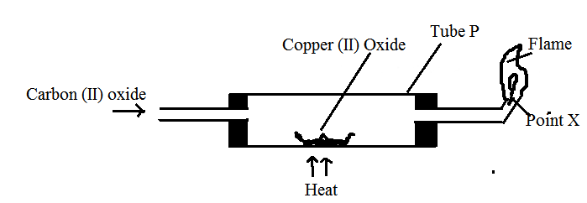

- State the observation made in the tube P [1 mk]
_____________________________________________________________________________________________________________________________________________________________________________________________________________________________________________________________________
- Write an equation for the reaction which took place in tube P [1 mk]
______________________________________________________________________________________________________________________________________________________________________________
- Name the gas burning at point X [1 mk]
_______________________________________________________________________________________
- The diagram below illustrates the steps involved in the industrial manufacture of of nitric(v)acid.
Use it to answer the questions that follow.

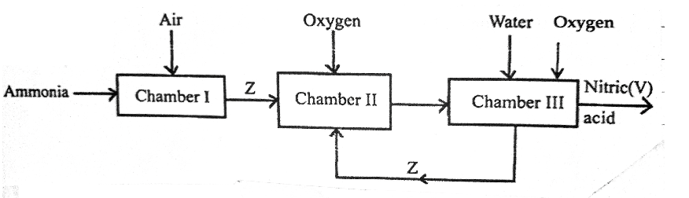
- Identify the chamber in which a catalyst is used. [1 mk]
_______________________________________________________________________________________
- Name substance Z [1 mk]
_______________________________________________________________________________________
- Write an equation for the reaction that takes place in chamber III [1 mk]
_______________________________________________________________________________________
- Draw a well labelled setup for the laboratory preparation and collection of dry sample of hydrogen chloride gas [3 mks]

- Account for the following observations made when a piece of sodium is placed in a trough half filled with water.
- Hissing sound [1 mk]
______________________________________________________________________________________________________________________________________________________________________________
- Darts on the water surface [1 mk]
______________________________________________________________________________________________________________________________________________________________________________
_______________________________________________________________________________________
- Solution formed turns red litmus paper blue [1 mk]
_____________________________________________________________________________________________________________________________________________________________________________________________________________________________________________________________________
- The diagram below shows the structure of iodine

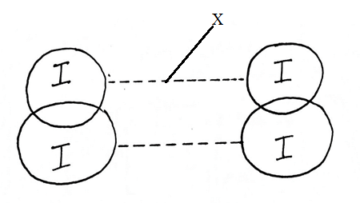
- Name;
- Part X [1 mk]
_______________________________________________________________________________________
- Type of bond in the solid [1 mk]
_______________________________________________________________________________________

- Explain why iodine has very low melting point [1 mk]
_____________________________________________________________________________________________________________________________________________________________________________________________________________________________________________________________________
- 20g of salt X dissolves in 80g of water to form a saturated solution at 45ºC. calculate the solubility of salt X at 45ºC [2 mks]

- When excess chlorine gas is bubbled through dilute sodium hydroxide solution, the resulting solution acts as bleaching agent.
- Write an equation for the reaction between chlorine gas and sodium hydroxide [1 mk]
_______________________________________________________________________________________
- Explain how the resulting solution acts as a bleaching agent [2 mks]
_____________________________________________________________________________________________________________________________________________________________________________________________________________________________________________________________________
- Element Z has initial mass of 80g. After 5 years the remaining mass was 5g.
- What is meant by the term half-life [1 mk]
_____________________________________________________________________________________________________________________________________________________________________________________________________________________________________________________________________
- Calculate the half-life of element Z [2mks]
____________________________________________________________________________________________________________________________________________________________________________________________________________________________________________________________________________________________________________________________________________________________

- Complete the table below [3 mks]
Metal | Aluminum | Lead | Sodium
Chief ore | Bauxite | __________________ | Rock salt
Chemical formulae | _______________ | __________________ | ___________
Method of extraction | _______________ | reduction | ___________
- Use the reaction scheme below to answer the questions that follow.
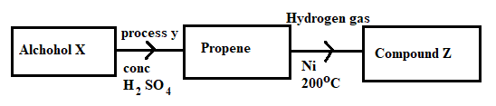
- Draw the structure of alcohol X [1 mk]

- Name process Y [1 mk]
_______________________________________________________________________________________
- Write the molecular formulae of the 5th member of the homologous series in which propene belongs

[1 mk]
- Calculate the enthalpy for the reaction:
C₂H_{4(g)} + H_{2(g)} C₂H₆ [3 mks]
Give the following bond energies
C – C | 347 kJ/mol
C = C | 612 kJ/mol
C – H | 413 kJ/mol
H – H | 436 kJ/mol

- Study the reactions below and answer the questions that follow.
Reaction Equation
J Ba²⁺_{(aq)} + BaSO_{3(S)}
K Br_{2(g)} + 2I⁻_{(aq)} 2Br⁻_{(aq)} + I_{2(g)}
l HSO⁻_{4(aq)} + OH⁻ _{(aq)} + H₂O_{(l)}
Which of these reactions indicate: [3 mks]
- A precipitation reaction
_______________________________________________________________________________________
- A displacement reaction
_______________________________________________________________________________________
- Neutralization reaction
_______________________________________________________________________________________
- An atom of element A has mass number 39 and 19 protons. (A is not the actual symbol of the element)
- Using crosses (x) to represent electrons, draw the atomic structure of element A [1 mk]

- State the group and period to which element A belongs [1 mk]
Group
_______________________________________________________________________________________
Period
_______________________________________________________________________________________
- Name the type of structure adopted by element A [1 mk]
_______________________________________________________________________________________
- a) State Graham’s law of rate of diffusion of gasses [1 mk]
_____________________________________________________________________________________________________________________________________________________________________________________________________________________________________________________________________
b) It take 44 seconds for nitrogen(iv)oxide to diffuse through a porous pot. Calculate how long it will take an equal volume of chlorine gas to diffuse through the same porous pot under the same conditions.(N = 4, O = 16, Cl = 35.5) [2 mks]
___________________________________________________________________________________________________________________________________________________________________________________________________________________________________________________________________________________________________________________________________________________________________________________________________________________________________________________
- The setup below represents electrolysis of dilute sulphuric (vi) acid.
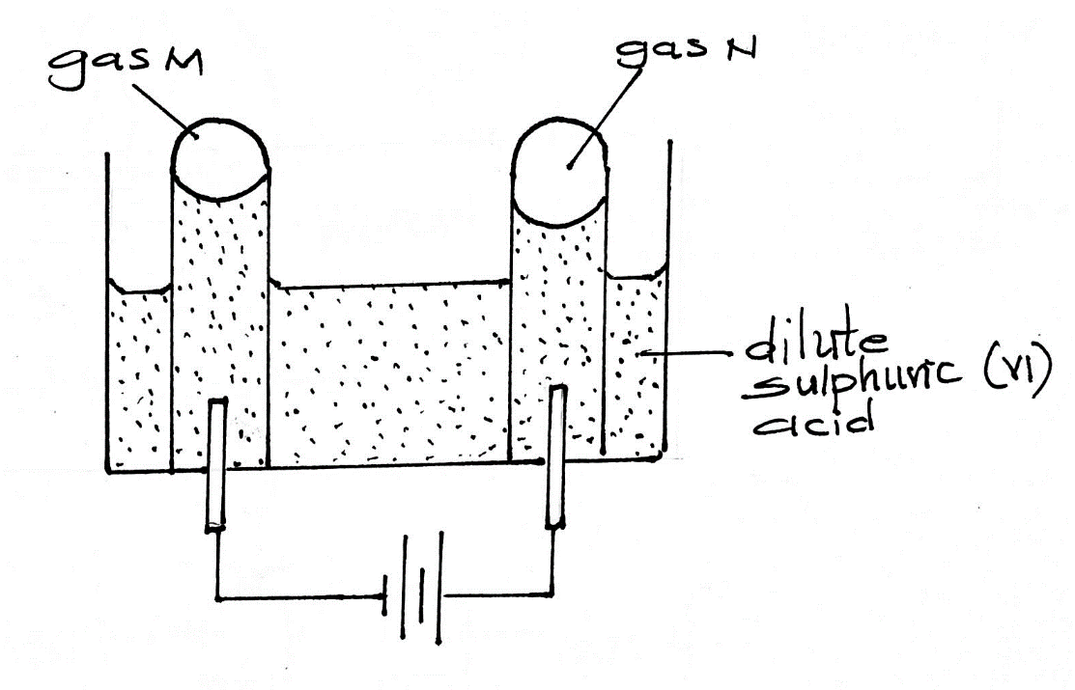
- Name gas: [2mks]
M - ___________________________________________________________________________
N - ___________________________________________________________________________
- At what electrode does oxidation take place? [1 mk]
_______________________________________________________________________________________
- Dichromate (vi) ions are orange in colour while chromate (vi) ions are yellow. Consider the following equation at equilibrium
_{(aq)} + 2OH⁻_{(aq)} 2 + H₂O_{(l)}
State and explain the observation which would be made if a few drops of dilute sulphuric(vi)acid were added to the equilibrium mixture [2 mks]
___________________________________________________________________________________________________________________________________________________________________________________________________________________________________________________________________________________________________________________________________________________________________________________________________________________________________________________
- An element has an electron configuration of 2.8.6
- Name the element [1 mk]
_______________________________________________________________________________________
- This element forms a puckered ring. Draw the ring [1 mk]

- Write the formulae of the puckered ring [1 mk]
_______________________________________________________________________________________
- The melting point of sodium oxide is 1193ºC while that of sulphure(iv)oxide is -72ºC. In terms of the structure and bonding, explain why there is a large difference in the melting points of the two oxides [2 mks]
___________________________________________________________________________________________________________________________________________________________________________________________________________________________________________________________________________________________________________________________________________________________________________________________________________________________________________________
- The diagram below illustrates some steps involved in manufacturing sodium carbonate. Use it to answer the questions that follow

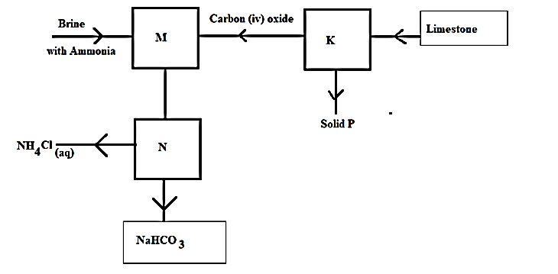

- Name the industrial process illustrated by the above flowchart [1 mk]
_______________________________________________________________________________________
- Write an equation for the reaction that takes place in chamber M [1 mk]
______________________________________________________________________________________________________________________________________________________________________________
- Name the process which takes place in chamber N [1 mk]
_______________________________________________________________________________________
- How is sodium carbonate obtained in this process [1 mk]
______________________________________________________________________________________________________________________________________________________________________________
- Explain why potassium is kept under paraffin while phosphorous is kept under water. [2 mks]
_____________________________________________________________________________________________________________________________________________________________________________________________________________________________________________________________________

- Dilute sulphuric (vi) acid was added to each of the three beakers containing the substances shown below
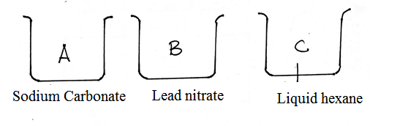
State the observation made in each beaker [3 mks]
A - ______________________________________________________________________________
B - ______________________________________________________________________________
C - ______________________________________________________________________________

- Hydrogen chloride gas was separately dissolved in water and methylbenzene and the solutions labelled B and A respectively. A piece of magnesium ribbon was placed in each of the solutions. There was a lot of bubbles in solution A but no bubbling occurred in solution B. Explain the observations [3 mks]
__________________________________________________________________________________________________________________________________________________________________________________________________________________________________________________________________________________________________________________________________________________________________________________________________________________________________________________________________________________________________________________________________________
- Give the IUPAC names of the following compounds [3 mks]
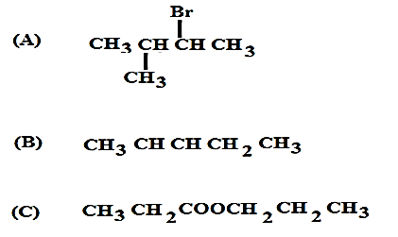
A______________________________________________________________________________________B______________________________________________________________________________________C______________________________________________________________________________________
- A solution contains 40.32g per litre of compound XOH. 25cm³ of this solution was exactly neutralized by 30cm³ of 0.3M sulphuric(vi)acid. Determine the relative atomic mass of X(O = 16,
H = 1) [4 mks]

THIS IS THE LAST PRINTED PAGE!

