NAME………………………………………………………….ADM NO………………………………….
SCHOOL………………………………………………………..CLASS………………..SIGN……………...
BIOLOGY
231/1
TIME: 2HOURS
RIFT VALLEY REGION SCHOOLS’ JOINT PREMOCKS
Kenya Certificate of Secondary Education. (K.C.S.E)
BIOLOGY PAPER 1

INSTRUCTIONS TO CANDIDATES.
1. Write your name and index number in the spaces provide above.
2. Sign and write the date of examination in the spaces provided above.
3. All working must be clearly shown where necessary.
4. Answer all the questions in English

For Examiners’ Use Only.
Questions | Maximum score | Candidates score
1-28 | 80marks

1. The apparatus below is used by entomologists in their work.
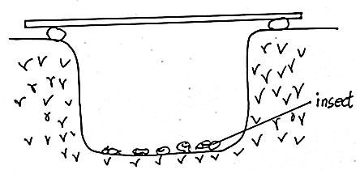
(a) Name the apparatus (1mark)
………………………………………………………………………………………………………..
………………………………………………………………………………………………………..
(b) Suggest a possible way on how the efficiency of the apparatus can be improved (1mark)
………………………………………………………………………………………………………..
………………………………………………………………………………………………………..
2(a) Name the organelle that:
(i) Stores chlorophyll (1mark)
………………………………………………………………………………………………………..
(ii) Is responsible for intracellular digestion (1mark)
………………………………………………………………………………………………………..
(b) State the function of the following parts of a microscope (2marks)
(i) Condenser
………………………………………………………………………………………………………..
(ii) Eye- piece
………………………………………………………………………………………………………..
3(a) State two components of blood that are absent in glomerular filtrate (2marks)
………………………………………………………………………………………………………..
………………………………………………………………………………………………………..
(b) Below is a diagram of variation in glucose concentration in human body.
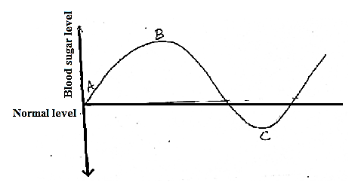
(i) State the process that can lead to the shape of the curve between points A and B. (1mark)
………………………………………………………………………………………………………..
………………………………………………………………………………………………………..
(ii) Explain the fate of excess glucose in the body. (2marks)
………………………………………………………………………………………………………..
………………………………………………………………………………………………………..

4. State two characteristics of species (2marks)
………………………………………………………………………………………………………..
………………………………………………………………………………………………………..
5. The graph below shows the time taken for cobalt (II) chloride to turn pink leaves of two plants.
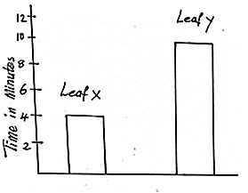
(a) Identify the leaf that is likely to be:
(i) Xerophyte (1mark)
………………………………………………………………………………………………………..
(ii) Hydrophyte (1mark)
………………………………………………………………………………………………………..
(b) Account for the time taken for leaf Y to turn pink (2marks)
………………………………………………………………………………………………………..
………………………………………………………………………………………………………..
6(a) Name two photochemical cells in the human retina. (2marks)
………………………………………………………………………………………………………..
………………………………………………………………………………………………………..
(b) Mention one chemical substance involved in nerve impulse transmission (1mark)
………………………………………………………………………………………………………..
7. The diagram below shows a certain phenomenon in plants

(i) State the type of response shown (1mark)
………………………………………………………………………………………………………..

(ii) Give the significance of the response. (1mark)
………………………………………………………………………………………………………..
………………………………………………………………………………………………………..
(iii) Which substance in the ear detect:
(a) Sound waves (1mark)
………………………………………………………………………………………………………..
(b) Change in posture (1mark)
………………………………………………………………………………………………………..
8.(a) What is eutrophication? (1mark)
………………………………………………………………………………………………………..
(b) Distinguish between a habitat and an ecological niche. (2marks)
………………………………………………………………………………………………………..
………………………………………………………………………………………………………..
9. State three advantages of genetic engineering in coffee plants. (3marks)
………………………………………………………………………………………………………..
………………………………………………………………………………………………………..
………………………………………………………………………………………………………..
10(a) How are spiracles in insects adapted to their functions? (2marks)
………………………………………………………………………………………………………..
………………………………………………………………………………………………………..
(b) List the gaseous exchange sites in terrestrial plants. (2marks)
………………………………………………………………………………………………………..
………………………………………………………………………………………………………..
11. Give two hormones responsible for breaking seed dormancy (2marks)
………………………………………………………………………………………………………..
………………………………………………………………………………………………………..
12. In an experiment the shoot tip of a plant was decapitated as shown below.
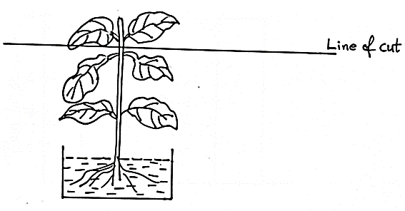
(a) State the expected results after 2 weeks (1mark)
………………………………………………………………………………………………………..
(b) Give a reason for your answer in (a) above (1mark)
………………………………………………………………………………………………………..
………………………………………………………………………………………………………..
13. The set up below was aimed at investigating a certain process.

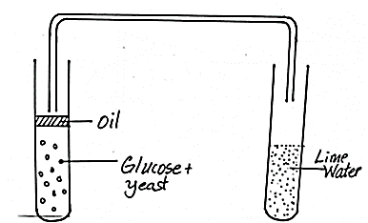
Boiling tube Test tube

(a) What was the role of oil in the set-up? (1mark)
………………………………………………………………………………………………………..
(b) Account for the observation in the test tube (3marks)
………………………………………………………………………………………………………..
………………………………………………………………………………………………………..
………………………………………………………………………………………………………..
14(a) Name the main feature that differentiate axis from other cervical vertebrae (1mark)
………………………………………………………………………………………………………..
………………………………………………………………………………………………………..
(b) State the fins that control: (2marks)
(i) Yawing
………………………………………………………………………………………………………..
(ii) Pitching
………………………………………………………………………………………………………..

15. The diagram below shows a bone.

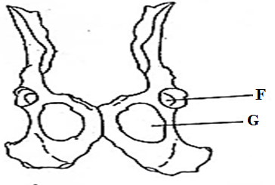
(a) Name the hole marked G. (1mark)
………………………………………………………………………………………………………..
………………………………………………………………………………………………………..
(b)(i) Identify the bone that articulates with the structure F. (1mark)
………………………………………………………………………………………………………..
………………………………………………………………………………………………………..
(ii) State the joint formed when the bone identified in (b) (i) articulates with structure F (1mark)
………………………………………………………………………………………………………..
………………………………………………………………………………………………………..
16. An experiment was carried out to investigate the effect of pH on the rate of enzyme –catalyzed reaction. The results were tabulated as shown:
pH | 0.5 | 1.5 | 2.0 | 3.0 | 4.0 | 5.5 | 7.0 | 8.0 | 9.0
Rate of reaction in mg of product per unit time | 0.2 | 1.5 | 2.3 | 3.4 | 2.2 | 0.1 | 0.0 | 0.0 | 0.0 | Enzyme R
Rate of reaction in mg of product per unit time | 0.0 | 0.0 | 0.0 | 0.0 | 0.8 | 1.6 | 2.6 | 3.2 | 1.2 | Enzyme T
(a) What is the optimum pH of each enzyme. (2marks)
Enzyme R
………………………………………………………………………………………………………..
Enzyme T
………………………………………………………………………………………………………..
(b) Assuming that the two enzymes are involved in human digestion, suggest the likely identity of enzyme R and name the part of the alimentary canal where it is found (2marks)
Enzyme R
………………………………………………………………………………………………………..
Region
………………………………………………………………………………………………………..
17. Identify the key principles of Lamark’s theory (2marks)
………………………………………………………………………………………………………..
………………………………………………………………………………………………………..
18. Briefly explain how cell biology can be an evidence of organic evolution. (3marks)
………………………………………………………………………………………………………..
………………………………………………………………………………………………………..
………………………………………………………………………………………………………..
19. State the stage of cell division in which the following events occur:
(a) Replication of genetic material (1mark)
………………………………………………………………………………………………………..
(b) Exchange of genetic material. (1mark)
………………………………………………………………………………………………………..
………………………………………………………………………………………………………..
20. Using the roles of follicle stimulating hormone and progesterone, explain how menstrual cycle is a negative feedback mechanism (2marks)
………………………………………………………………………………………………………..
………………………………………………………………………………………………………..
………………………………………………………………………………………………………..
………………………………………………………………………………………………………..
21. When Amoeba and red blood cells are placed in distilled water, the red blood cell burst but amoeba doesn’t burst yet, both lack cell walls. Explain this observation. (2marks)
………………………………………………………………………………………………………..
………………………………………………………………………………………………………..
………………………………………………………………………………………………………..
22. The illustration below shows a biological process in animals.
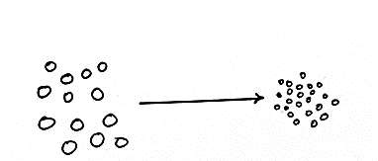
Fat molecule fat molecule

(i) Name the process (1mark)
………………………………………………………………………………………………………..
………………………………………………………………………………………………………..
(ii) State the biological significance of the above process. (2marks)
………………………………………………………………………………………………………..
………………………………………………………………………………………………………..
(iii) Give the digestive juice used in the process above (1mark)
………………………………………………………………………………………………………..
………………………………………………………………………………………………………..

23. State the importance of the following;
(i) Reversed stomata rhythm to desert plants (1mark)
………………………………………………………………………………………………………..
………………………………………………………………………………………………………..
(ii) Closing of stomata on a hot dry sunny day. (1mark)
………………………………………………………………………………………………………..
………………………………………………………………………………………………………..

24. Differentiate between smooth and skeletal muscles (2marks)
………………………………………………………………………………………………………..
………………………………………………………………………………………………………..
25. What changes occur in arterioles during thermoregulation in humans. (2marks)
………………………………………………………………………………………………………..
………………………………………………………………………………………………………..
26. The diagram below shows a specialized cell.
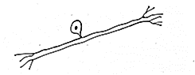
(a) Identify the type of neuron (1mark)
………………………………………………………………………………………………………..
(b) Give a reason for your answer (1mark)
………………………………………………………………………………………………………..
(c) State the role of the cell (1mark)
………………………………………………………………………………………………………..
………………………………………………………………………………………………………..
27. Name the causative agents of the following:
(a) Amoebic dysentery (1mark)
………………………………………………………………………………………………………..
(b) Schistosomiasis (1mark)
………………………………………………………………………………………………………..
28. State two genetic disorder that affect blood in humans (2marks)
………………………………………………………………………………………………………..
………………………………………………………………………………………………………..
THIS IS THE LAST PRINTED PAGE!

