MID TERM ASSESSMENT
SUBJECT: PHYSICS
Name: _____________________________________ ADM NO___________CLASS………….
TIME: 1 HOURS
SCORE

INSTRUCTIONS
ANSWER ALL QUESTIONS IN THE SPACES PROVIDED AFTER EACH QUESTION.

- State three careers that are physics dependent. (3 marks)

- A balloon rising in the atmosphere may burst as it rises. Explain this phenomena. (2 marks)

- State ONE factors that affect pressure in fluids. (1 mark)

- Determine the pressure of the gas below that raises the level of water as shown below.(3 marks)
(Density of water=1000kg/m3)
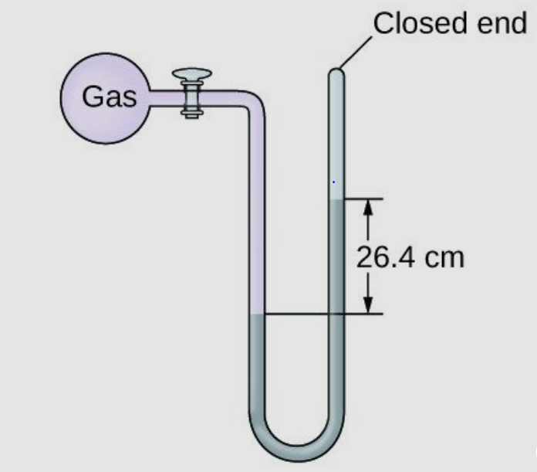

- A fisherman dives 25m below the sea water. Given that the sea water is 1.03g/cm3, gravitational force (g) is 10N/Kg and atmospheric pressure is 103, 000n/m2. Determine the following:
i) The pressure exerted by the sea water on the man. (3 marks)

ii) Total pressure on him. (2 marks)

- Define the following term relating to material properties;
  - Elastic deformation. (1 mark)

  - Plastic deformation. (1 mark)

  - Ductility (1 mark)

  - Malleability (1 mark)

  - Brittleness (1 mark)

- State Hooke’s law (1 mark)

- A spring produces an extension of 8mm when a force of 0.8N is applied to it. Calculate the spring constant for the system that has two such springs arranged in:
- Series (2 mark)

- Parallel (2 mark)

- A wire of length 3 m and cross sectional area of 0.0001m² is stretched by a load of 1050 N. The wire is stretched by 0.2 cm. Calculate the following:
  - Longitudinal or tensile stress (3 marks)

  - Longitudinal or tensile strain (3 marks)

  - Young’s modulus of elasticity (3 marks)

